How to Preserve and Mount Insects

(From: How To Collect and Preserve Insects, by Kathleen R. Methven, Michael R. Jeffords, Richard A. Weinzierl, and Kathryn C. McGiffen. Illinois Natural History Survey Special Publication 17. Illinois Natural History Survey, 607 East Peabody Drive, Champaign, IL 61820; telephone (217) 333-6880.)

You can preserve and mount insect specimens for your display in one of two basic ways:

- Dry and pin the specimens (hard-bodied insects such as beetles, flies, wasps, moths, butterflies)
- Preserve soft-bodied insects, such as caterpillars and aphids, in 70% ethanol (ethyl alcohol, not isopropyl alcohol [rubbing alcohol], should be used)

Pinning Insects

Mount insects on pins as soon as possible after collecting and killing.

Insects should be displayed on pins made especially for this purpose, not on ordinary straight pins. The pins can be obtained from your local Extension Office.

All insects should be at the same height on the pins so that about 1/4 to 3/8 inch of the pin projects above the insect. A pinning block with holes drilled 3/8, 3/4, and 1 1/8 inch deep will help.

Different insect should be pinned vertically through different body parts:

Bees, wasps and flies: pin through the thorax between the bases of the front wings slightly to the right of the middle of the body.

Stink bugs and other true bugs: pin just to the right of the midline of the scutellum, the large triangle between the bases of the front wings.

Grasshoppers: pin through the back part of the prothorax (the “saddle” behind the head) just to the right of the midline.

Beetles: pin near the front margin of the right wing cover near the midline of the body.

Moths and butterflies: WE WILL NOT BE COLLECTING MOTHS OR BUTTERFLIES!

Small insects: glue (clean nail polish, for example) the insect to a triangular point made of stiff paper (such as a notecard). Insert the pin through the wide end of the point, and glue the specimen to the narrow tip of the point.

How to Preserve and Mount Insects

(From: How To Collect and Preserve Insects, by Kathleen R. Methven, Michael R. Jeffords, Richard A. Weinzierl, and Kathryn C. McGiffen. Illinois Natural History Survey Special Publication 17. Illinois Natural History Survey, 607 East Peabody Drive, Champaign, IL 61820; telephone (217) 333-6880.)

Immediately after capturing your insects, you should prepare temporary labels that show the dates and places where the insects were collected, including county, nearby town, and where the insect was collected, (for example, type of plant on which the insect was found, whether it was found in or on the water, whether it was found on a pet, etc.). You can write other information, such as the insect’s behavior at the time of capture, in a field notebook.

When you mount your specimens on pins for display, you must also place permanent labels on the pins.

Use a fine-point pen to write the correct information on the labels. Print carefully.

Each pinned insect should also have two labels that include the following:

The first essential label, placed directly below the pinned specimen, should include the following information in the order presented:

State (2-letter abbreviation): County
Other locality data (town or distance and direction from nearest town, park, forest, river, etc.)
Date (day, then month [abbreviation is okay], then year [do not abbreviate])
Collector (your name, or the collector’s name)
Additional data (host, habitat, behavior, trapping method, etc.)

The second essential label should include the following information:

Insect Order
Scientific name of the insect, if known, and/or the common name of the insect.
Also, the individual who determined the identification of the insect can be placed on this label.

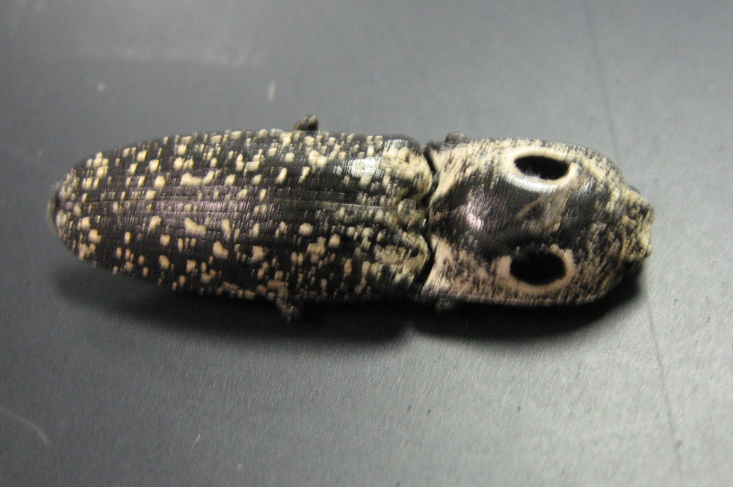
KS: Johnson County
De Soto High School
11 August, 2007
S. Sharp
Pit trap at east end of West Woods

Order: Coleoptera
Alaus oculatus
Eyed-Click Beetle
ID by Scott Sharp

