Name: _________________

Block :______

Date: ________

Introduction to Microscopes Lab
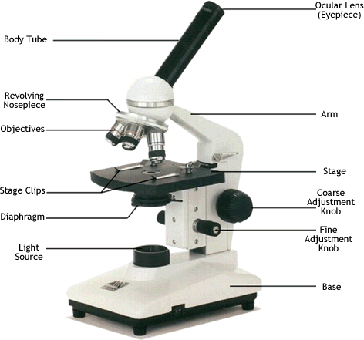
Examine the microscope and familiarize yourself with the parts of the microscope.
1. Magnification: The magnification written on the ocular lens (eyepiece) is _____________The magnification on the Scanning objective ___________ Low Power Objective ___________ High Power Objective ___________
What is the total magnification for each lens (multiply ocular times objective) Scanning _________Low Power __________High Power __________
2. Diaphragm: Examine the diaphragm, what are the numbers written on it? ___________ Which setting makes the specimen the brightest? ______The darkest? ________
3. Focus Knobs: Describe what happens when you adjust the coarse focus knob (include the word “stage” in your answer). ________________________________________________________
Describe what happens when you adjust the fine focus knob (the smaller one).
________________________________________________________
4. Investigation of Pond Water  1. Prepare a wet mount of pond water - a sample of pond water is provided in a jar. The best specimens usually come from the bottom and probably will contain chunks of algae or other debris that you can see with your naked eye. (Be careful that your slide isn't too thick)  2. Use the microscope to focus on the slide - try different objectives, some may be better than others for viewing the slide..  3. Make three separate drawings below at different areas of the slide and at different magnifications. Label where appropriate.
  Drawing Specimens
  1. Use pencil - you can erase and shade areas
  2. All drawings should include clear and proper labels (and be large enough to view details). Drawings should be labeled with the specimen name and magnification.
  3. Labels should be written on the outside of the circle. The circle indicates the viewing field as seen through the eyepiece, specimens should be drawn to scale - i.e......if your specimen takes up the whole viewing field, make sure your drawing reflects that.
Scanning  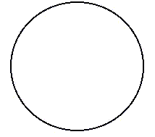 | Low Power | High Power

5. Viewing Prepared Slides
Select two prepared slides. Focus the slide first with the scanning objective, then click to lower power and focus again. Finally, focus the slide under high power. Remember, at high power, you should ONLY use the fine adjustment knob.
Draw each object exactly as it appears in your viewing field for each magnification. The circles below represent your viewing field. The drawings should take up as much space in the drawing as they do in your viewing field while you're looking at it.
Specimen A: __________________________

Scanning | Low Power | High Power
Specimen B: __________________________
Scanning | Low Power | High Power

6. Investigation of Large Specimens
Light microscopes are only useful for viewing small thin specimens. In biology, you will perform dissections on larger specimens and may need to magnify the area of interest. In this situation, a stereoscope may be the best instrument. Stereoscopes present a larger field of viewing and handle depth much better than the light microscope. The drawback of the stereoscope is that it does not have a high magnification. Examine one of the stereoscopes in the room. They will be positioned around the room with specimens.
Practice changing the light source and the focus on the stereoscope. Choose two specimens, and then determine which light and magnification is best for viewing each.
Specimen 1: ____________________________________________
Magnification _________ Light ____________ Reason that combination of magnification and light were best for viewing that specimen:
_____________________________________________________________
Specimen 2: ____________________________________________
Magnification _________ Light ____________ Reason that combination of magnification and light were best for viewing that specimen:
_____________________________________________________________

7. Reflection: Identify the most interesting thing you observed today, and explain what about it made you think it was interesting! (4pts: 1 pt for stating what you observed, and 3 points for thoughtful sentences describing what interested you today)

