Student-Snake Locomotion

For each demonstration, student will form a line and stand with their hands on the shoulders of the person in front. The front person will be the head of the snake and guide movement.

Rectilinear motion:

https://www.youtube.com/watch?v=vnLDq8Lz5hg

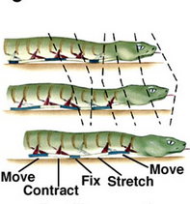

Movement is independent of surroundings.

- Head takes one step forward.
- After the head has completed movement, 2nd person takes one step forward.
- Process is repeated through the entire snake (line).
- Head can only move forward again AFTER the person directly behind them has moved forward.

Lateral undulation:

https://www.youtube.com/watch?v=zEto1-ZTbd4

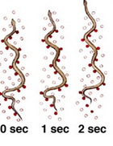

Movement of each section (except the head) requires an environmental contact.

- Head steps forward.
- Each section behind can ONLY step forward if two conditions are met.
  - Segment (person) in front of them is one step ahead of them.
  - They are touching an object to their side with one hand.
- Each segment (including the head) must be careful not to move too far ahead.
  - Segments MUST remain connected at all times with at least one hand.
- Repeat steps 1-3

Concertina motion:

https://www.youtube.com/watch?v=a9y-C7LDpq0

https://www.youtube.com/watch?v=DYxjr605rxA

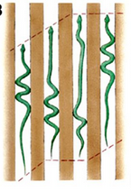

Movement requires each section (except the head) to be making an environmental contact on the opposite side as the segment in front of them BEFORE they can step forward.

- Every body segment (except the head) must touch an object next to them.
- The side they are touching must be on the opposite side as the segment in front of them.
- Once EVERY segment is touching an object, everyone can take one step forward.
- Repeat, but you must touch an object on the opposite side as last time.

Sidewinder motion:

https://www.youtube.com/watch?v=B3NbPUTD5qA

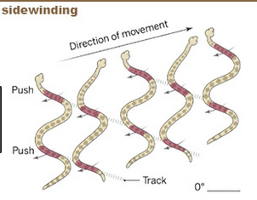
Movement is accomplished by sections of the snake getting thrown forward and approx. 60 degrees to its direction of travel.

- Head remains stationary
- While remaining attached (hands to shoulders) the rest of the snake moves forward and to the side until 6 body segments are lined up to the side of the head but angled slightly back.
- The 6th segment stops and tells the head to move.
- The head begins to move forward.
- Every segment moves forward following the path of the one in front of them.
- The head moves forward until the last segment reaches the bend and begins moving forward again. They yell stop.
- Head stops, repeats steps 2-6

