KABT Spring Field Trip:
Saturday, May 31 – Sunday, June 1

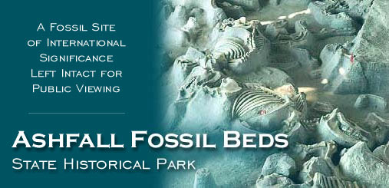
Informative and Family Friendly. Bring the entire family… friends welcome too!

Saturday, May 31
10:00 am Meet at Nebraska State Museum on NU’s campus in Lincoln
Nebraska State Museum at NU
307 Morrill Hall
Lincoln, NE 68588-0256
(402) 472-2642
10:00 Tour museum
11:45 Lunch in Lincoln
12:30 pm Leave for Niobrara State Park in NE Nebraska
Niobrara State Park
89261 522 Ave
Niobrara, NE 68760
(402)857-3373
5:00 Arrive at Niobrara State Park and set up camp
Bison Dinner

Sunday, June 1
Morning Explore Niobrara & Breakfast (on your own)
12:00 Lunch in Niobrara
1:30 TOUR Ashfall Fossil Beds State Historical Park
86930 517th Avenue
Royal, NE 68773
(402) 893-2000
Lodging:
Niobrara State Park Campgrounds (Saturday evening only)

Cost:
$14 DUE BY MAY 14 to reserve time at Ashfall Fossil Beds
(make check payable to KABT mail to Olathe East High School c/o Paula Donham 14545 W. 127th St, Olathe, Ks. 66062)

$31.05 ($9.05 Park Permit per vehicle for 2 days, $5.00 museum, $8.00 per tent site, $9.00 Buffalo Burgers/Cookout on Saturday evening)

Additional: Travel and meal costs (remember Saturday evening’s cookout is above)

Items to Bring:
- Tent, Sleeping Bag, sleeping pad, pillow
- Flashlight
- Binoculars
- Spending money (there is a great bookstore at the fossil site, meals, and snacks)
- Toiletries (including towel)

