AP Biology Name _________________________
Chapter 10 Guided Reading Assignment

- Label the diagram below.
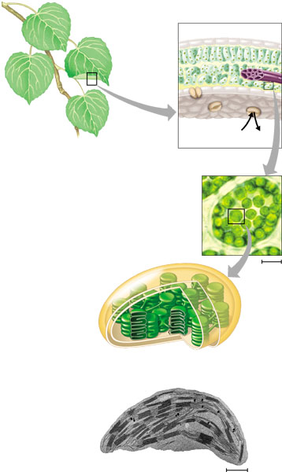
- Explain the experiment reasoning that Van Niel used to understand photosynthesis.
- Use the diagram to label and identify the two broad stages of photosynthesis.
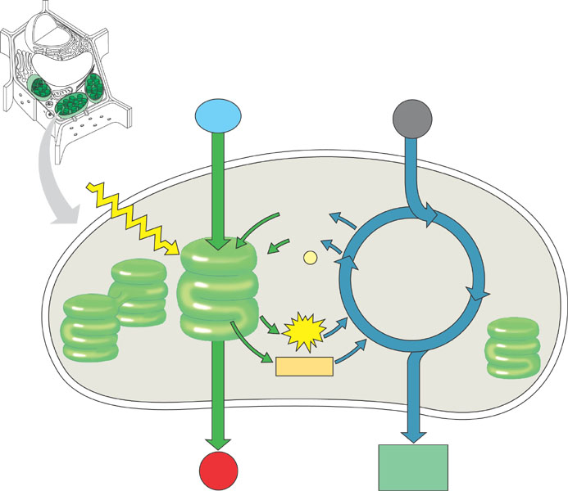
- What is carbon fixation?
- What is a photon?
- Why are leaves green?
- Describe Engelmann’s experiment and explain its results.
- What is the difference between an absorption spectra and action spectrum?
- What happens to chlorophyll when it is hit by light? How does this relate to potential energy?
- Identify the following parts of a photosystem:
  - Photosystem
  - Light harvesting complex
  - Reaction center
  - Primary electron acceptor
- What are the steps in noncyclic electron flow in photosynthesis?
- What is cyclic electron flow?
- Use the diagram below to assist – but also write a response – compare and contrast chemiosmosis in mitochondria and chloroplasts.
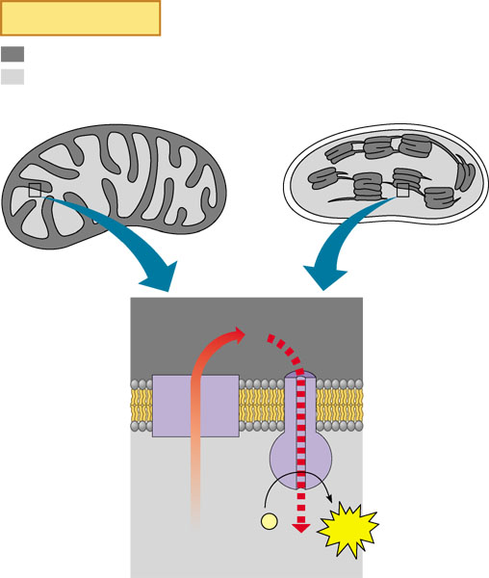
- Use the diagram below to summarize the activities in the light reactions of photosynthesis.
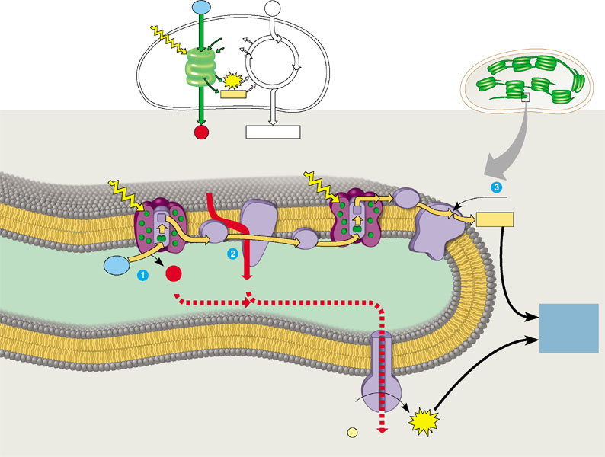
- Describe and explain the overall purpose of the Calvin cycle and each phase listed below:
  - Calvin cycle
  - Carbon fixation
  - Reduction
  - Regeneration
- Label the diagram below of the Calvin Cycle.
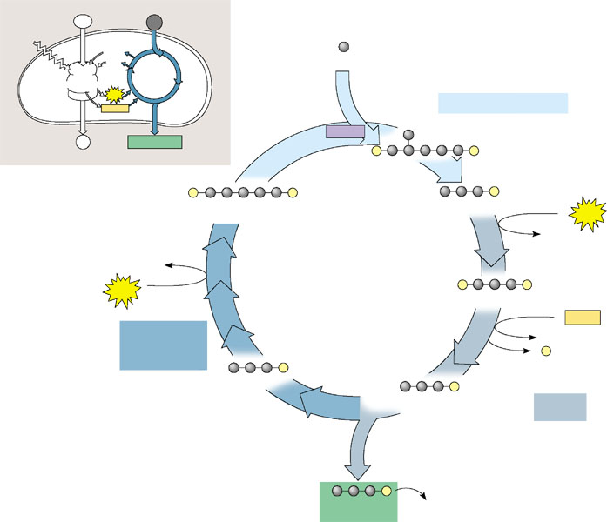
- What is a plant’s most valuable resource and why did plants need to evolve adaptations for hot, arid climates?
- Why is photorespiration such a “waste”?
- Use the diagram below to explain C4 plants.
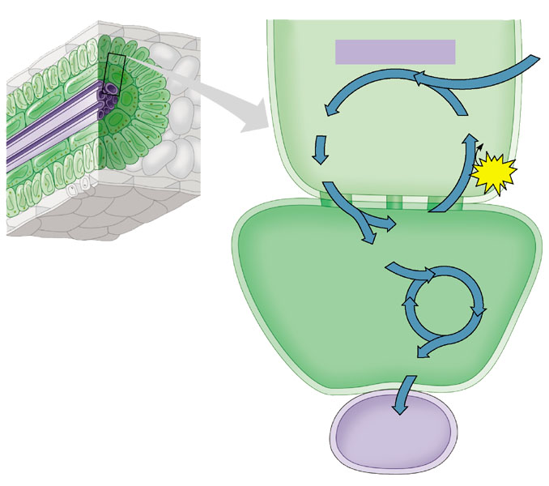
- What are CAM plants and what is their “advantage”?
- Use the diagram below to summarize the activities of photosynthesis.
