AP Biology Name _________________________
Chapter 12 Guided Reading Assignment

- Compare and contrast the role of cell division in unicellular and multicellular organisms.
- Define the following terms:
  - Genome
  - Chromosomes
  - Somatic cells
  - Gametes
  - Chromatin
  - Sister chromatids
  - Centromere
  - Mitosis
  - Cytokinesis
  - Meiosis
- List the activities of the cell cycle:
  - Mitotic phase
  - Interphase
  - G1 phase
  - G2 phase
  - S phase
- Define the following terms:
  - Mitotic spindle
  - Centrosome
  - Microtubule organizing center
  - Aster
  - Kinetochore
  - Label below:
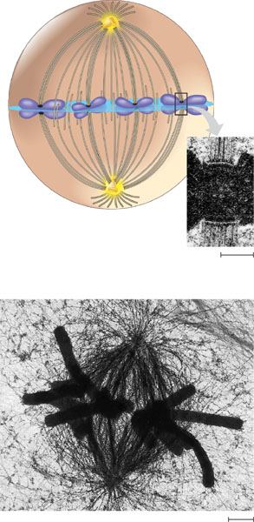
- Label the diagram below:
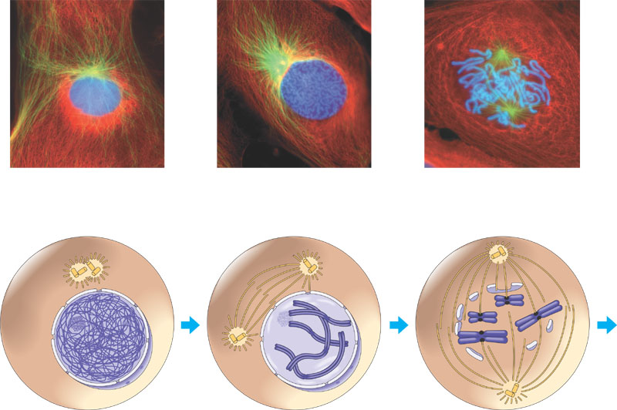
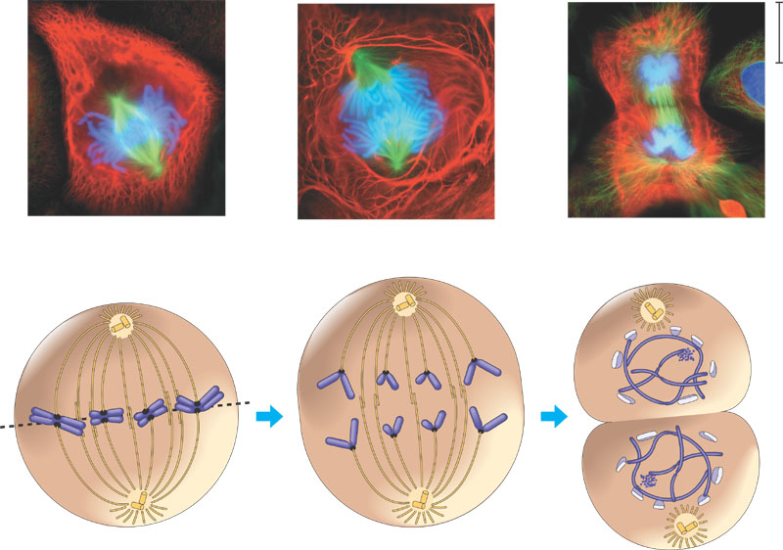
- Describe the experiment concerning the movement of microtubules during mitosis and its results.
- Contrast cytokinesis in plant and animal cells.
- Define binary fission and label the diagram below:
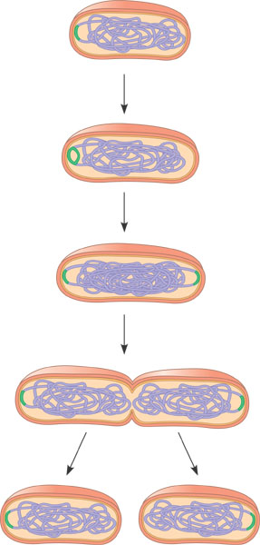
- Discuss the hypothetical evolution of mitosis.
- What is the cell cycle control system and how do checkpoints play into this?
- What is a cyclin and what does it activate?
- What are Cdk’s?
- What does MPF stand for and what does it promote?
- Label the diagram below illustrating the molecular control of the cell cycle?
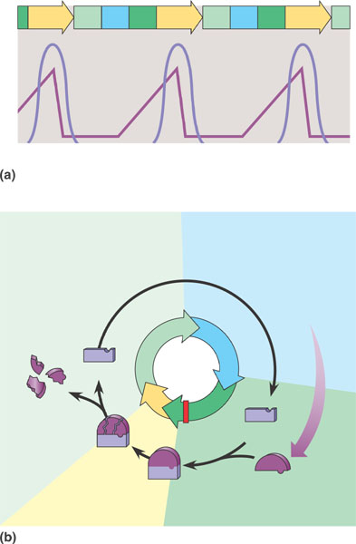
- What is a growth factor?
- What is density-dependent inhibition?
- What is anchorage dependence?
- Define the following terms:
  - Transformation
  - Benign tumor
  - Malignant tumor
  - metastasis

