AP Biology Name _________________________
Chapter 13 Guided Reading Assignment

- Compare and contrast asexual and sexual reproduction.
- Define the following terms:
  - Life cycle
  - Somatic cell
  - Karyotype
  - Homologous chromosomes
  - Sex chromosomes
  - Autosomes
  - Diploid cell
  - Haploid cell
  - Fertilization
  - Zygote
  - meiosis
- How are karyotypes prepared?
- Describe the three different types of life cycles.
- What exactly is meant by alternation of generations?
- Complete the diagram below outlining an overview of meiosis.
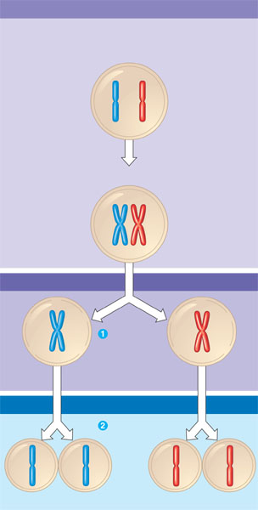
- What are the two broad goals of meiosis?
- Label the following diagrams of meiosis.
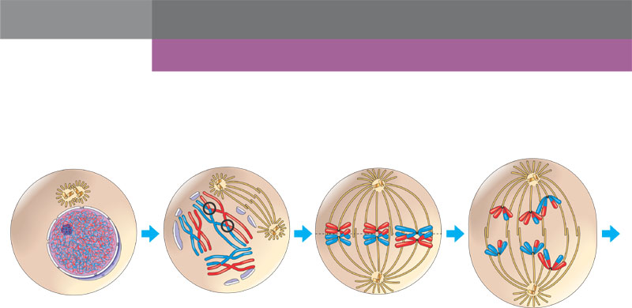
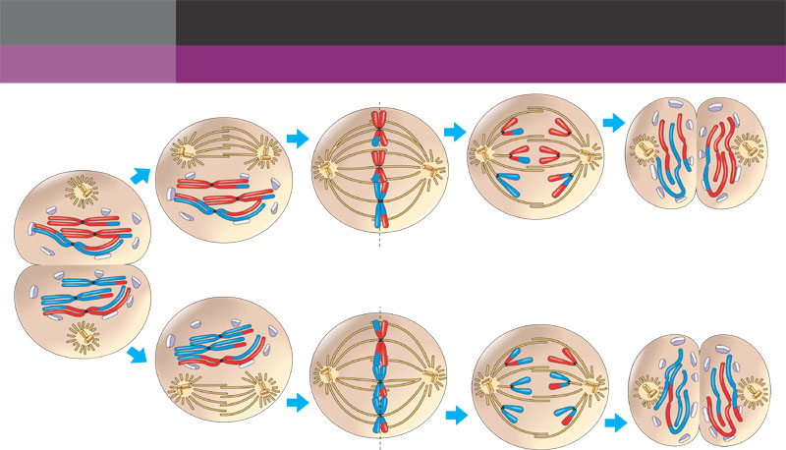
- Summarize the comparison of mitosis and meiosis.
- Describe in detail the three sources of genetic variation in meiosis.

