AP Biology Name _________________________
Chapter 15 Guided Reading Assignment

- What is the chromosomal basis of inheritance?
- IN YOUR OWN words, explain what is demonstrated by 15.2 on page 275.
- What does wild type mean?
- Why was Morgan’s choice of fruit fly such a good one for genetic experiments?
- How did Morgan associate traits with the sex of the fruit fly?
BE CAREFUL with the way the letters represent the traits – the + superscript means the trait is absent – vg+ means normal wings, not vestigial wings. This is counterintuitive and appears backwards – be careful with it while you read or you will get VERY confused.
- What does it mean when genes are linked or we can say there is linkage?
AGAIN – the word recombinant is critical. Recombinants are the traits that are in the offspring – mix and matched – meaning – think of it in terms of the peas – round and yellow parents crossed with green and wrinkled seeds. The offspring that are round and yellow OR green and wrinkled ARE NOT recombinants. The offspring that are yellow and wrinkled OR green and round ARE recombinants. The parental genes are – mix and matched. Understanding this term is essential to your reading.
- In what step of meiosis, would recombinants form and why?
- What is the difference between a genetic map, a linkage map and a cytogenetic map?
- Explain the chromosomal basis of sex determination in the following organism:
  - Mammals
  - Grasshoppers
  - Birds and some fish
  - Bees and ants
- What is the SRY gene and why is it important?
- What is a sex-linked gene?
- What is X inactivation?
- Why are most Calico cats female?
- What is nondisjunction and when in meiosis can it occur?
- Define the following terms:
  - Aneuploidy
  - Monosomic
  - Polyploidy
- Label the following alterations in chromosomal structure. Define the term alongside the diagram. These terms will be used in the coming chapters.
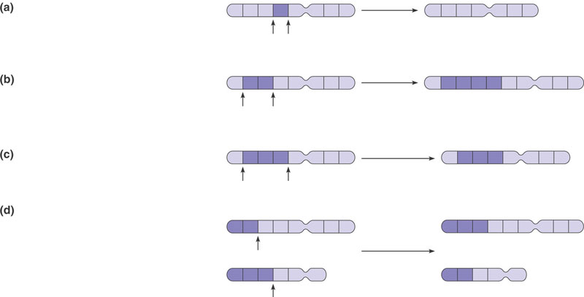
- Explain the following human disorders that result from chromosomal alterations.
  - Down Syndrome
  - Klinefelter Syndrome
  - Turner Syndrome
  - CML
- What is genomic imprinting?
- What are extranuclear genes?
- What are two diseases carried in maternal mitochondria?

