AP Biology Name _________________________
Chapter 16 Guided Reading Assignment

- Explain Griffith’s experiment and the concept of transformation in detail.
- What did Avery, MacLeod and McCarty contribute to this line of investigation?
- What is a bacteriophage?
- Label the diagram below and explain the Hershey Chase experiment.
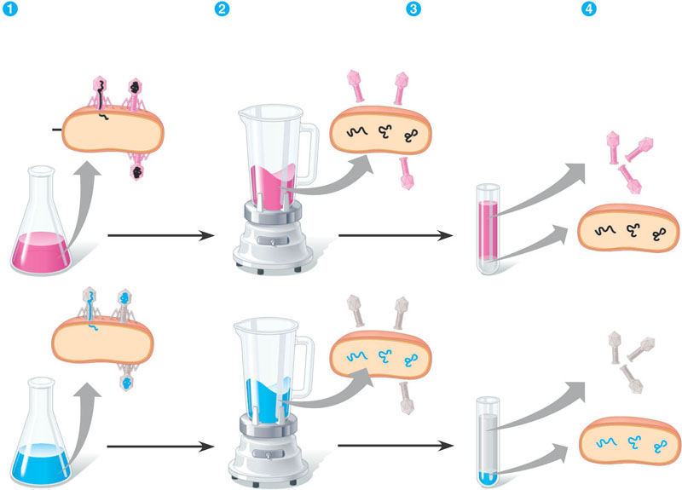
- How did Chargraff’s work contribute to understanding the structure of DNA?
- Why was Rosalind’s Franklin’s work essential to the understanding of the structure of DNA?
- Label the structure below:
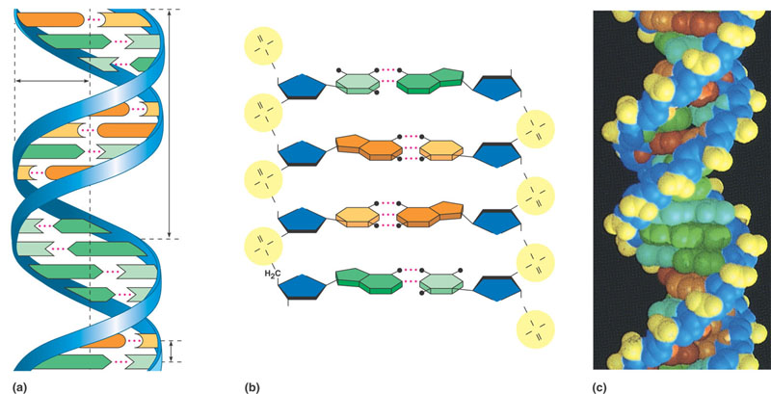
- Why does adenine always pair with thymine and guanine with cytosine in DNA?
- What is meant by the term that DNA replication is semiconservative?
- Detail the Meselson and Stahl experiment concerning DNA replication.
- How is bacterial DNA replication accomplished?
- What are DNA polymerases?
- In your own words, what is meant by the term – DNA is antiparallel in arrangement”?
- Define the following terms:
  - Leading strand
  - Lagging strand
  - Okazaki fragments
  - DNA ligase
  - Primer
- Label the diagram below:
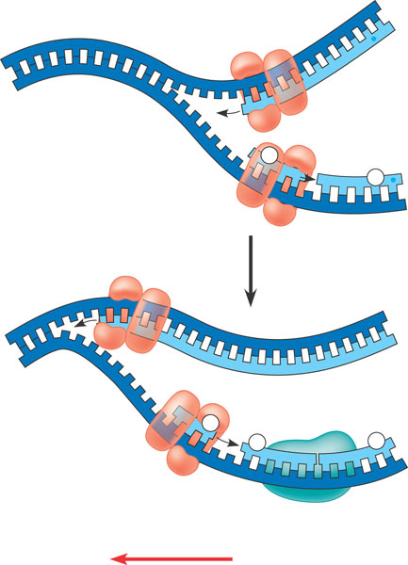
- Identify and label the diagram below:
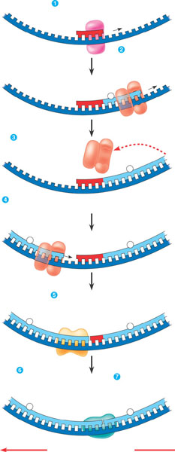
- List the functions of the following enzymes:
  - Helicase
  - Single stranded binding protein
  - Topoisomerase
  - Primase
  - DNA Polymerase III
  - DNA Polymerase I
  - DNA Ligase
- Identify and label the diagram below:
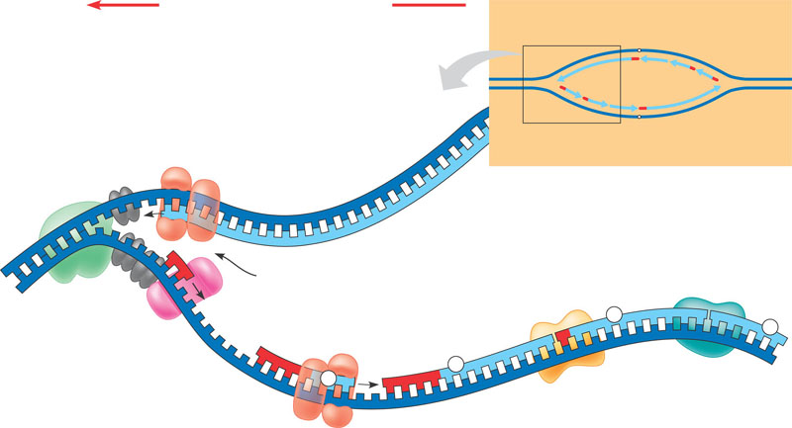
- What is mismatch repair?
- Label the diagram below:
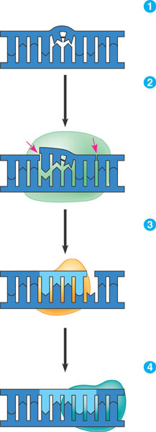
- Why is there a short section of a cell’s DNA that cannot be repaired or replaced? Draw your own diagram explaining the problem. It is very important that you understand this conceptually.
- What are telomeres and why are they important? How does telomerase play a role?

