AP Biology Name _________________________
Chapter 17 Guided Reading Assignment

- What did Garrod mean by “inborn errors of metabolism?”
- Describe the Beadle and Tatum experiment with mold in detail – use the diagram below to help. The logic behind both the experiment and the results are critical.
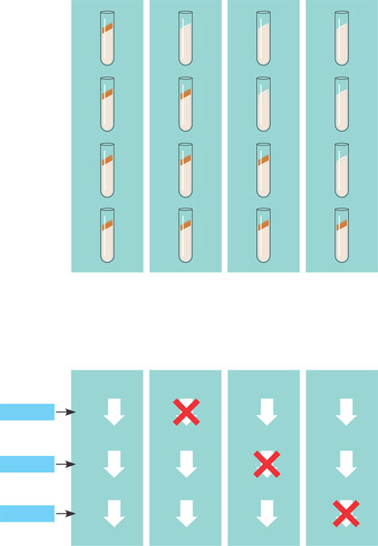
- What was Beadle and Tatum’s final hypothesis?
- Use the diagram below to note the flow of genetic information in a eukaryotic cell – next to each label in the square – write the definition of the term.
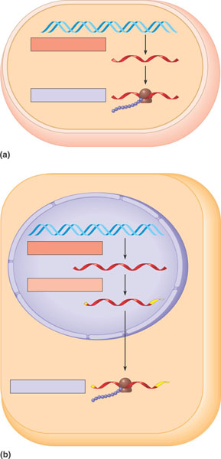
- Why does the “code” have to be in triplets and not singles or doubles?
- What is the template strand?
- Compare and contrast the codon and anticodon?
- How did Nirenberg “figure out” which amino acids went with which codes?
- What is the reading frame?
- What conclusions can be drawn from the similarities of the genetic code among living organisms?
- Use the diagram below to understand transcription: Define all terms.
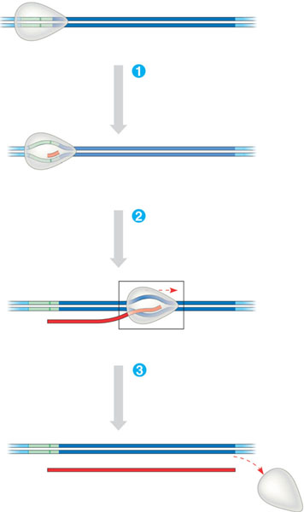
- What is a transcription unit?
- Describe the prokaryotic promoter and terminator.
- Use the diagram below to demonstrate initiation of transcription at a eukaryotic promoter. Write definition of all terms in diagram.
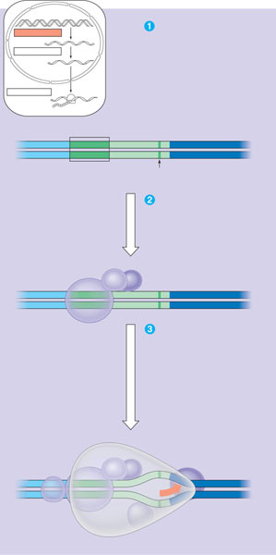
- Contrast termination of transcription for prokaryotic and eukaryotic organisms.
- Why is important that the promoter be upstream of the transcription unit?
- Why is RNA processing necessary?
- What does adding a 5’ cap and poly A tail mean and why is it important?
- Define the following terms:
  - RNA splicing
  - Introns
  - Exons
  - Spliceosome
  - snRNP’s
  - ribozymes
  - UTR
  - Alternative RNA splicing
  - domains
- Describe the structure and function of transfer RNA.
- Why is the enzyme aminoacyl-tRNA synthetase important to translation and protein synthesis?
- What is “wobble”?
- Describe the structure and function on ribosomal RNA – use the diagram below.
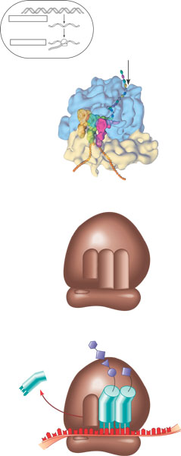
- Detail the steps of initiation of translation.
- Use the diagram below to detail elongation cycle of translation. Define terms.
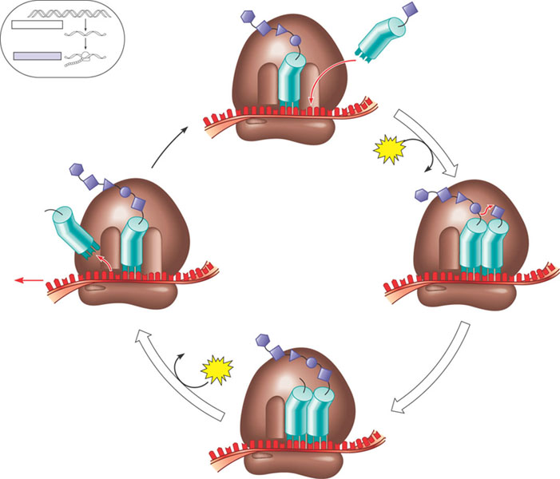
- Use the diagram below to detail the termination of translation – define all terms.
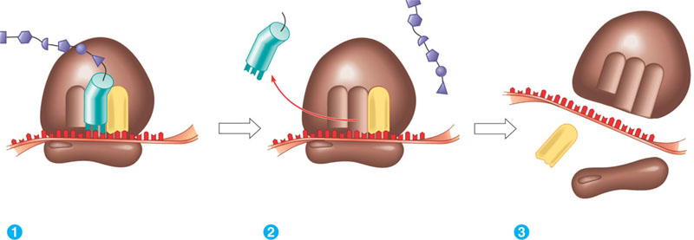
- What are polyribosomes?
- What is an example of a post translational modification of a protein?
- What is a signal peptide?
- What is a signal recognition particle?
- Use the diagram below to highlight the signal mechanism for targeting proteins to the ER.
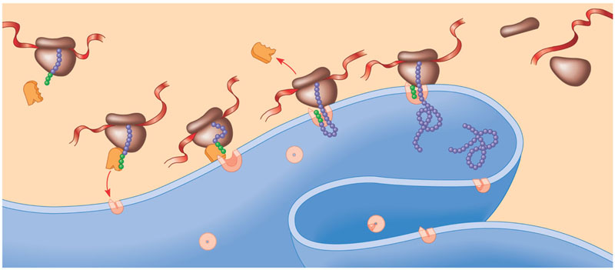
- You are responsible for the content in Table 17.1 on page 327.
- Define the following terms:
  - Mutations
  - Point mutations
  - Base pair substitution
  - Missense
  - Nonsense
  - Insertions
  - Deletions
  - Frameshift mutation
  - Mutagen
- How has a gene been “redefined” and why?
- Use the diagram below to help you study the “whole” picture.
