AP Biology Name _________________________
Chapter 2 Guided Reading Assignment

This chapter is a review of basic chemistry – we will be going through this chapter very quickly. If you have any problems – please see me before school for additional help.
- Contrast the term element with compound.
- Label the diagram below and define the terms that you label.
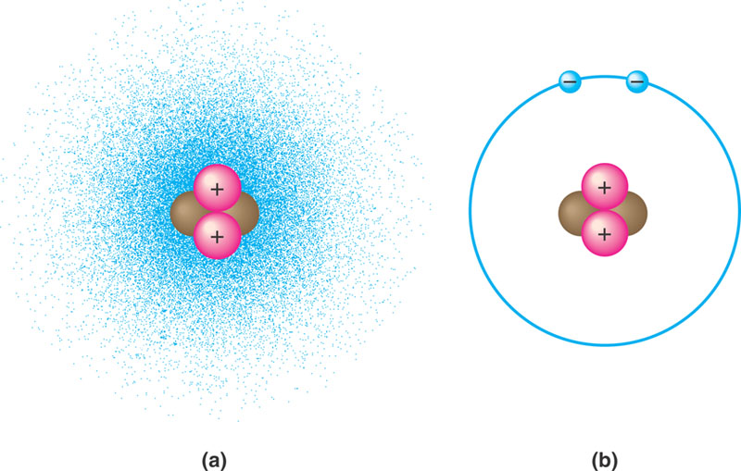
- Contrast the terms atomic mass and atomic number.
- What is the difference between the terms atomic mass and atomic weight?
- What is an isotope and what is “special” about radioactive isotopes?
- Explain how radioactive tracers are used in science?
- Explain how the movement of electrons relates to the concept of potential energy – use the diagram below to help answer the question.
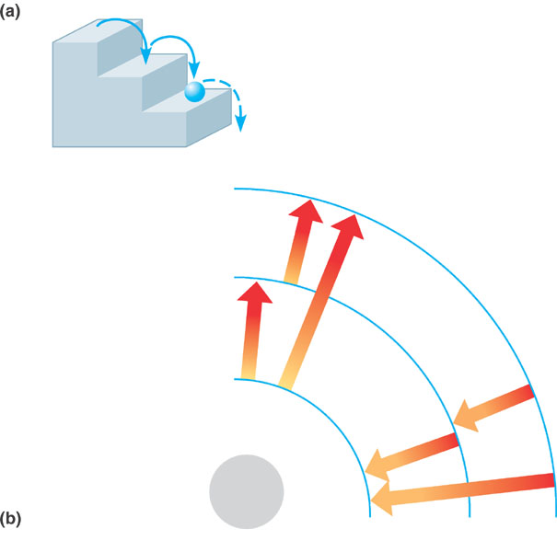
- What determines interactions between atoms? Why are valence electrons important?
- Define the following terms:
  - Chemical bond
  - Covalent bond
  - Single bond
  - Double bond
  - Valence
  - Electronegativity
  - Nonpolar covalent bond
  - Polar covalent bond
- What is the difference between a structural and molecular formula?
- How do ionic bonds compare with covalent bonds?
- Compare and contrast hydrogen bonds and van der Waals interactions.
- Based on the reading, what is an example, in a living system, of how molecular shape is critical?
- Define a dynamic chemical equilibrium in terms of quantities of reactants and products. This is a critical concept!

