AP Biology Name _________________________
Chapter 20 Guided Reading Assignment

- Define the following
  - Recombinant DNA
  - Genetic engineering
  - Biotechnology
  - Gene cloning
- Why did restriction enzymes evolve in bacteria?
- Define the following terms
  - Restriction site
  - Restriction fragments
  - Sticky end
- Label the following diagram.
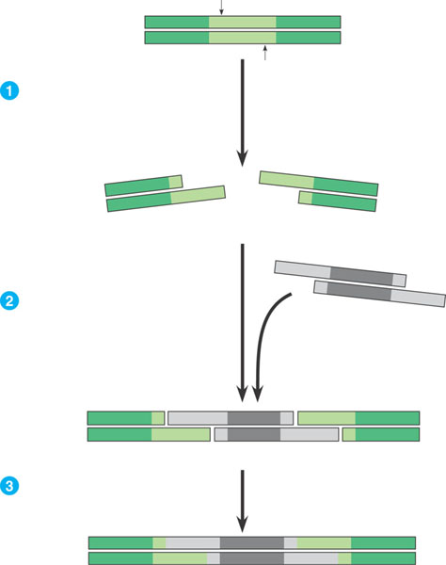
- Using the diagram below – label the steps to cloning a human gene in a bacterial plasmid
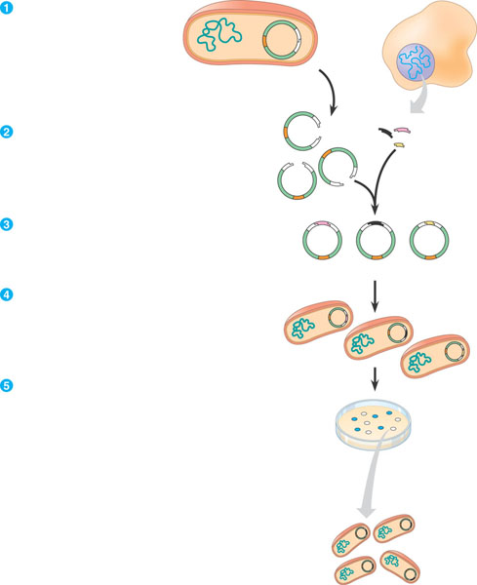
- Explain in your own words two ways that we know the cell clones carry the recombinant plasmids?
- What is the purpose of nucleic acid hybridization? Why is the word hybrid used?
- What is a complementary, short, single stranded nucleic acid that can be either DNA or RNA called?
- Why do scientists use a radioactive isotope tag for the probes?
- How is DNA denaturation different than protein denaturation?
- Label the following steps of nucleic acid probe hybridization.
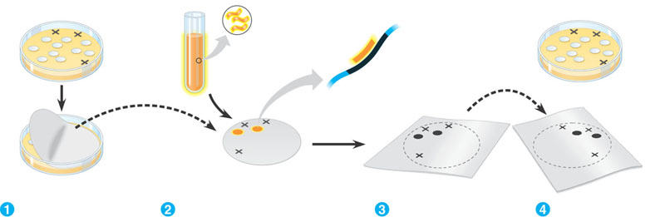
- Define genomic library.
- How are bacteriophages used for making genomic libraries and what are some of the advantages of this?
- What are the steps in making complementary DNA – cDNA?
- Compare and contrast the advantages of cDNA libraries and genomic libraries.
- What is an expression vector and what problem does it solve?
- Why do molecular biologists use yeast as opposed to bacteria for expressing genes of interest?
- Define yeast artificial chromosomes.
- What is electroporation?
- Why is PCR – polymerase chain reaction important in many aspects of biotechnology?
- Label the diagram of PCR below.
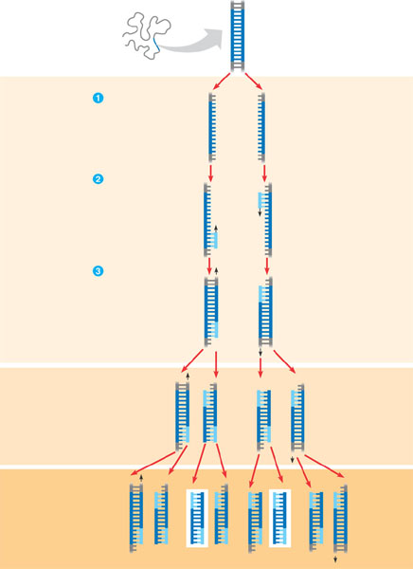
- What is the purpose and general process of gel electrophoresis?
- Label the diagram below – focus on the charge, molecule size and results.
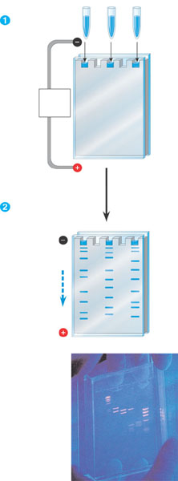
- Label the diagram below – focus on identifying the fragments.
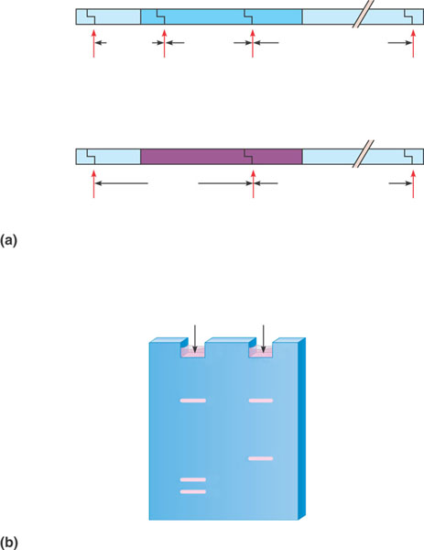
- Define and explain the significance of RFLP’s – restriction length polymorphisms.
- What was the purpose of the Human Genome Project?
- Label the diagram outlining the Southern Blotting of DNA Fragments
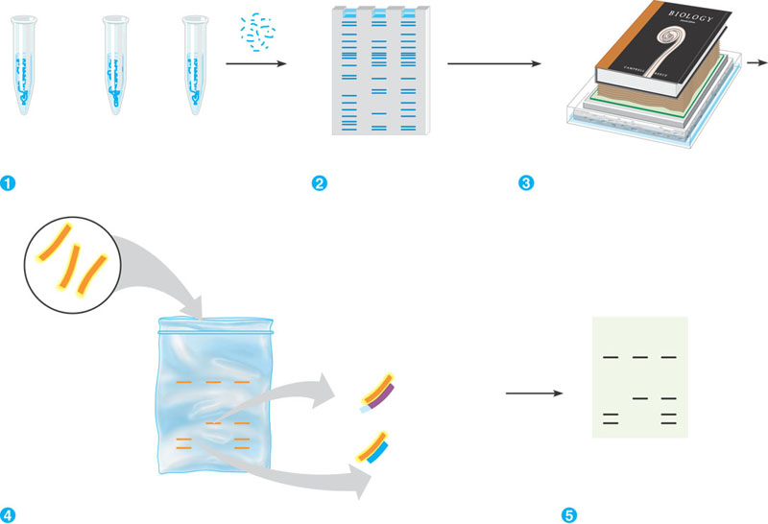
- Why is genetic mapping considered a “relative mapping” as opposed to physical mapping?
- What is the goal of DNA sequencing?
- Outline the diagram below of Dideoxy Chain Termination – I know this seems difficult to follow at first but at least copy the main ideas before we go over it in class.
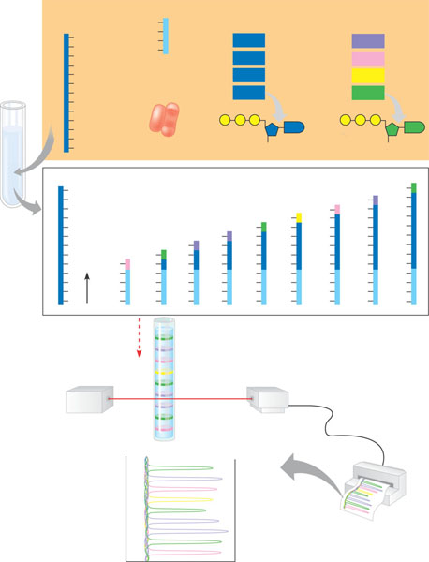
- What is the basic concept of the whole-genome shotgun approach to sequencing?
- Define genomics.
- Is there a direct correlation between size of the genome and the complexity of the organism?
- What is in vitro mutagenesis and what does it help the scientist understand?
- What is proteomics?
- Define single nucleotide polymorphisms.
- What are some of the examples of the medical applications of biotechnology?
- What are the basic steps in human gene therapy with a retroviral vector?
- Have there been problems with this procedure?
- What is a DNA fingerprint?
- What is a transgenic animal?
- How are plasmids used in agriculture and genetic engineering in plants?
- What are genetically modified foods and do you think that you have eaten any?

