AP Biology Name __________________________
Guided Reading Chapter 23

- What is the smallest using of evolution and why is this important to understand?
- Define the following terms:
  - Microevolution
  - Population
  - Population genetics
  - Gene pool
- What is the Hardy-Weinberg Theorem and why does it appear to be an apparent contradiction to evolution?
- What is Hardy-Weinberg equilibrium?
- Use the blank diagram below to relate the H-W equation to a Punnett square.
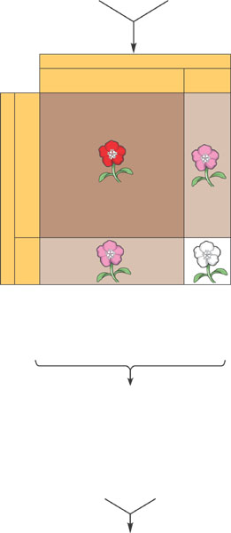
- What are the five conditions for H-W equilibrium to maintained?
- How can the H-W equation be used to today in terms of human health?
- What are the two broad processes that make evolution possible?
- What is the impact of the following:
  - Point mutation
  - Gene duplication
  - Sexual recombination
- What is the relationship between mutation rates and generation span?
- Define the following:
  - Genetic drift
  - Bottleneck effect
  - Founder effect
  - Gene flow
- Why would we discuss adaptive evolution and what role does natural selection play?
- Give examples of phenotypical variation that is not inheritable.
- Explain the terms phenotypic polymorphism and genetic polymorphism in common terms giving an example from your own experience. I will be looking for a reasonable answer for this question – points will be deducted if not answered.
- How do we measure genetic variation?
- How can very small differences in nucleotide sequences lead to such diversity in the human population?
- What is geographic variation and how does the term cline relate?
- What is different about the terms fitness and relative fitness?
- Why is it said that evolution acts on phenotypes and not genotypes?
- Use the diagram below to differentiate between the modes of selection.
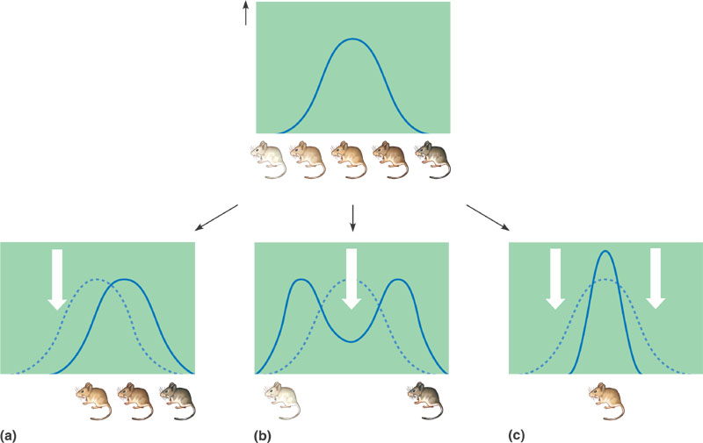
- Why does diploidy preserve genetic variation?
- How does balancing natural selection relate to the term balanced polymorphism?
- Define and give an example of the following:
  - Heterozygote advantage
  - Frequency dependent selection
  - Neutral variation
  - Sexual dimorphism
  - Intrasexual selection
  - Intersexual selection
- What are the limitations to Natural Selection
- Complete text Investigation 23.1 “How can the frequency of alleles be calculated?” found on disc or through online text under Concept 23.1 heading – type your completed data table with headings and answer questions 1-4 of the activity using complete sentences that EXPRESS a complete thought. This means that a sentence “the number is….” Would be unacceptable because it does not stand alone. Without this assignment only half credit will be given.

