AP Biology Name __________________________
Guided Reading Chapter 25

This chapter can be a bit difficult as we are extending and learning new ways to view classification. There are those who see the future of taxonomy abandoning the kingdom – phylum – class, etc. system altogether. This chapter introduces classifications with a greater understanding of molecular biology. A study help is in learning the vocabulary at the inception of the unit.

- Define the following terms:
  - Phylogeny
  - Systematics
  - Molecular systematics
  - Homoplasies
  - Taxonomy
  - Binomial nomenclature
  - Phylogenetic trees
  - Cladogram
  - Clade
  - Cladistics
  - Shared primitive character
  - Shared derived character
- Use the following blank diagram to compare and explain monophyletic, paraphyletic and polyphyletic – include the definition of each term in your diagram
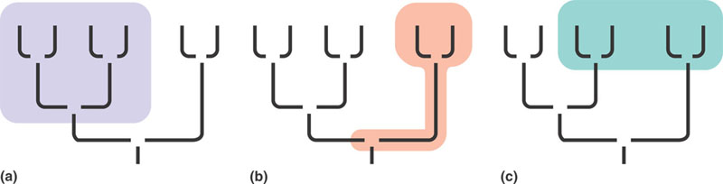
- What is the relationship between the ingroup and the outgroup in classification?
- What is the difference in the meaning between the lengths of lines in a phylogram and ultrametric tree?
- Look up the term parsimony in the dictionary and write its definition here:
- How is this applied to understanding evolution – what is the principle of maximum parsimony and the principle of maximum likelihood?
- What is the difference between orthologous genes and paralogous genes?
- What is the concept of a molecular clock and how is it useful?
- What domains have been agreed upon?

