AP Biology Name __________________________
Guided Reading Chapter 26

- Define the following

  - Protobionts -

b. Ribozymes -

c. Radiometric Dating -

d. Half-life -

e. Magnetic Reversals -

f. Geologic Record -

g. Stromatolites -

h. Serial Endosymbiosis -

k. Pangea -

l. Three Domain System -

2. How old is the Earth?

3. Use the diagram below describe and explain Urey and Miller’s 1953 experiment.
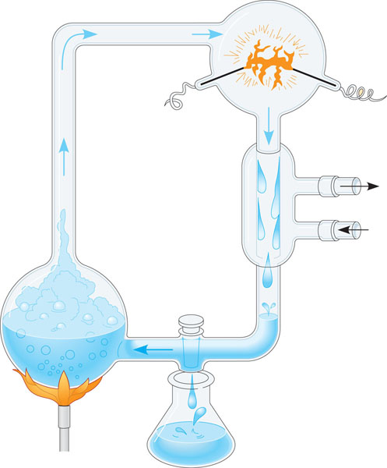

4. Where were the first organic compounds on Earth probably formed?

5. Explain why RNA developed before DNA

6. What did the atmosphere of early Earth primarily consist of?

7. Use the following diagram to help explain serial endosymbiosis.
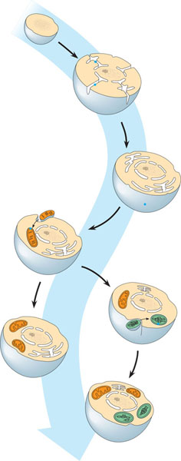

8. List the periods in which there were mass extinctions, and if possible explain why they occurred for each extinction

9. During which period are we currently living?

10. How did early prokaryotes evolve and change early Earth?

11. Name several traits of the first prokaryotes.

12. When did the first prokaryotes exist on Earth?

13. Contrast the five kingdom system with the three domain system.

14. Mitochondria and plastids likely formed in eukaryotes in what way?

15. How, and by whom, was the first concept of taxonomy set-up?

