AP Biology Name __________________________
Guided Reading Chapter 28

This can be a very confusing chapter with organismal names that are completely new to you. The key concepts listed on page 549 are a great way to focus your understanding.

- What is meant by the statement that Protista Kingdom is paraphyletic?
- Why is the term protist still used?
- What are the four main areas of protist diversity?
- What is endosymbiosis? What is secondary symbiosis?
- Label the diagram below to trace the evolution of protists.
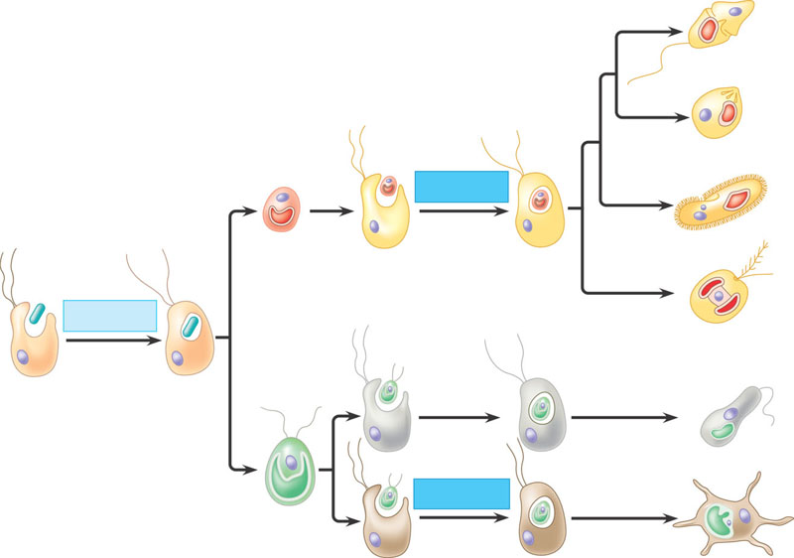
- Do concept check 28.1 - #2 – check you answer and be able to explain.
- What are the basic characteristics of diplomonads?
- What are the basic characteristics of parabasalids?
- What types of organisms are included in the Euglenozoans?
- What human disease is associated with the kinetoplastids?
- Label the diagram of the Euglenid below
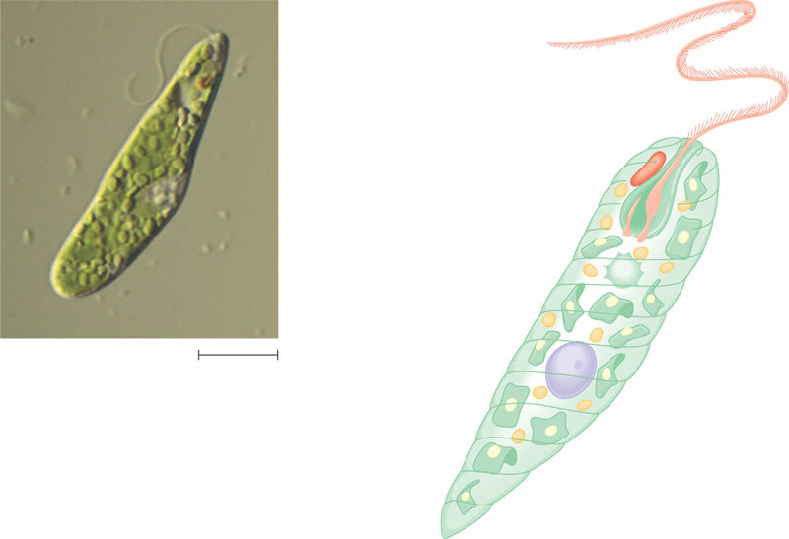
- What are the three groups of Alveolata?
- Label the diagram of Plasmodium – an apicomplexan
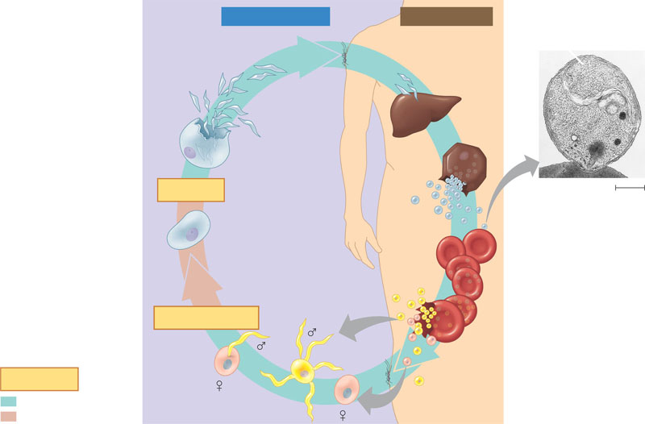
- What are the Ciliates named for?
- Label the two diagrams below concerning structure and function of Paramecium caudatum.
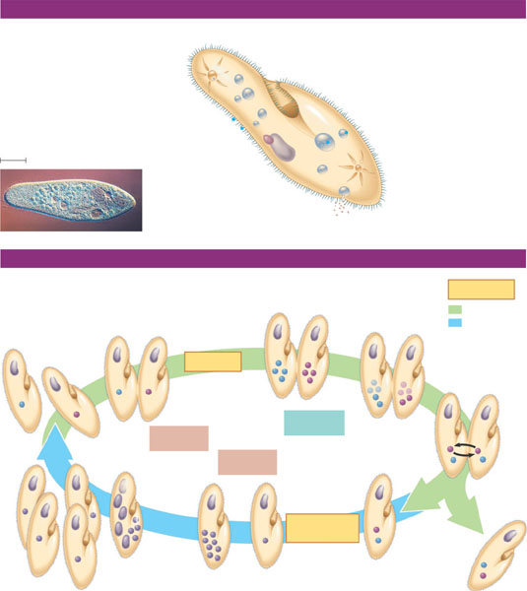
- What types of organisms are in the clade Stramenopila?
- What are the differences between oomycetes and fungi?
- Label the diagram below of the life cycle of a water mold.
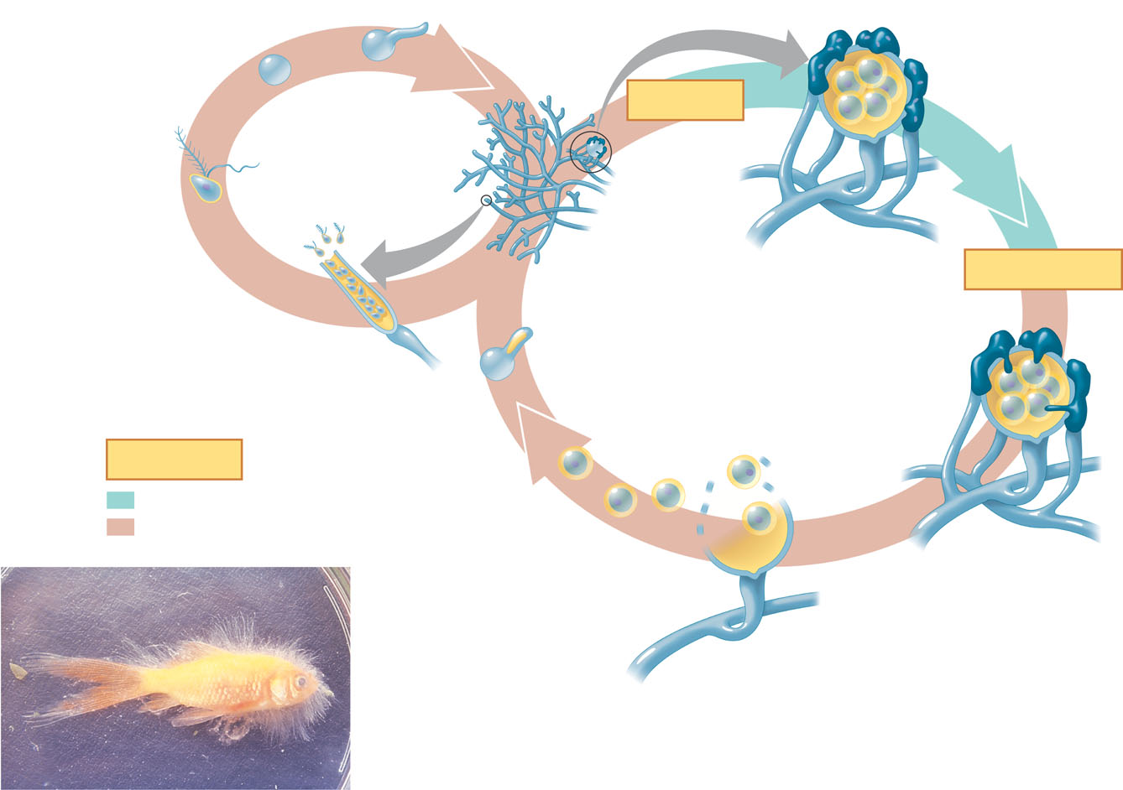
- What adaptation do Diatoms have against predation – how does physics play a role?
- What are the general characteristics of golden algae?
- Define the following term concerning algae:
  - Thallus
  - Holdfast
  - Stipe
  - Blades
- Are the structures above homologous or analogous to plant organs? Explain your choice.
- What is meant by the term alternation of generations>
- Label the diagram of the life cycle of Laminaria.
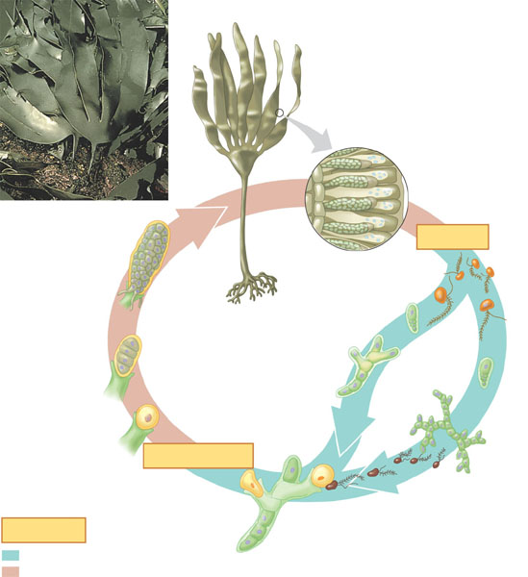
- What does heteromorphic mean?
- What are the general characteristics of Forams?
- What are Radiolarians known for?
- What organisms are included in the Amoebozoans?
- Label the following diagram of a plasmodial slime mold.
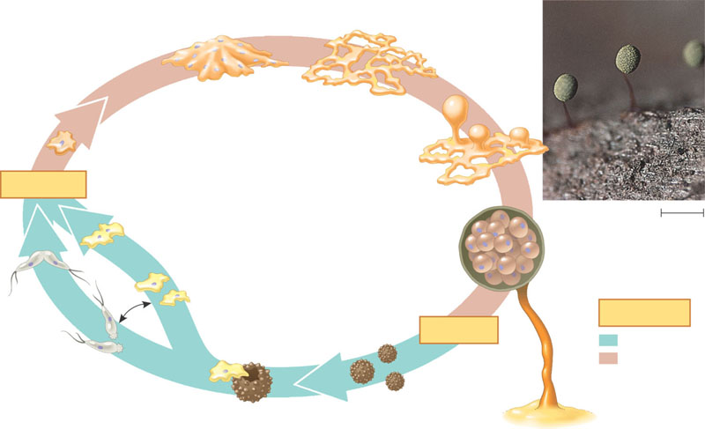
- Label the following diagram of a cellular slime mold.
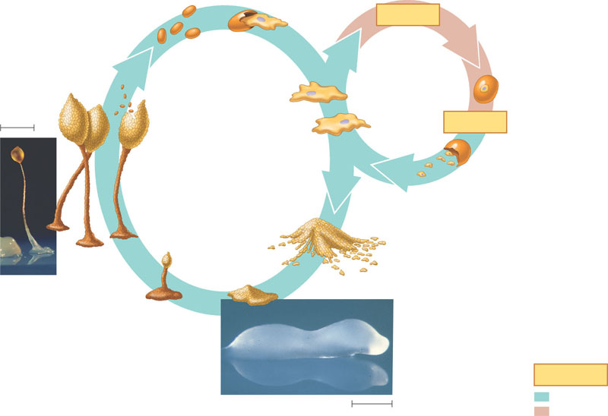
- What is the difference between a plasmodial slime mold and a cellular slime mold?
- What are some of the general characteristics of red algae?
- What are the two main divisions of green algae?
- What were the three mechanisms that larger size and greater complexity evolved in the chlorophytes?
- Label the life cycle below of the Chlamydomonas.
