AP Biology Name __________________________
Guided Reading Chapter 29

- List and describe the four traits that land plants share with charophyceans.
- What resource did plants need to find a way to conserve to move to land?
- Why is the text using the definition of embryophytes for inclusion in the plant kingdom?
- What are the five derived traits that appear in nearly all land plants but are absent in the charophyceans?
- Thinking back to our chapter on classification – how is the clade terminology using primitive and derived traits a clear way of studying the evolution of plants?
- What is a cuticle?
- What are secondary compounds and how are they an advantage to plants? Give some examples.
- Use the diagram below to view plant evolution in broad terms.
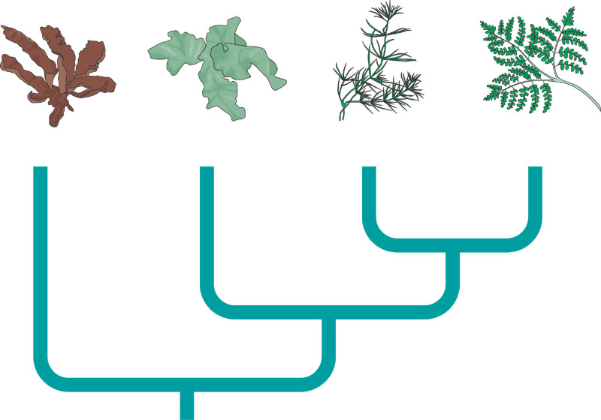
- What general characteristics could you infer about plants that lack vascular tissue?
- What general characteristics could you infer about plants that have a vascular system?
- What is the alternative to having a seed?
As you read about plant life cycles consider these questions:
Is the gametophyte dependent on the sporophyte?
Is the sporophyte dependent on the gametophyte?
Doe the organism spend a greater part of the life cycle as haploid or diploid?
Notice the trends.
- What are the three phyla represented by the Bryophytes?
- Define the following terms:
  - Protonema
  - Gametophore
  - Rhizoids
  - Foot
  - Seta
  - Capsule
  - Calyptra
  - Peristome
  - Stomata
- Complete the following diagram representing the life cycle of a moss.
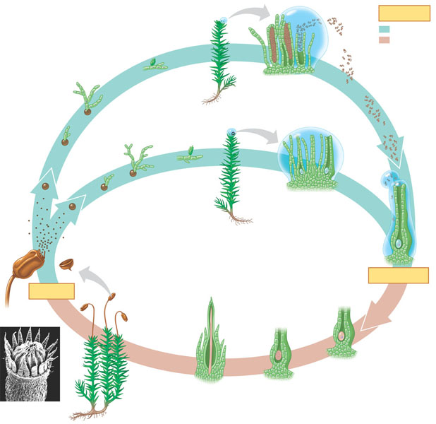
- What are some of the ecological and economic benefits of moss? List at least three.
- What was the dominant life cycle in Seedless Vascular Plants?
- Define the following terms:
  - Xylem
  - Tracheids
  - Lignin
  - Phloem
  - Roots
  - Leaves
  - Microphylls
  - Megaphylls
- Complete the diagram below outlining the life cycle of a fern.
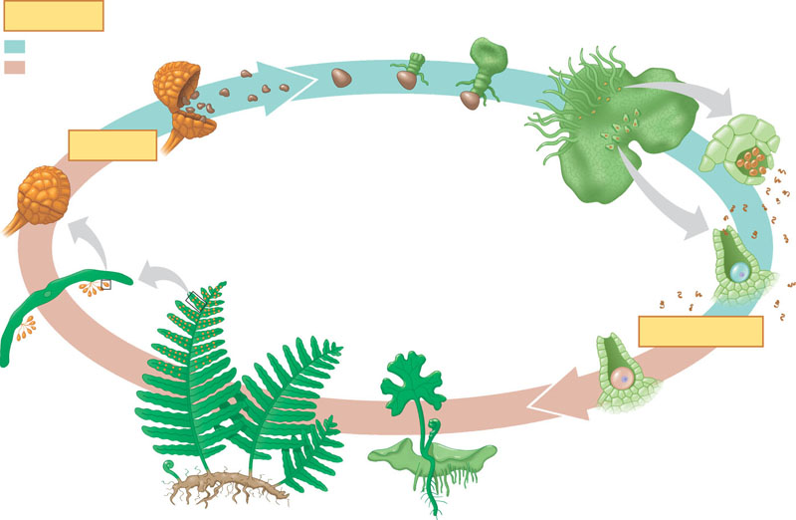
- Define the following terms:
  - Sporophylls
  - Sori
  - Strobili
  - Megaspores
  - Microspores
- What is the difference between a plant being homosporous and heterosporous?
- What effect did the development of the first forests have on carbon dioxide in the atmosphere?

