AP Biology Name _________________________
Chapter 3 Guided Reading Assignment

This chapter is a review from your previous biology class – these concepts are critical and repeated throughout the year. If you have not covered this material previously or need additional assistance with the concepts please schedule time to see me.

- Why is water considered a polar molecule?
- For each of the below listed properties of water – briefly define the property and then explain how water’s polar nature and polar covalent bonds contribute to the water special property. Include an example in nature of each property also.
  - Cohesion
  - Adhesion
  - Surface tension
  - High specific heat
  - Heat of vaporization
  - Evaporative cooling
- What is special about water and density?
- Define the following terms:
  - Solute
  - Solvent
  - Aqueous solution
  - Hydrophilic
  - Hydrophobic
  - Colloid
  - Hydration shell
  - Molarity
- Label the diagram below to demonstrate the dissociation of the water molecule and then relate this diagram to pH.
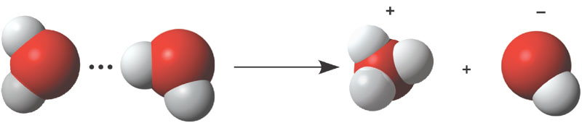
- What defines an acid and a base?
- Why are “apparently” small changes in pH so important in biology?
- What is a buffer and write and explain the carbonic acid buffer system in human blood – yes we are back to the equation AGAIN!
- What is acid precipitation and why is it important to living organisms?

