AP Biology Name __________________________
Guided Reading Chapter 30

- What are some of the advantages to having a reduced gametophyte in plants?
- Define the following terms:
  - Integuments
  - Ovule
  - Pollen grains
  - Pollination
  - Seed
- What are the evolutionary advantages to seed formation?
- What does the term Gymnosperm mean?
- Are all conifers gymnosperm?
- What are progymnosperms?
- Complete the diagram below of the life cycle of a pine.
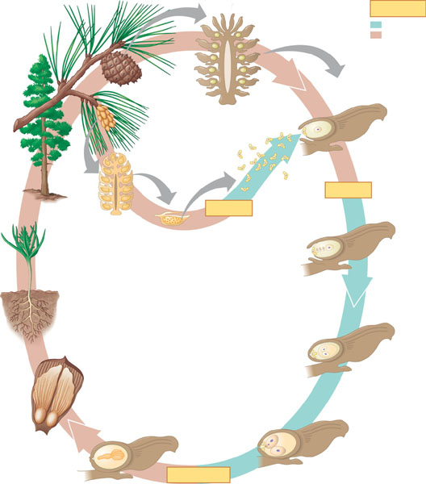
- What is the common name of Angiosperms?
- Define the following terms:
  - Flower
  - Sepals
  - Petals
  - Stamen
  - Filament
  - Anther
  - Stigma
  - Style
  - Ovary
  - Receptacle
  - Pistil
  - Fruit
  - Pericarp
  - Micropyle
  - Cross-pollination
- What is the alternate term for the gametophyte in angiosperms?
- What is double fertilization?
- What is a cotyledon?
- What function does the endosperm serve?
- Complete the diagram below of the life cycle of an angiosperm.
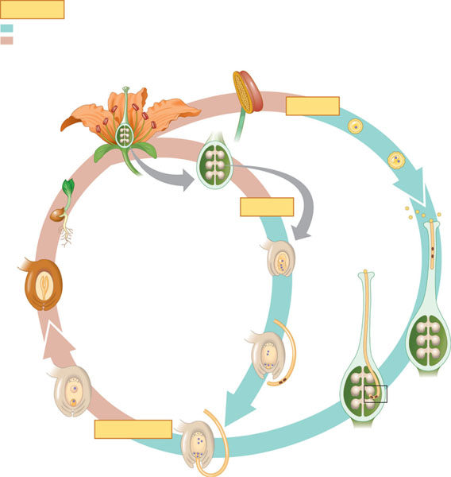
- Some gymnosperms also have double fertilization – is this homologous or analogous?
- Why do we now know that monocot and dicot classification of angiosperms does not completely reflect the evolution of these plants? What is the newer classification system?
- How does the development of angiosperms and animals in the same time frame meet the definition of coevolution?
- How does human welfare depend on seed plants?
- Why should we worry about destroying the tropical rain forest?

