AP Biology Name __________________________
Guided Reading Chapter 31
The concept that gives students the most difficulty in this chapter is the varying life cycles. First focus on the diagram on page 611 and then move on to the other cycles.

- How do fungi acquire their nutrients?
- What are exoenzymes and how does surface area connect with this concept?
- Define the following terms concerning the body structure of fungi:
  - Hyphae
  - Chitin
  - Mycelium
  - Septa
  - Coenocytic
  - Haustoria
  - Mycorrhizae
- What is the difference between ectomycorrhizal fungi and endomycorrhizal fungi?
- What are the signaling molecules that assist in sexual reproduction of fungi called?
- Define these terms associated with sexual reproduction in fungi:
  - Plasmogamy
  - Heterokaryon
  - Dikaryotic
  - Karyogamy
- Complete the following diagram that represents a generalized life cycle of a fungi.
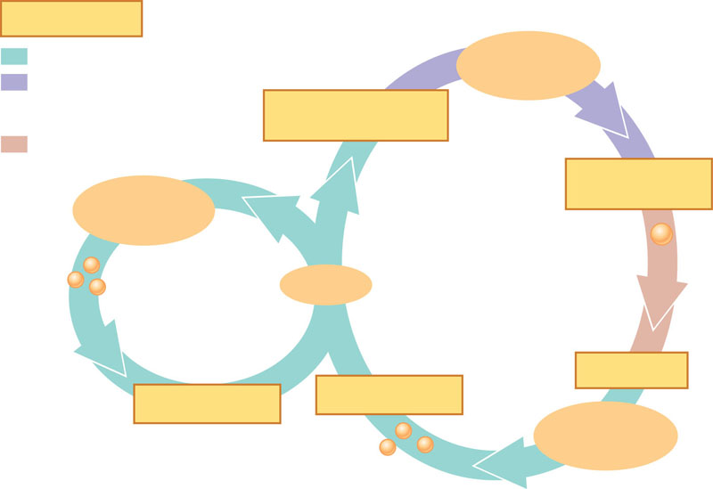
- How do molds and yeast reproduce?
- How is it believed that fungi evolved?
- Complete the diagram below concerning the phylogeny of fungi.
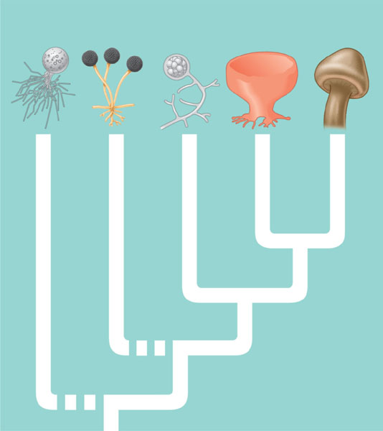
- What about chytrids are unique among fungi?
- What are the general characteristics of Zygomycetes?
- Complete the following diagram of the life cycle of the zygomycete.
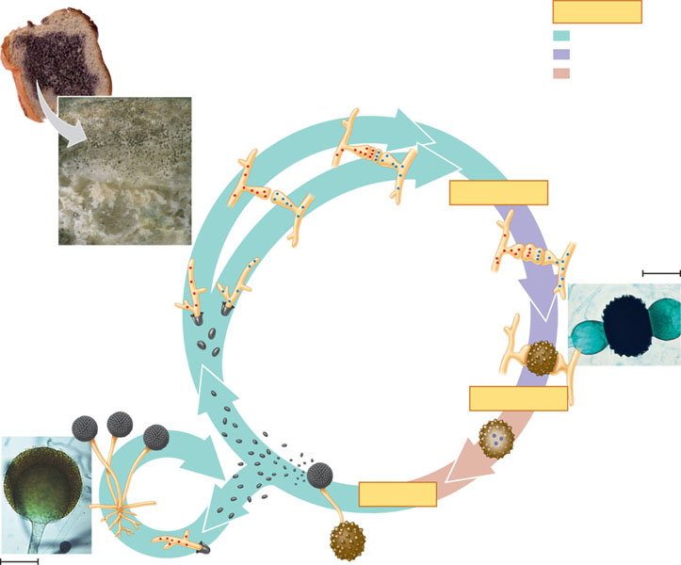
- Why is a zygosporangium, despite being 2n, not a typical zygote?
- What are microsporidida?
- What type of endomycorrihzae do glomeromycetes have and what is special about it?
- What are the general characteristics of Ascomycetes? What is their common name?
- What are Ascomycetes asexual spores called?
- Complete the following diagram of the life cycle of an ascomycete.
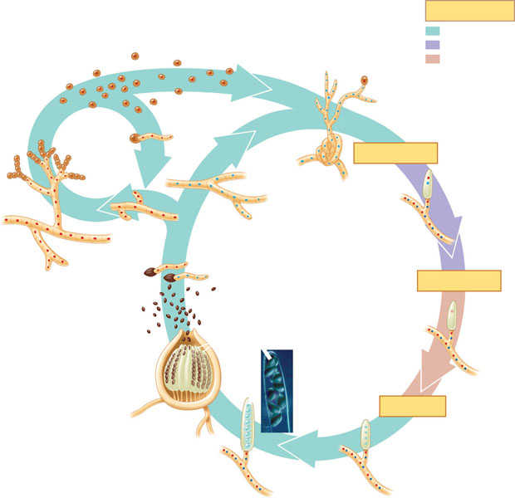
- What are the general characteristics Basidiomycetes?
- Complete the following diagram of the life cycle of a basidiomycete.
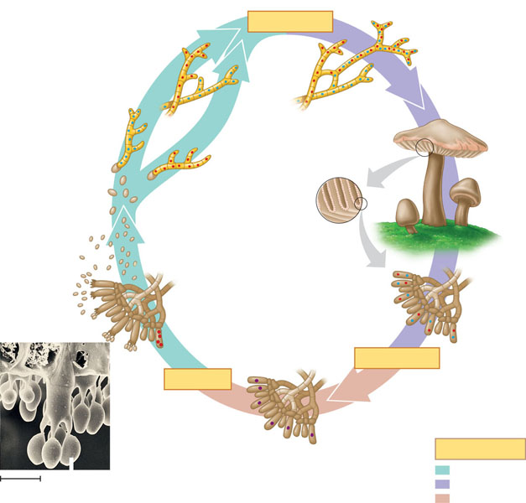
- What are the three broad categories of symbiotic relationships between fungi and other organisms – list and DESCRIBE them below.

- What are some examples of plant and animal diseases due to fungi?
- What are some practical uses of fungi?
- Table below is for your study and review
