AP Biology Name __________________________
Guided Reading Chapter 32

- Define the following terms:
  - Cleavage
  - Blastula
  - Gastrula
  - Larva
  - Metamorphosis
- Label the diagram below of early embryonic development
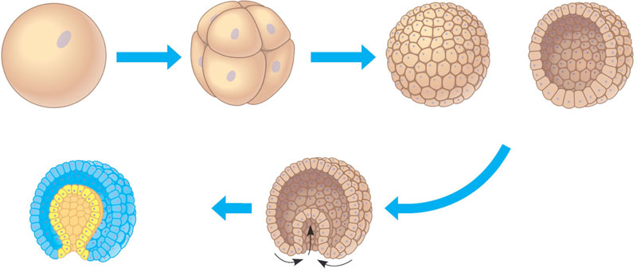
- What is believed to be the common ancestor of living animals?
- What are two hypotheses for the Cambrian Explosion?
- Define the following terms with regard to animal body plans.
  - Grade
  - Body plan
  - Radial symmetry
  - Bilateral symmetry
  - Dorsal
  - Ventral
  - Anterior
  - Posterior
  - Cephalization
  - Germ layers
  - Endoderm
  - Ectoderm
  - Archenteron
  - Diploblastic
  - Triploblastic
  - Mesoderm
  - Body cavity
  - Coelom
  - Pseudocoelomate
  - Coelomate
  - Acoelomate
- Color and label the following diagram
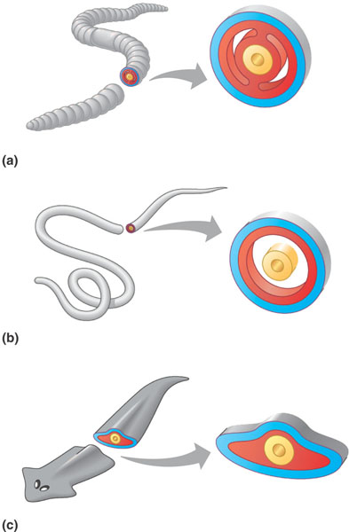
- Use the unlabeled diagram to compare and contrast protostomes and deuterostomes development.
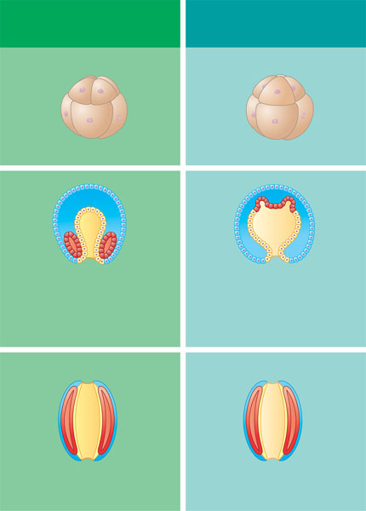
- What is the difference between determinate cleavage, radial cleavage and indeterminate cleavage?
- What is the difference between schizocoelous and enterocoelous?
- What are the 5 points of agreement on animal phylogeny?

- Studying the two phylogenic trees on pages 634-635 – what is the basic disagreement – what does the molecular data tell us? Use the following vocabulary in your response: ecdysozoans, lophotrochozoans, lophophore and trochophore larva. Points will be deducted if you do not use all of these terms.

