AP Biology Name __________________________
Guided Reading Chapter 33

The guided reading will be very limited – the majority of the homework will be completing the animal survey grid that has been distributed. As you read, focus on the trends, the increasing complexity of the organisms and the adaptations to their environment.

- Use the diagram below to label the anatomy of a sponge.
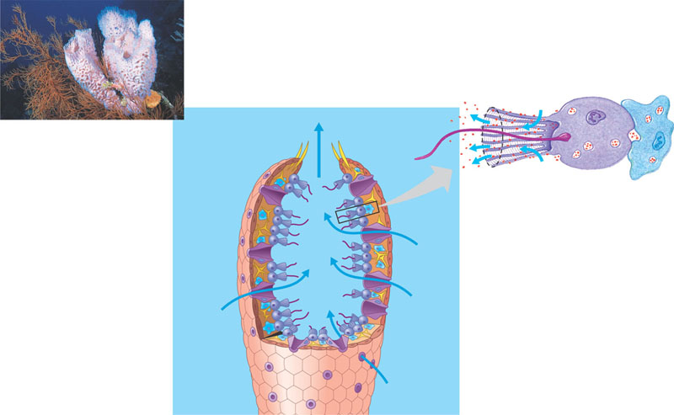
- What is the difference between a polyp and a medusa?
- Label the diagram below representing the life cycle of Obelia.
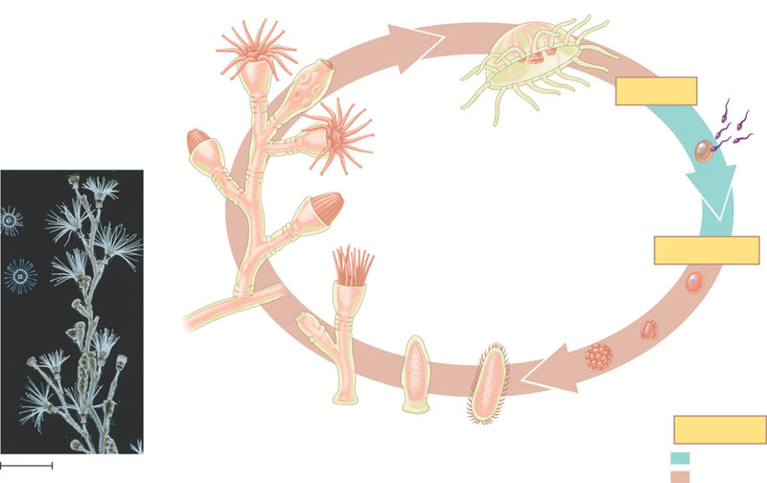
- Label the diagram below of a planaria
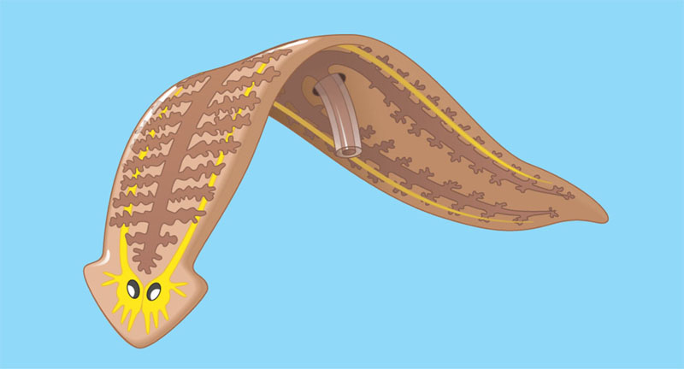
- Describe the life cycle of the blood fluke.
- What are the three main parts of a mollusk, list and describe?

