AP Biology Name _____________________
Chapter 35 Guided Reading

- Label the parts of a flower in the following diagram:

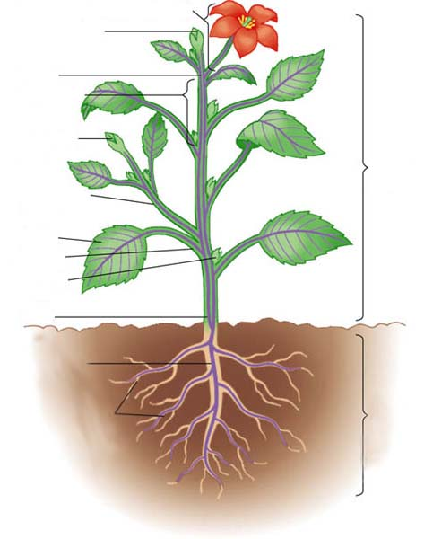

- Describe the three different root systems.

- Describe all types of leaves and conclude as to why there are different shapes.

- Define the following terms:

  - Stem

  - Nodes

  - Internodes

  - Axillary bud

  - Terminal bud

  - Apical dominance

- Explain how the dermal tissue system functions.

- What is the purpose of the Xylem and Pholem and how do they work together to form a system?

- Compare and contrast the three types of plant cells.

- Define meristems and say why they are important.

- Define the following terms:
  - Primary plant body
  - Root cap
  - Zone of cell division
  - Zone of elongation
  - Zone of maturation
  - Endodermis
  - Pericycle

- Describe the function and importance of stomata.

- Label the parts of the following diagram.

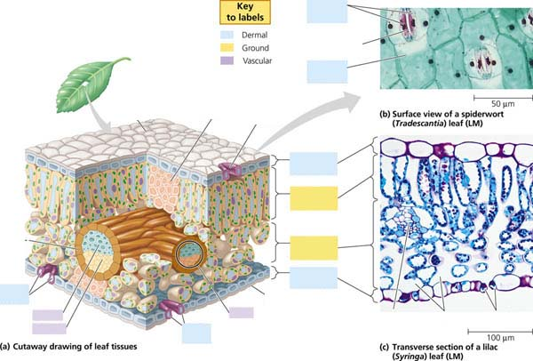

- Compare and contrast primary and secondary growth.

- Describe plant growth and cell expansion.

