AP Biology Name _________________________
Chapter 36 Guided Reading Assignment

- What 3 scales does transport in vascular plants occur on?
- These terms are a review, but also very critical to know to understand the transportation of nutrients in vascular plants. Define these terms.

  - Passive Transport
  - Active Transport
  - Transport Proteins
  - Proton Pump
  - Membrane Potential
  - Cotransport

  - Chemiosmosis

  - Water Potential

    - Megapascals

    - Solute Potential

    - Osmotic Potential

    - Pressure Potential

- Use this picture to explain the overview of transport in a vascular plant.
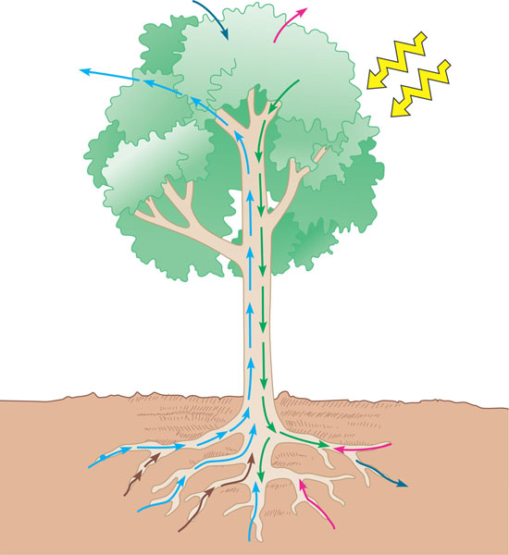
- Define the following terms:
  - Flaccid
  - Turgid
  - Plasmolyze
  - Aquaporins
  - Vacuolar membrane (Tonoplast)
  - Symplast
  - Apoplast
- Compare and contrast the bulk flow of nutrients in the xylem and phloem.

- How do root hairs, mycorrhizae, and cortical cells assist vascular plants?
- What are the roles of the apoplast and the symplast, and how does the Casparian strip relate to these structures?

- Label the following diagram to explain lateral transport of minerals and water in roots.
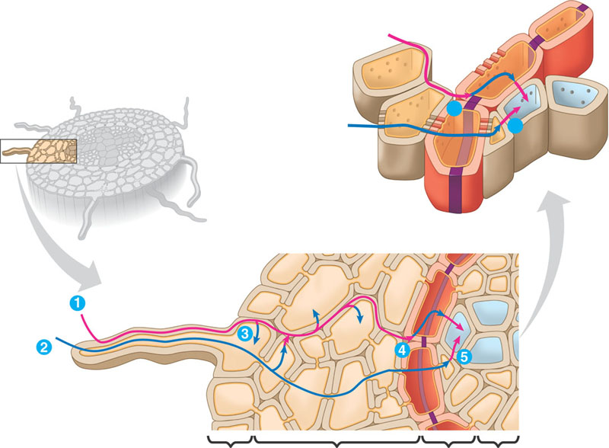

- Describe the process of transpiration in your own words and how it affects the transportation of minerals and water.

- Label the diagram and use it to explain how water potential affects transport of nutrients and minerals through vascular plants.

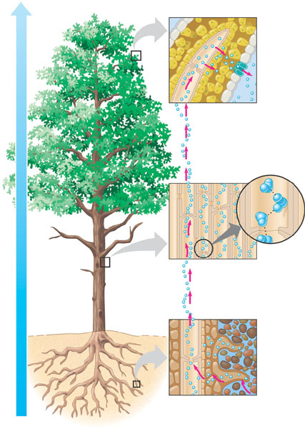

- What are stomata and how do they help regulate the rate of transpiration?

- What are some factors that could possible stimulate the opening and closing of stomata?
- What are some evolutionary adaptations that allow xerophytes to survive in arid climates?

- What is translocation?

- Define these terms and give an example

  - Sugar source

  - Sugar sink

  - Transfer cells

- Label the following diagram, describing pressure flow in a sieve tube.

