AP Biology Name __________________________
Guided Reading Chapter 39

- Define the following terms:
  - etiolation
  - de-etiolation
  - second messengers
- Explain the two ways that signaling pathways activate enzymes.

- Complete the diagram below, and explain what it shows.

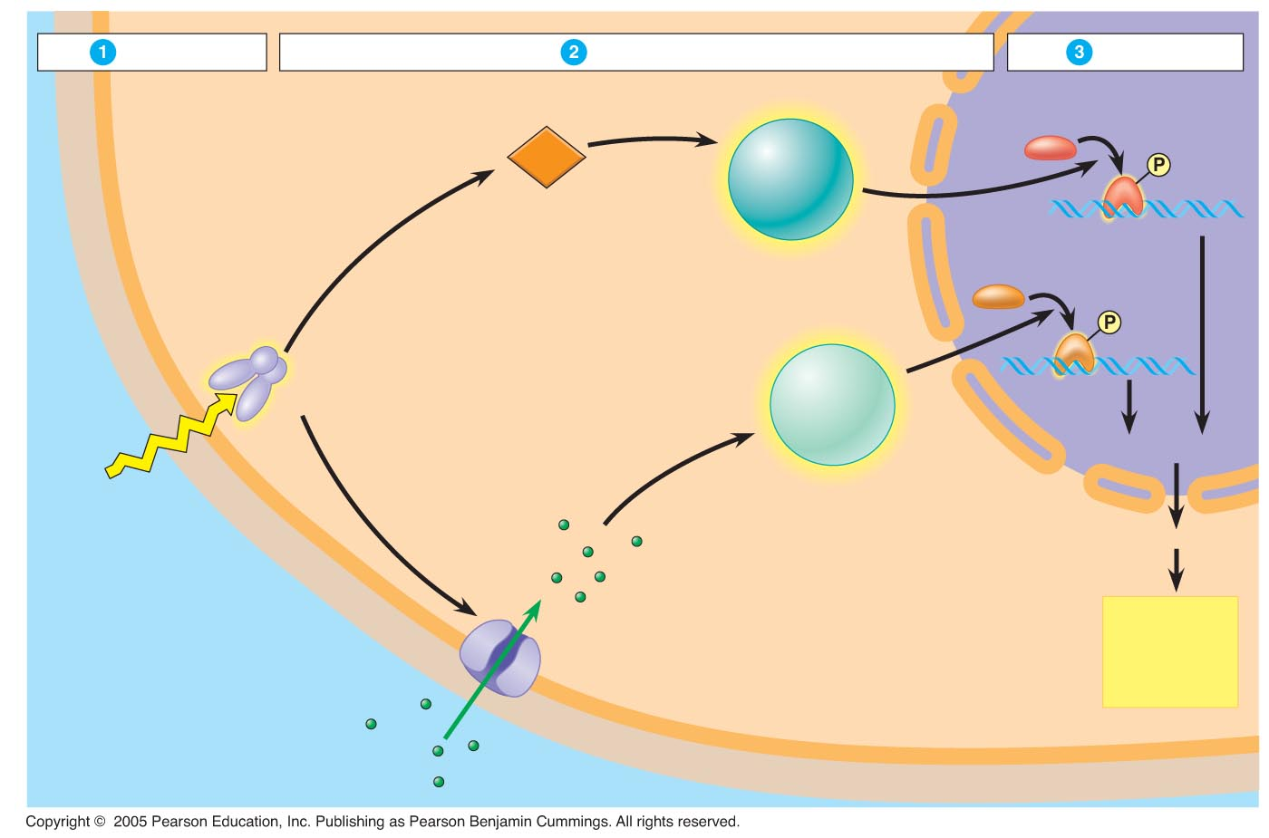
- Define the following terms:
  - tropism
  - phototropism

- Explain the importance of auxin in plants

- Complete the following figure, and explain what it shows.
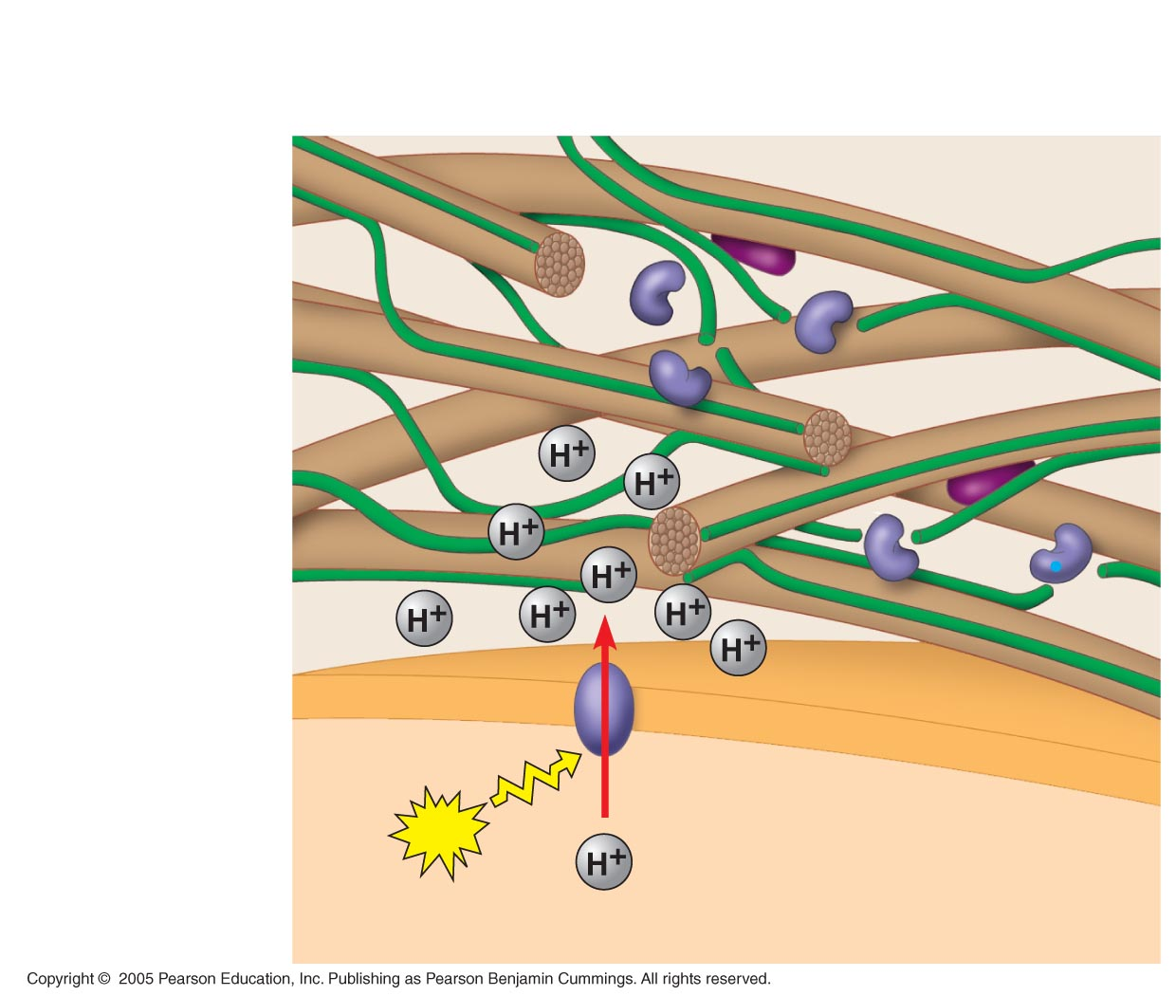
- Include a brief description of the following:
  - ethylene

  - triple response

  - apoptosis

- Explain the meaning of each word root in the word “photomorphogenesis”.

- What is the action spectrum and how do photoreceptors determine it?

  - blue-light photoreceptors
  - phytochromes
- Explain what circadian rhythms are and how each plant determines them:

- Define the following terms in a way that makes sense to you.
  - statoliths
  - thigmomorphogenesis
  - thigmotropism
  - action potentials
  - abiotic
  - biotic
  - heat-shock proteins
  - Gene-for-gene recognition
  - Elicitors
  - Oligosaccharins
  - Phytoalexins
  - PR proteins
  - Hypersensitive response
  - Systemic acquired resistance (SAR)
  - Salicylic acid

12. Other than light what types of stimulus do plants respond to?

13. Define gravitotropism:

14. What are the 5 types of environmental stress?

15. Compare and contrast how plants defend themselves from herbivores and how they defend themselves from pathogens.

16. How do plants use gene-for-gene recognition?

17.Complete the following figure, and explain what it is showing.

