AP Biology Name _________________________
Chapter 4 Guided Reading Assignment

Again, this chapter is a review of previously covered material. We will be moving through the material very quickly, please see me for extra assistance if needed.

- Why is organic chemistry so important in the study of biology?
- Why was the Urey-Miller experiment so important?
- What is special about carbon that makes it the central atom in the chemistry of life?
- Use the diagram below to label and contrast the three types of isomers.
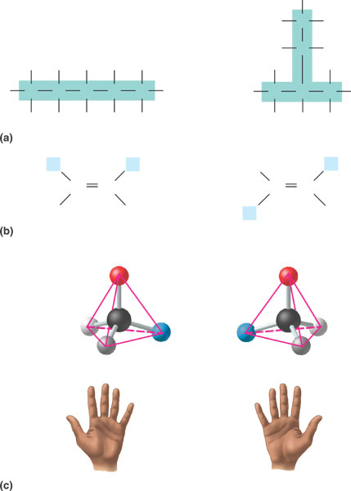
- Create a table below: after each functional group – draw the structure, name the compound, write and example and note the functional properties – (doesn’t this look like great quiz material?)
  - Hydroxyl
  - Carbonyl aldehyde

c. Carbonyl ketone
d. Carboxyl
e. Amino
f. Sulfhydryl
g. Phosphate

