AP Biology Name __________________________
Guided Reading Chapter 40
Basic Principles of Animal Form and Function

- How do Anatomy and Physiology differ?
- Explain how convergent evolution applies to animal form.

- Compare and contrast diffusion in a single-celled protist to an animal with two cell layers.

- Label the diagram of the internal exchange surfaces.
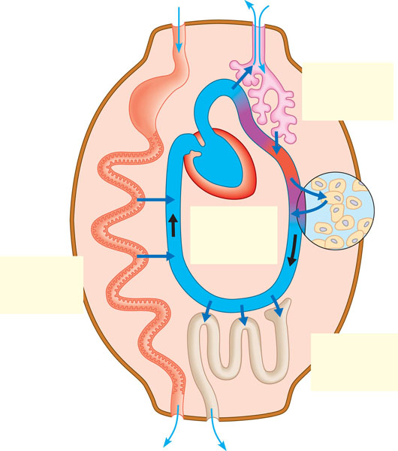
- Define the following:
  - Tissues-
  - Epithelial Tissues-

Glandular epithelia-

Mucus membranes-

Simple epithelium-

Stratified epithelium-

Cuboidal cells-

Columnar cells-
Squamous cells-
  - Connective Tissues-

Collagenous fibers-

Elastic fibers-

Reticular fibers-

Fibroblasts-

Macrophages-

  - Muscle Tissues-

  - Nervous Tissue-

- How are the tissues arranged into organs and then into organ systems? Explain this using the digestive system as an example.

- Label the diagram explaining bioenergetics in animals

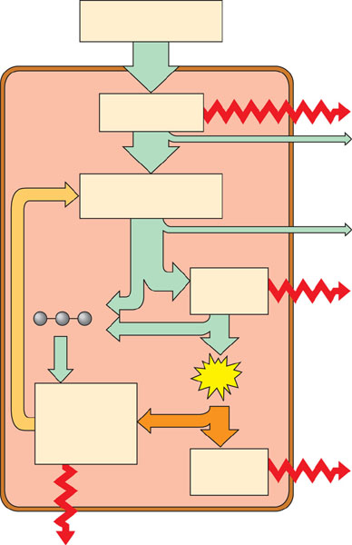

- What is metabolic rate and how is it determined?

- Explain the three influences on metabolic rate.

- Based on figure 40.10, what is an energy budget and how does it vary in four different animals?

- Define and explain the following:
Regulators-

Conformers-

Negative feedback-

Positive feedback-

Thermoregulation-

- Compare and contrast ectotherms and endotherms.

- There are 5 categories of adaptations that help animals thermoregulate. Describe each one and how they work in your own words.

Insulation-

Circulatory Adaptations-

Cooling by Evaporative Heat Loss-

Behavioral responses-

Adjusting Metabolic Heat Production-

- Name three of the organ systems that help with thermoregulation by complex negative feedback mechanisms.

- Define the following:
  - Acclimatization-
  - Stress-induced proteins-
  - Heat-shock proteins-
  - Torpor-
  - Hibernation-
  - Estivation-

  - Daily torpor-

- Complete the diagram below:

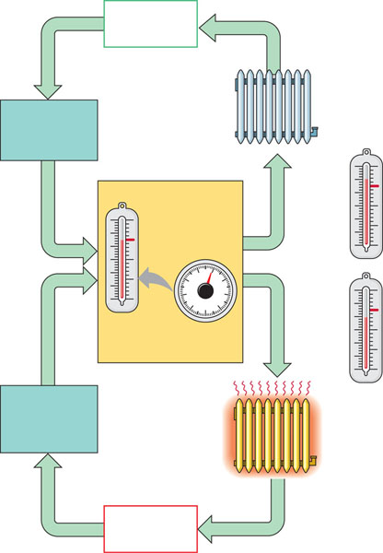

- Torpor involves a __________ in what metabolic rates.

