AP Biology
Guided Reading Chapter 41

- Define the following types of feeding mechanisms:
  - Suspension
  - Substrate
  - Fluid
  - Bulk
- Complete the diagram below concerning animal homeostasis and blood sugar regulation.
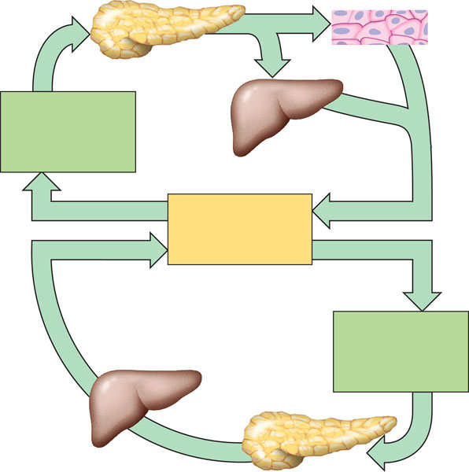
- How do hormones regulate appetite in humans?
- Contrast the terms undernourished, overnourished and malnourished?
- What are essential amino acids and essential fatty acids?
- Contrast vitamins and minerals.
- Define the following terms:
  - Ingestion
  - Digestion
  - Enzymatic hydrolysis
  - Absorption
  - Elimination
- Contrast intracellular and extracellular digestion.
- Label the diagram below of the human digestive system.
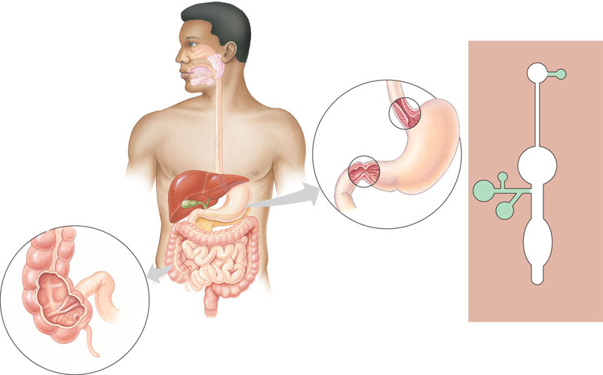
- What are the accessory glands of the digestive system and why are they call “accessory” – are they part of the digestive tract?
- What is peristalsis?
- Use the diagram below to label and explain the process of swallowing.
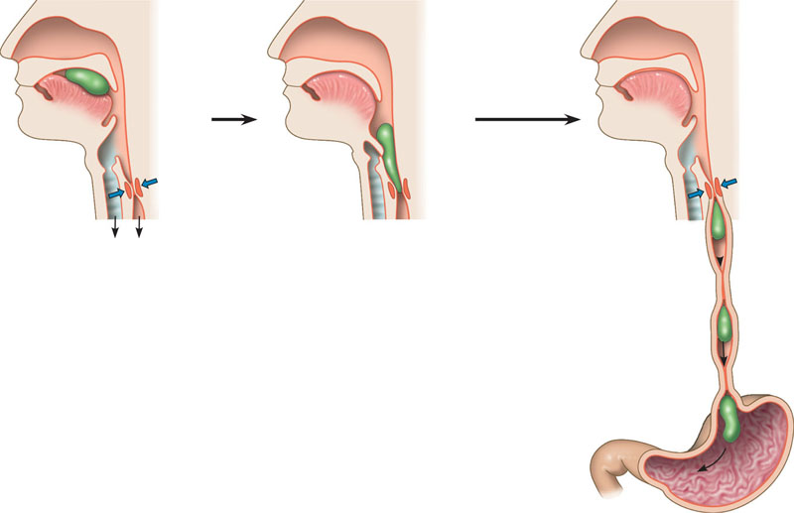
- What are the three cell types of the gastric glands and what does each of them secrete?
- Why is it an advantage that pepsin is secreted in its inactive form?
- Describe the first part of the small intestine – what activity is occurring here?
- What is bile – is it’s action mechanical or chemical digestion?
- Complete the chart below – use it as a study guide for the process of enzymatic digestion and the respective enzymes.
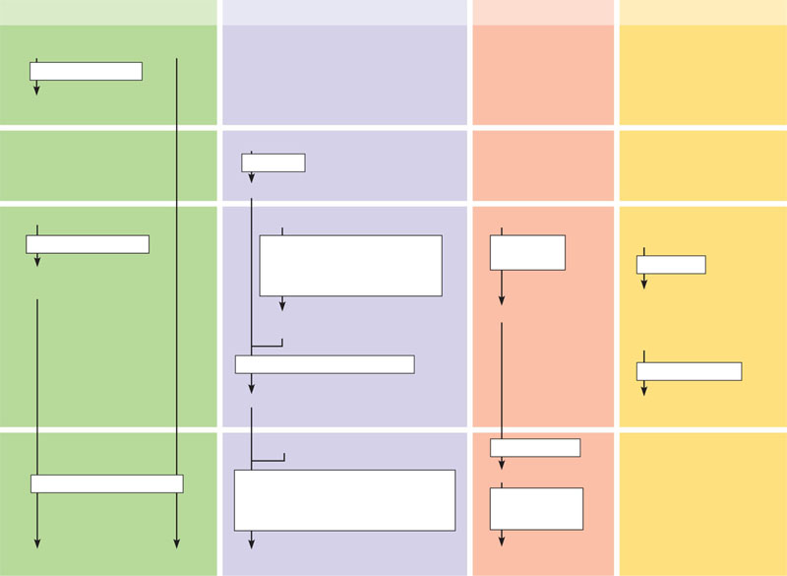
- Explain the roles of the hormones listed below on digestive activity – note whether each are a case of stimulation or inhibition. Why is this level of control an advantage to the organism?
  - Enterogastrone
  - Gastrin
  - Secretin
  - Cholecystokinin
- How does the body control the absorption of nutrients in the small intestine?
- What is the route for fat absorption? Include the term chylomicrons and the role of bile.
- What role does the liver play in homeostasis with regard to digestion?
- What is the major role of the large intestine in the digestive process?
- Does the appendix have a role in the human body?
- How can you infer an organism’s diet based on it’s teeth?
- What general trends are noted in the digestive tracts of herbivores and carnivores?
- What is different about the ruminant’s digestive system that adapts it to eating a diet of “cellulose”?
- How does symbiotic interactions impact digestion?

