AP Biology
Chapter 42 Guided Reading

- What are the limits to diffusion as a means of transport for living organisms?
- Compare and contrast open and closed circulatory systems. Be certain focus on advantages of each.
- Contrast arteries, arterioles, capillaries and venules and veins,
- Contrast the vertebrate circulatory systems of fish, amphibians, non-avian reptiles and mammals/birds.
- What is the advantage to double circulation?
- Write the path of blood through the heart.
- 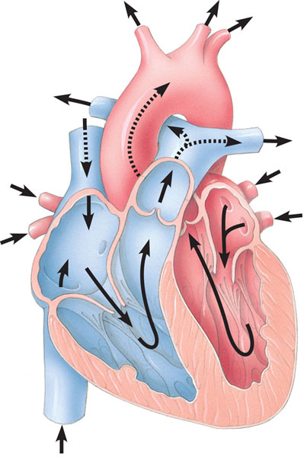
- Define the following terms:
  - The cardiac cycle – describe in terms of valves opening and closing
  - Systole
  - Diastole
  - Cardiac output
  - Stroke volume
- What does the SA node do?
- What is the difference between the myogenic heart and neurogenic heart?
- Label the diagram below concerning the structure of blood vessels.
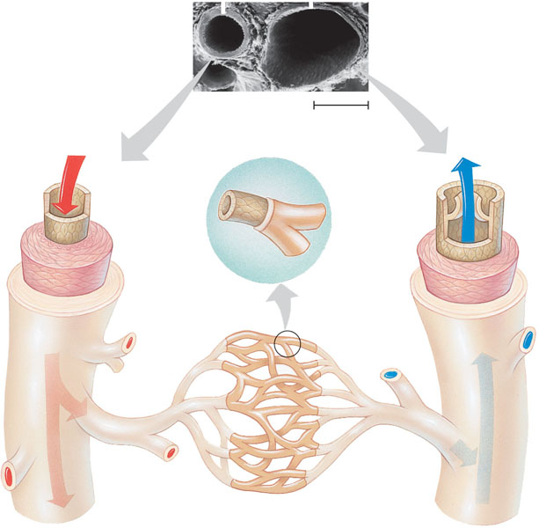
- How does the law of continuity relate to the velocity of blood flow and what is the relationship between blood pressure, velocity and total cross-sectional area? This is a key concept – why would blood flow slow in a capillary just when you think it will speed up because the capillary is narrow?
- How does peripheral resistance impact blood pressure?
- How is blood flow to the capillaries controlled with respect to meeting the bodies needs? Why are people with severe cardiac disease instructed not to “overeat” at the holidays?
- What is the lymphatic system and why is it important to the circulatory system with regard to blood volume?
- What are the major components of plasma and what are their functions?
- What are the three cell types in blood and what are their relative amounts and functions?
- What are pluripotent stem cells and where do they come from? What role does erythropoietin play?
- Label the diagram below concerning blood clotting.
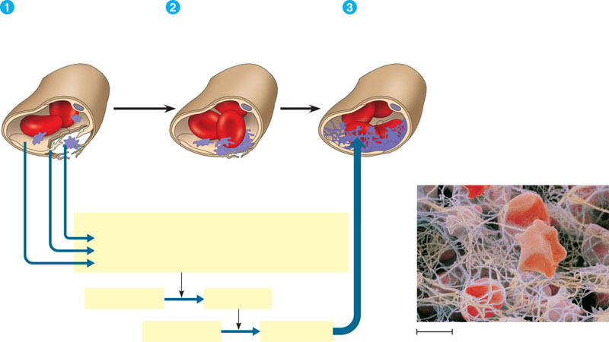
- What is the difference between the LDL’s and HDL’s?
- Define the following:
  - Heart attack
  - Stroke
- Why is gas exchange essential to all living organisms?
- Considering the rate of diffusion, why is it essential for respiratory surfaces to maximize surface area?
- What is meant by the term countercurrent exchange and why is it an advantage to animals?
- How does the tracheal system “work” in insects and why is this an advantage to gas exchange?
- Why do organisms with lungs require a circulatory system?
- On the diagram below – label the respective structures and then briefly list the function of each below the label.
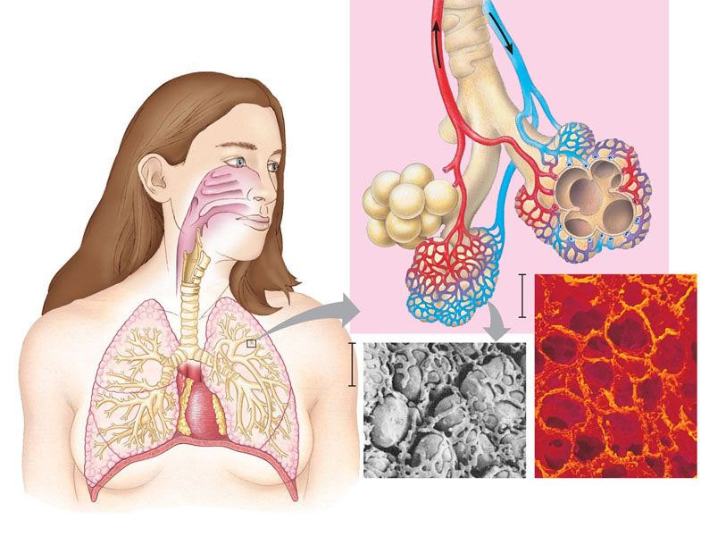
- Contrast amphibian and mammalian breathing with regard to pressure.
- Define the following terms:
  - Tidal volume
  - Vital capacity
  - Residual volume
- Describe the process of inhalation and exhalation with regard to the contraction of the diaphragm – which is an active process and which is passive?
- Use the diagram below to explain how a bird breathes – why is this an advantage to organism that require energy to fly?
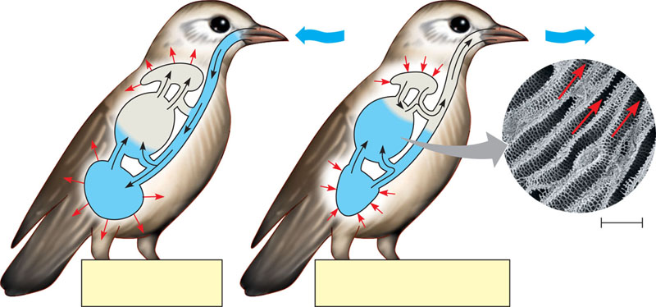
- Label the diagram below concerning the control of breathing in humans>
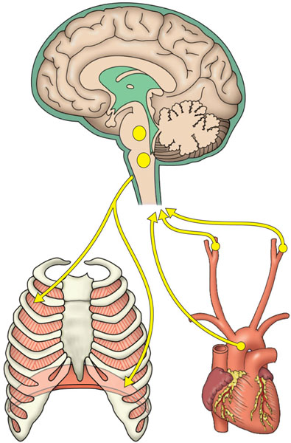
- The diffusion of oxygen and carbon dioxide is dependent on the partial pressure of the gases – use the diagram below to assist in your understanding.
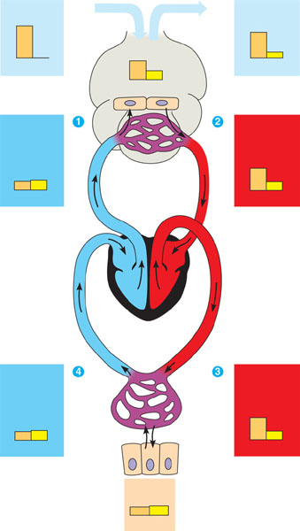
- What is the relationship between oxygen releasing from hemoglobin and the pH of the blood – why does this make it critical that humans maintain pH within a very strict range?
- How is carbon dioxide transported? Write the equation of respiration that I have reviewed sooooooooo many times and relate the diagram on page 893 to this.
- What is the adaptation of diving mammals that allow them to swim to great depths for very long periods of time?

