AP Biology Name __________________________
Chapter 43 Guided Reading

- Label the diagram below:

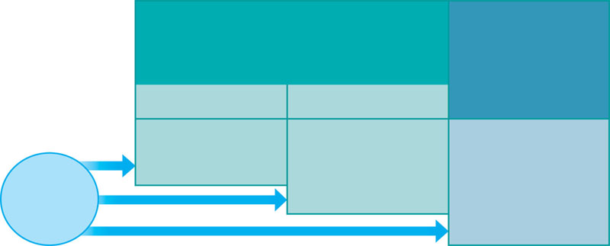
- Contrast the four types of leukocytes (white blood cells).

- Describe the process of phagocytosis by macrophages.

- Describe the role of histamine in the inflammatory response.

- Define the following terms:
  - Natural Killer (NK) cells

  - Antigen

  - Epitope

  - B lymphocyte

  - T lymphocyte
- Label the diagram below concerning antigen receptors on lymphocytes.

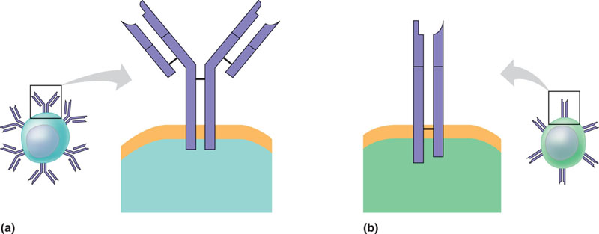

- Contrast the way T cell receptors recognize and bind with antigens with the way that B cell receptors do?

- Label the diagram below concerning clonal selection of B cells:
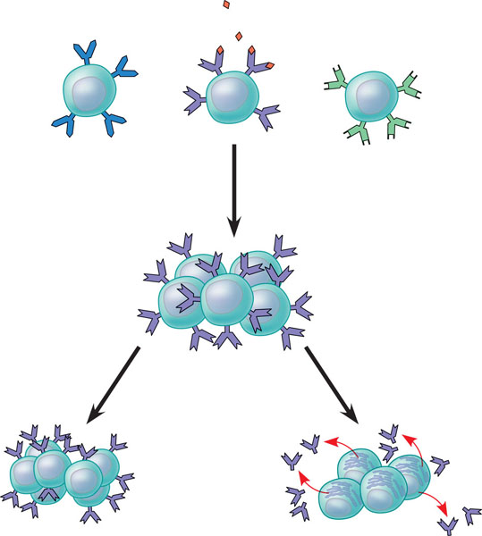

- Contrast the primary immune response with the secondary immune response.

- Define the following terms:

  - Humoral immune response

  - Cell-mediated immune response

  - Helper T cell

- Label the following overview of the acquired immune response:

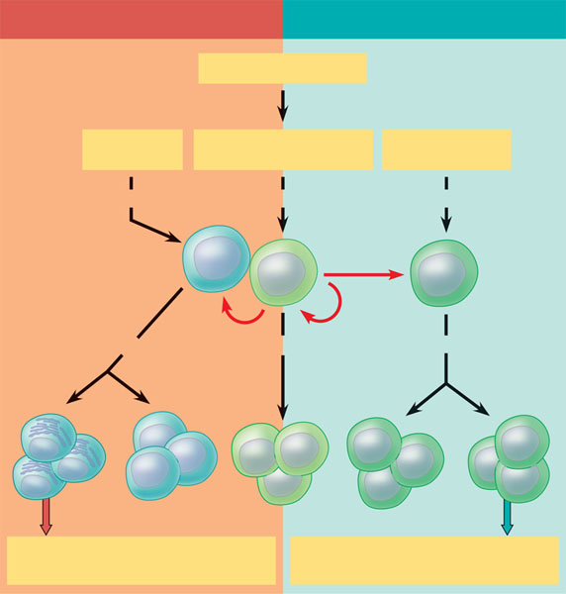
- Label the following diagram concerning the role of helper T cells
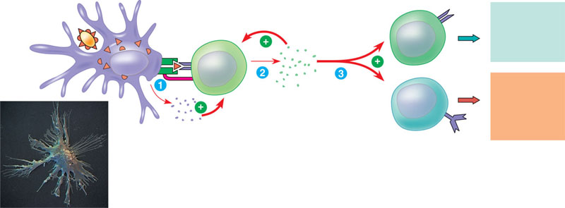

- Contrast active and passive immunity:

- Describe the various compatibilities and incompatibilities of the various blood types, including Rh factors.

- Describe how MHC molecules are responsible for rejection of tissue or organ transplants.

- Label the diagram below concerning the allergic response.
