AP Biology
Chapter 44 Guided Reading

- Define the following terms:
  - Osmoregulation
  - Excretion
  - Osmolarity
  - Osmoconformer
  - Osmoregulator
  - Stenohaline
  - euryhaline
- Describe how saltwater fish deal with osmoregulation.
- Describe how freshwater fish deal with osmoregulation
- What is anhydrobiosis and what is special about tardigrades?
- How do birds deal with excess sodium that drink seawater?
- What are transport epithelium?
- What are the three forms that animals use to dispose of nitrogenous waste?
- Use the diagram below to label and define filtration, reabsorption, secretion and excretion – be very clear on their meanings.
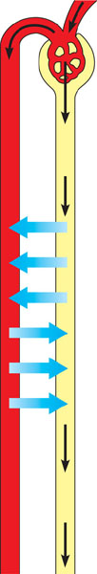
- Contrast protonephridia, metanephridia and Malpighian tubules.
- Use the diagram below to label the mammalian excretory system – I suggest that you also color the associated blood vessels to assist in understanding.
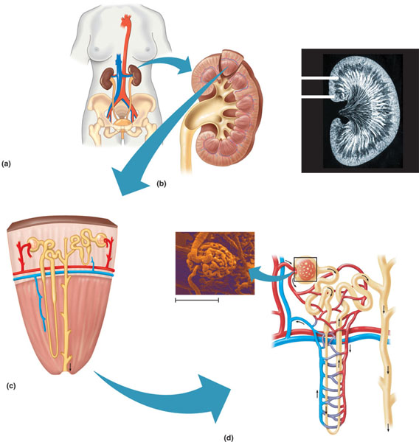
- Describe the blood that is flowing in the following vessels in terms of “where it came from”, “where it is going” or what it is surrounding?
  - Afferent arteriole
  - Efferent arteriole
  - Peritubular capillaries
  - Vasa recta
- Use the diagram below to review the functions of the transport epithelium – note by different colors active and passive transport.
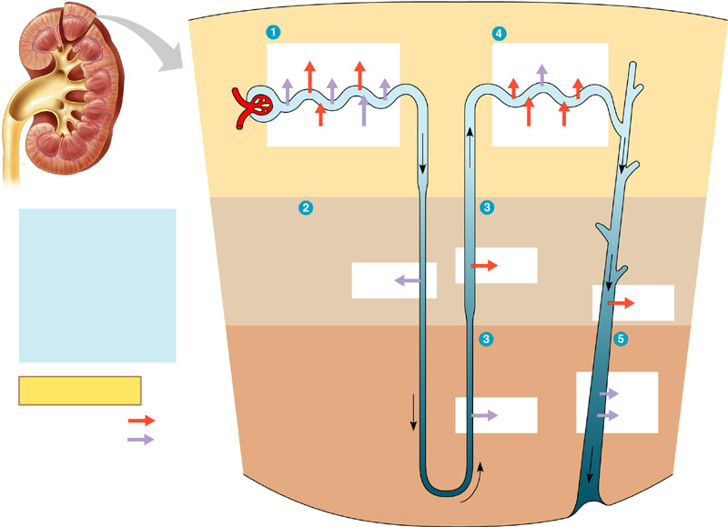
Be clear on the terms reabsorption and secretion.
Restate the activities at the following locations:
  - Proximal tubule
  - Descending loop of Henle
  - Ascending loop of Henle
  - Collecting duct
- Summarize figure 44.15 in text – how do the changing concentrations in Osmolarity reflect the ability of the human kidney to concentrate urine. This concept is very important. The formation of concentrated urine conserves water. Why is this system called a countercurrent multiplier system?
- Complete the diagram below to illustrate the hormonal control of the kidney by negative feedback mechanisms – be sure you can explain how each of the following work:
  - ADH
  - Juxtaglomerular appartatus
  - Angiotensin II
  - Aldosterone
  - RAAS
  - Atrial natriuretic factor
