AP Biology Name _________________________
Chapter 45 Guided Reading Assignment
This chapter can be a difficult read as there are many unfamiliar physiologic pathways. Take your time and focus on the diagrams first and then reread the text. This chapter focuses on regulation and regulatory processes overlap. This is a chapter that will require slow note taking and memorization.
1. What is a hormone?

2. What constitutes the endocrine system and what are its functions?
3. What are endocrine glands?
4. How do neurosecretory cells demonstrate the overlap between the endocrine and nervous system?
5. Review the basics of negative feedback – explain negative feedback using the following terms: receptor, control center, effector, and efferent signal.
6. Label the diagram below representing the basic patterns of hormonal control.
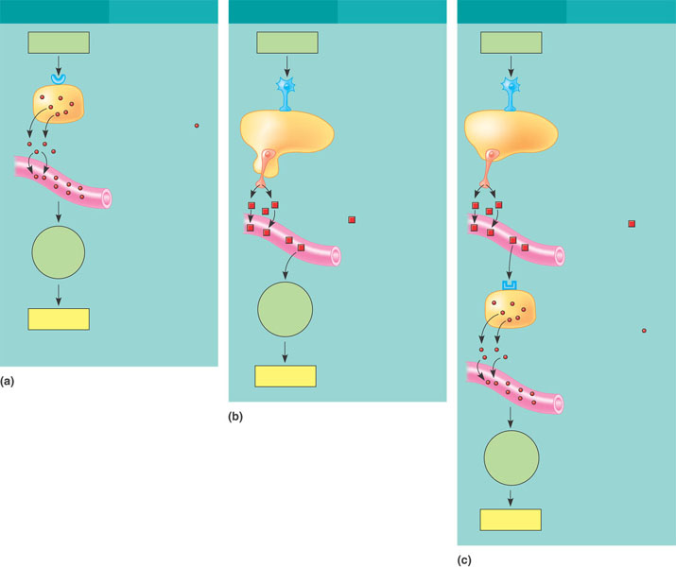
7. What are the three major classes of molecules that function as hormones in vertebrates?
8. Use the diagram below to review basics of signal transduction pathways.
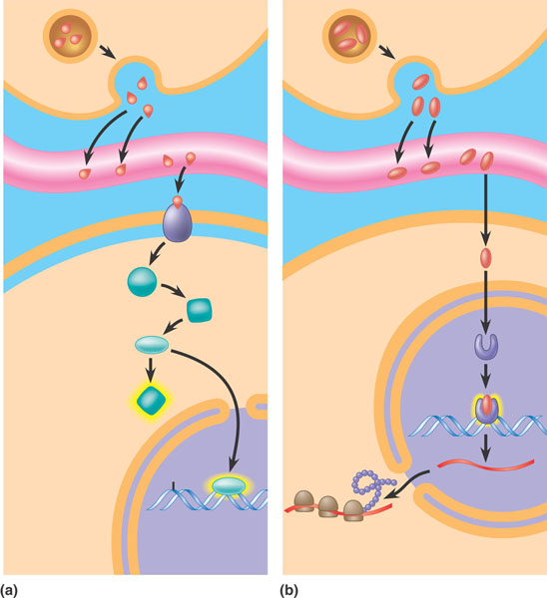
9. How can one chemical signal cause different effects?
10. What type of molecules are intracellular receptors? Include the why and give an example in your answer.
11. Detail the following local regulators.
a) cytokines
b) growth factors
c) nitric oxide
d) prostaglandins
Study the table on page 949 – it is overwhelming when presented with a long list of information – the easier way to approach the memorization is first look through the list for what you already know and would associate together – for example pancreas and insulin/glucagon. Then attack the glands with the least amount of information. As you can see, the pituitary has the most. If you memorize the others then by default, the pituitary is any you didn’t memorize.
12. How does the hypothalamus integrate information?
13. What two hormones are released by the posterior pituitary and what are their actions?
14. What is the importance of tropic hormones?
15. List three tropic hormones and their action.
16. What is the general function on the anterior pituitary nontropic hormones?
17. What is special about the structure of growth hormone?
18. List one example of a physiological response to overproduction and underproduction of growth hormone.
19. What are the types of hormones that nonpituatary?
20. Label the feedback loop for regulation of the thryroid?
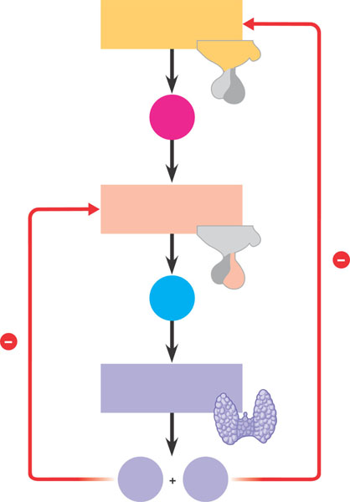
21. Describe one example of hypothyroidism and one of hyperthyroidism. Why are they both a problem?
22. What is the main function of the parathyroid hormone and in your own words, why is it important?

23. Complete the diagram below of the feedback loops concerning calcium regulation.
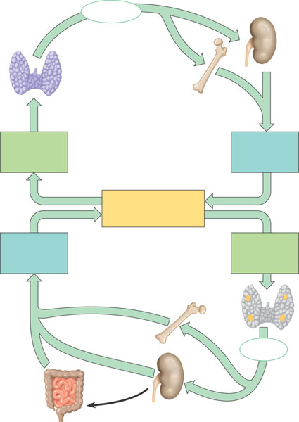
24. Complete the diagram below – you have seen this before – concerning glucose homeostasis.
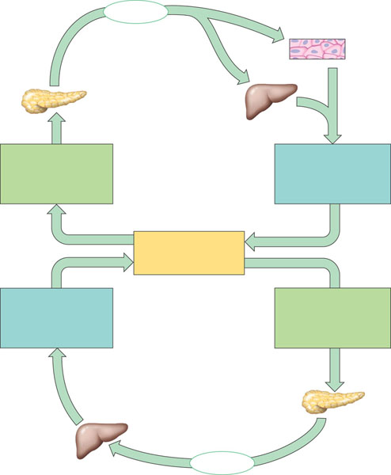
25. How does the body respond differently to long term and short term stress and why is this an advantage to the organism?
26. How could chronic short term stress responses be a disadvantage to the organism?
27. Compare and contrast glucocorticoids and mineralocorticoids.
28. What are the gonadal sex hormones?
29. What is the pineal gland and why is it important?
30. Label the diagram below representing hormonal regulation of insect development.
