AP Biology Name_________________________
Chapter 46 Guided Reading Assignment

1. Define the following terms:
a. Fragmentation

b. Regeneration

c. Parthenogenesis

d. Hermaphroditism

2. Explain the term sequential hermaphroditism and why it occurs.

3. Compare and contrast internal and external fertilization.

4. Define the term pheromone and explain its uses.

5. Compare and contrast the embryos of eutherian mammals and marsupial mammals.

6. Describe the evolutionary benefits of the spermatheca.

7. Describe the main difference of the opening of the reproductive, digestive, and excretory systems between mammalian and non-mammalian vertebrates.

9. Label the diagram showing human female reproductive anatomy.

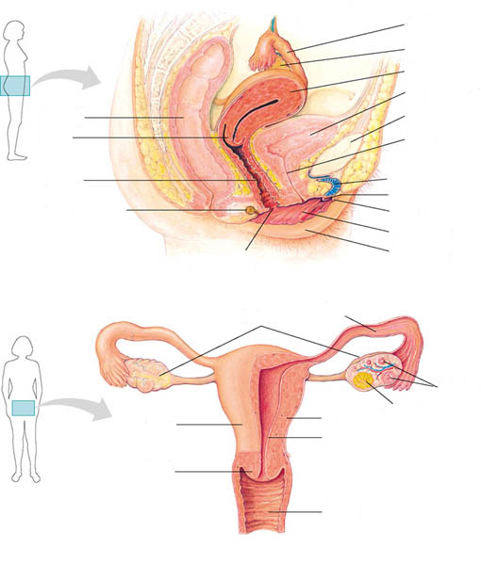

10. Discuss the mammalian reproductive importance of mammary glands.

11. Label the diagram showing human male reproductive anatomy

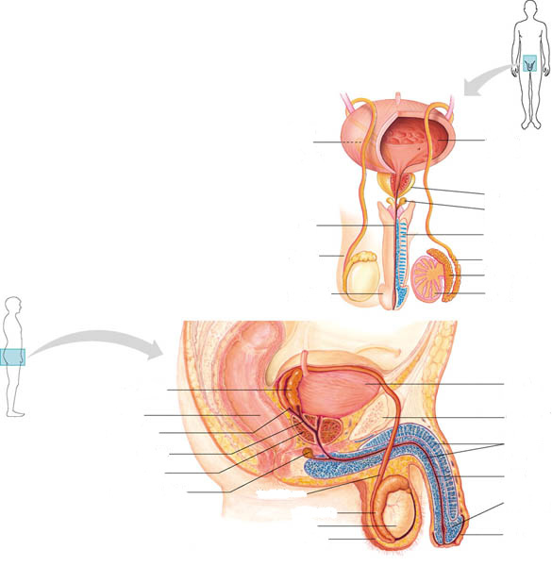

12. Describe two characteristics of semen that helps sperm survive the hostile environment of the vagina and travel through the female tract.

13. Define the term vasocongestion and myotonia and their roles in human sexual response.

14. Compare and contrast the two types of mammalian gametogenesis. (oogenesis and spermatogenesis)

15. Compare and contrast menstrual cycles and estrous cycles.

16. Label the diagram concerning human oogenesis..

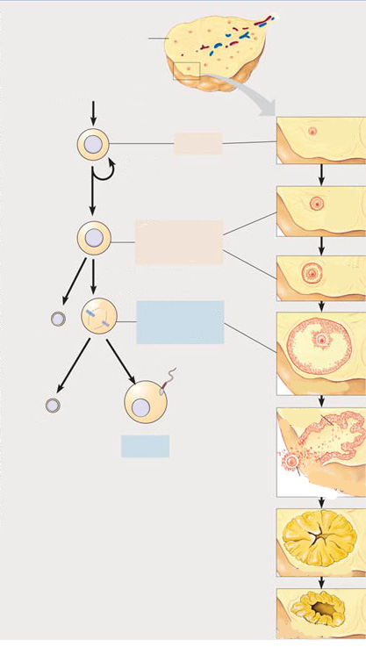

17. Why might a woman’s body NOT reject an embryo as a foreign body?

18. Label the diagram concerning human spermatogenesis.

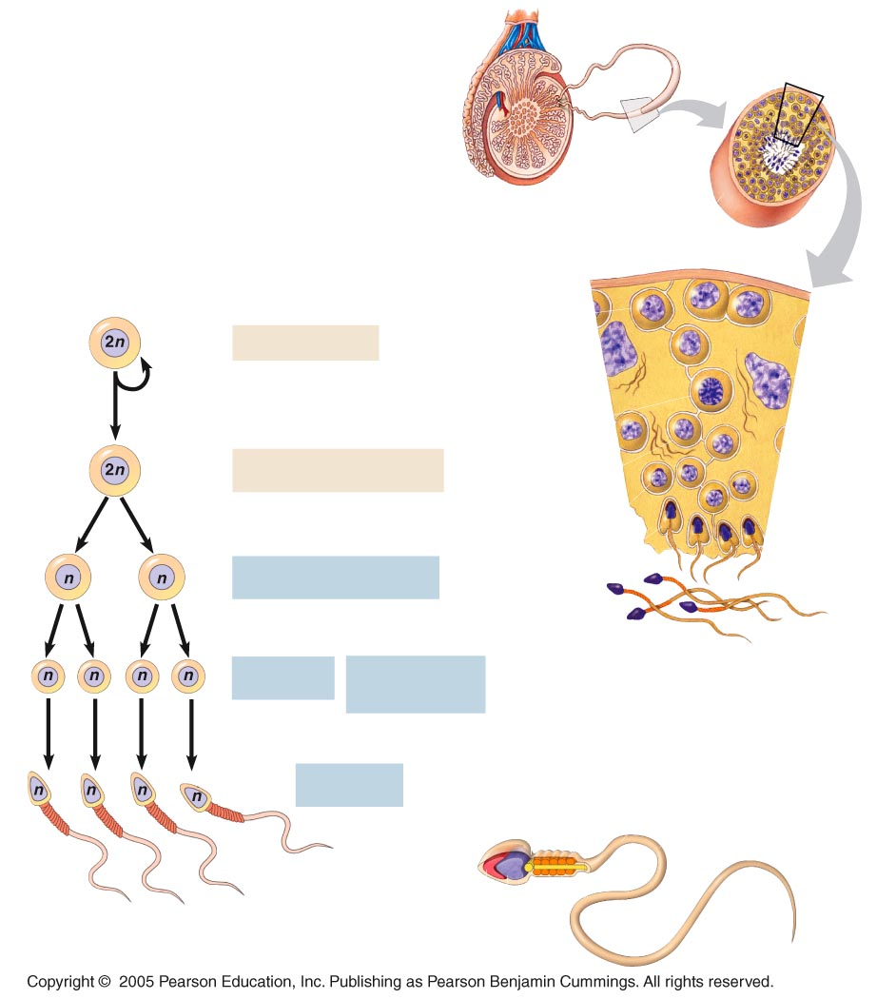

- Label the following diagram concerning the reproductive cycle of human
females.

