AP Biology Name _________________________
Chapter 48 Guided Reading Assignment

- What is a nerve net?
- Compare and contrast the central and peripheral nervous systems.
- How does the organization of the nervous system of a _____ compare with the organization of the nervous system of a ____?
  - Hydra and insect
  - Hydra and flatworm
  - Leech and salamander
- What are the functions of the following:
  - Sensory neurons
  - Interneurons
  - Motor neurons
  - Effector cells
- Use the diagram below to demonstrate the activity surrounding a reflex response.
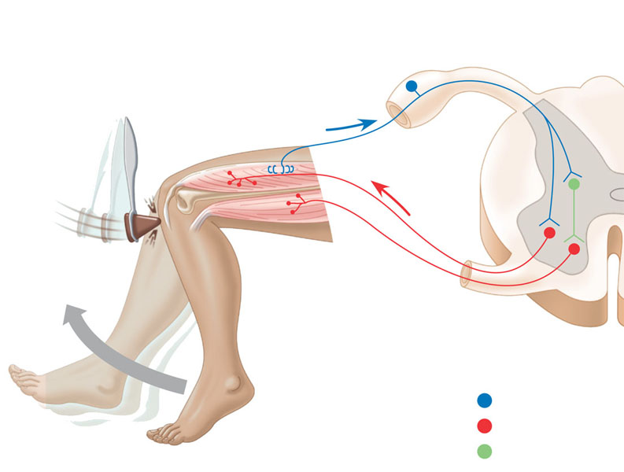
- Label the neuron below – be prepared to label this on a quiz the day that this is due.
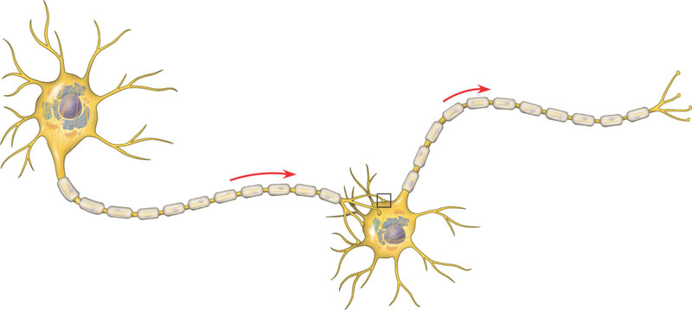
- Why are glial cells important?
- What are astrocytes?
- What is the blood brain barrier and why is it important?
- Label the diagram below and explain why myelin is important in nerve conduction?
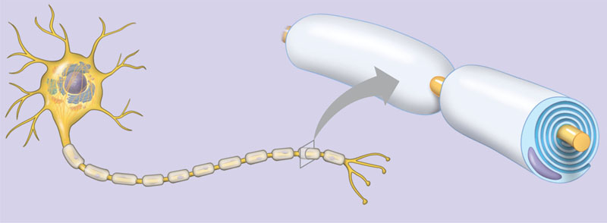
- Define the following terms:
  - Membrane potential
  - Resting potential
- Discuss the three types of gated ion channels below:
  - Stretch
  - Ligand
  - Voltage
- Define the following terms:
  - Hyperpolarization
  - Depolarization
  - Graded potentials
  - Threshold
  - Action potential
- Label the diagram below concerning the generation of an action potential.
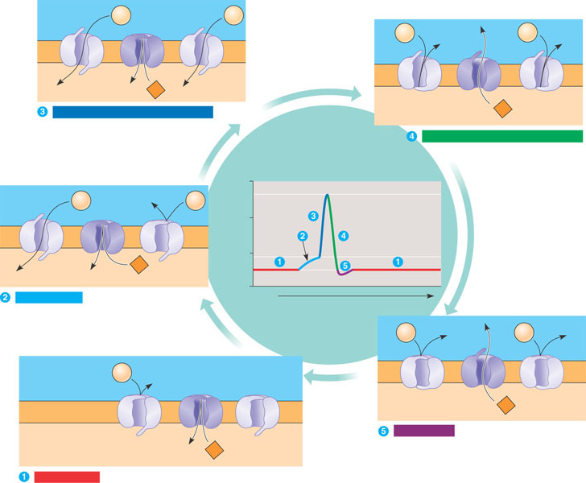
- How do the various factors affect the speed of an action potential?
  - Larger axon
  - Myelination and salutatory conduction
- Label the diagram below demonstrating the conduction of the action potential.
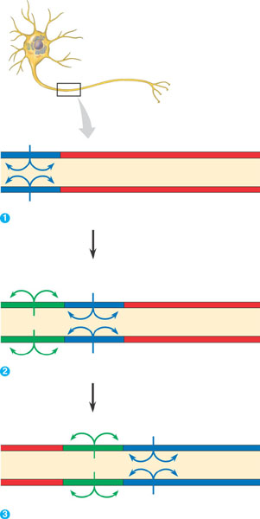
- What happens at the synaptic cleft?
- Contrast excitatory and inhibitory postsynaptic potentials.
- Contrast temporal and spatial summation.
- What happens when indirect synaptic transmission takes place?
- Discuss the neurotransmitters listed below:
  - Acetylcholine
  - Biogenic amines
    - Epinephrine and norepinephrine
    - Dopamine
    - Serotonin
  - GABA
  - Endorphins
  - Nitrous oxide
- What is the difference between gray matter and white matter?
- Define the following terms:
  - Central nervous system
  - Peripheral nervous system
  - Somatic nervous system
  - Autonomic nervous system
- Contrast the core functions of the parasympathetic and sympathetic nervous system.
- What are the three brain region during embryonic development?
- What are the parts of the brainstem and what are its functions?
- What is the reticular formation?
- What are the core functions of the cerebellum
- What are the parts of the diencephalons and what are its functions?
- What are circadian rhythms?
- Describe the cerebral hemispheres.
- What is the corpus callosum?
- What is the limbic system and what is its function?

