AP Biology Name _________________________
Chapter 49 Guided Reading Assignment

- Define the following words:
  - Mechanoreceptors-

  - Thermoreceptors-

  - Chemoreceptors-

  - Electromagnetic receptors-

  - Pain receptors-

  - Exteroreceptors-

  - Interoreceptors-

  - Sensory transduction-

- Use the following figure to discuss the inner working of the human ear:

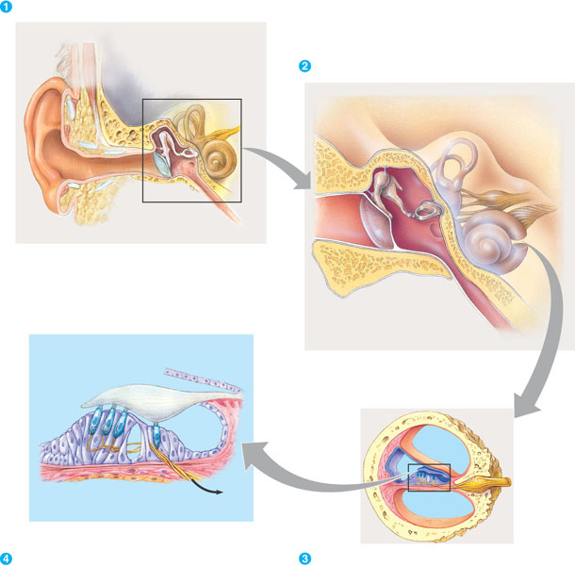

- Describe how the movement of fluids helps organisms to hear.

- Describe the relationship between taste and smell in most organisms.

- Label the following diagram of the structure of the vertebrate eye.

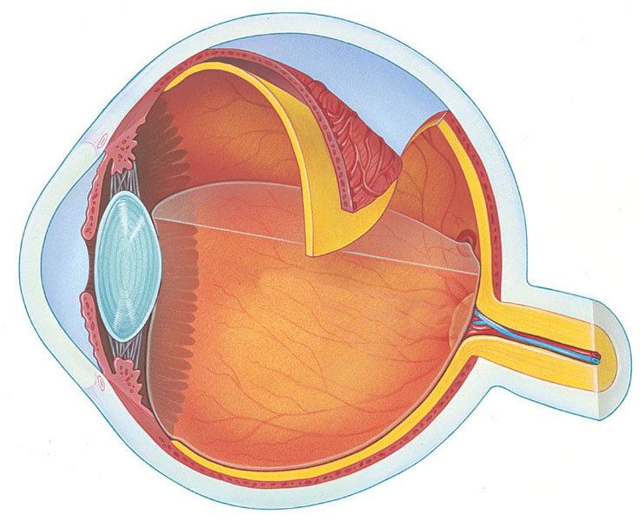

- Describe the function of the following terms.
  - Sclera-

  - Choroid-

  - Conjunctiva-

  - Cornea-

  - Iris-

  - Pupil-

  - Retina-

  - Lens-

  - Ciliary Body-

  - Aqueous Humor-

  - Vitreous Humor-

  - Rods-

  - Cones

- How is rhodopsin important to sight?

- What purposes do the skeleton serve for land mammals?

- How does the muscular system interact with the skeletal system to create movement?

- Use the following diagram to explain muscle contraction from the nerve all the way to the roles of actin and myosin.

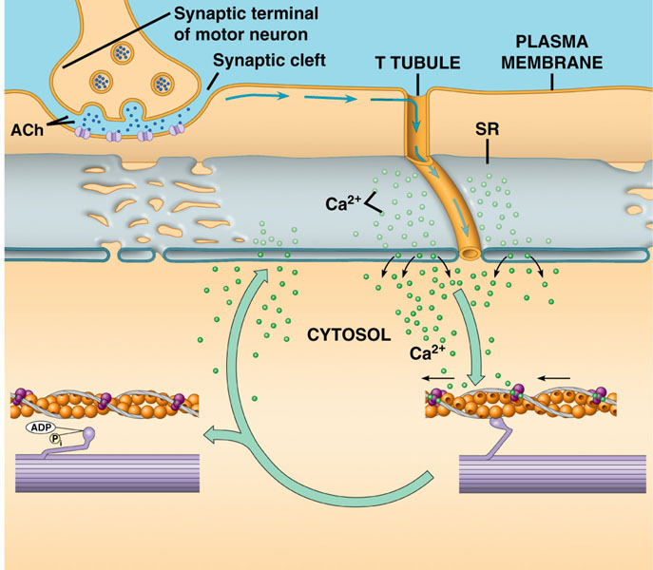

- Compare and contrast the different types of muscles.

- Label the following diagram concerning energy use and locomotion.

