AP Biology Name _________________________
Chapter 5 Guided Reading Assignment

- Label the diagram below – identify a monomer, polymer, condensation reaction, and hydrolysis.
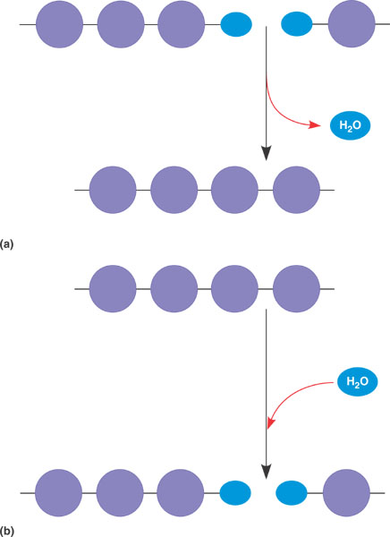
- What are the three hexose monosaccharides?
- What is a glycosidic linkage and what do the numbers 1-4 and 1-2 relate to?
- Compare and contrast the two storage polysaccharides.
- Compare and contrast the two structural polysaccharides.
- Why are lipids grouped together?
- What are the building blocks of fats?
- Contrast saturated and unsaturated fats – how does this relate to the concept that structure and function are linked?
- Label the molecule below.
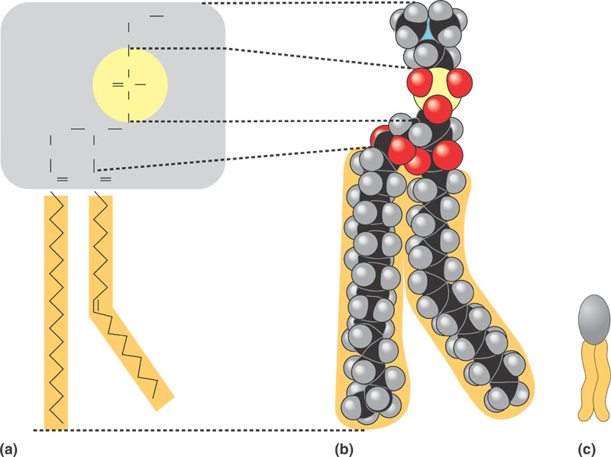
- How would you recognize a basic steroid molecule?
- List the eight types of proteins and their basic function.
- What are the names for the monomers and polymers of proteins?
- Label the diagram below concerning the catalytic cycle of an enzyme -
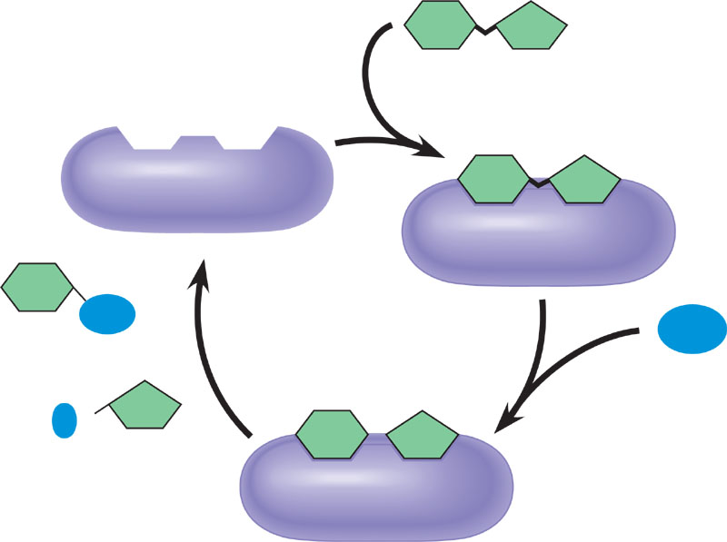
- Draw two amino acids – note the amino group, the carboxyl group and the alpha carbon, circle the water molecule to be removed and then note the peptide bond formed when the two are joined.
- Explain the four levels of protein structure –
  - Primary
  - Secondary
  - Tertiary
  - Quaternary
- How does the characteristics of an amino acid – nonpolar, polar, acidic or basic relate to the issue of tertiary and quaternary structure?
- What does denaturation mean and why is it important?
- What are chaperonins and what is their role in protein structure?
- Describe the technique of x-ray crystallography.
- What are the roles of nucleic acids?
- Label the blank diagram below:
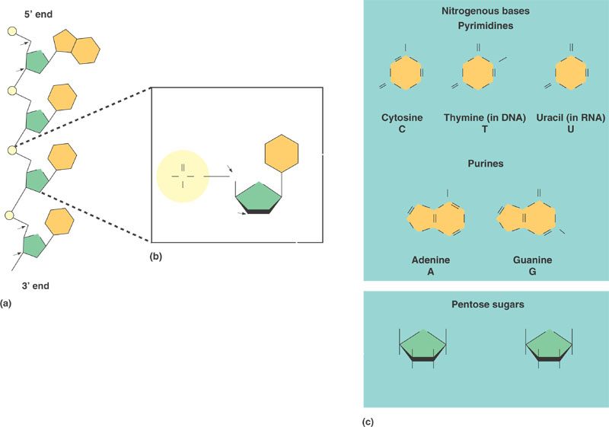
- What is meant by the term that DNA is antiparallel?

