AP Biology Name ____________________________
Chapter 50 Guided Reading

- Define the following terms:
  - Abiotic
  - Biotic
  - Biota
  - Give an example of the interactions of biotic and abiotic factors.
- What do the following subfields of ecology study?
  - Organismal ecology
  - Population ecology – include the definition of ecology
  - Community ecology – include the definition of community
  - Ecosystem ecology – include the definition of ecosystem
  - Landscape ecology
- Explain the factors that affect dispersal of organisms.
- Give two examples of the impact of abiotic factors on the distribution of organism:
  - Temperature
  - Water
  - Sunlight
  - Wind
  - Rocks and soil
- What is the difference between macroclimate and microclimate?
- How does latitude affect sunlight intensity?
- What causes the seasons?
- Explain how mountains affect rainfall?
- How does seasonal turnover in lakes affect the oxygen level available to the aquatic organisms?
- Label the below listed diagrams of aquatic and marine environments – also include a written description of the zone.
  - Aquatic
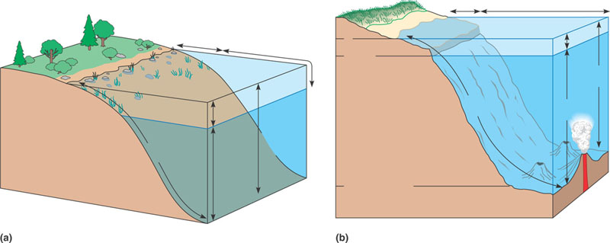
  - Marine
- Describe the following aquatic biomes – write enough to use this guided reading as a study guide for the test.
  - Lakes
  - Wetlands
  - Streams and Rivers
  - Estuaries
  - Intertidal Zones
  - Ocean Pelagic Biome
  - Coral Reef
  - Marine Benthic Zone
- How does temperature and precipitation impact the distribution of terrestrial biomes? Use figure 50.18 to answer this question. This is a core concept.
- Describe the following terrestrial biomes – write enough to use this guided reading as a study guide for the test.
  - Tropical forest
  - Desert
  - Savanna
  - Chaparral
  - Temperate grassland
  - Coniferous forest
  - Temperate broadleaf forest
  - Tundra

