AP Biology Name _________________________
Chapter 6 Guided Reading Assignment

- What is resolving power and why is it important in biology?
- How does an electron microscope work and what is the difference between a scanning and transmission electron microscope?
- Describe the process and purpose of cell fractionation.
- Label the prokaryotic cell below – list structure and function.
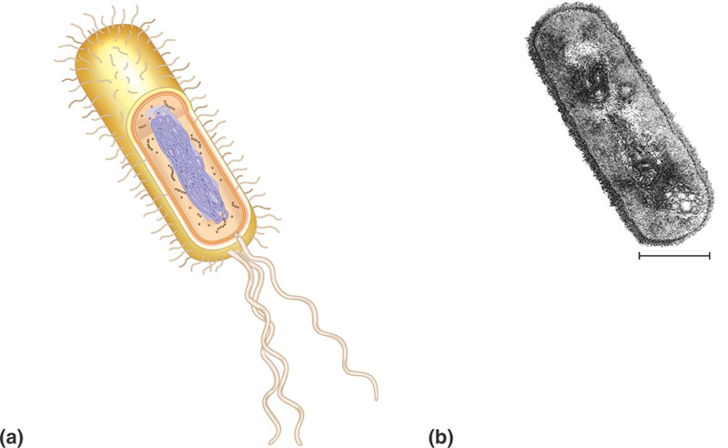
- Why is surface area to volume such an important concept as it applies to the size of a cell?
- For each of the structures below – note the specific structure and the function of the organelle or part of the organelle. The important concept is to note how the specific structure allows for the specific function to be accomplished.
  - Nucleus
    - Nuclear envelope
    - Nuclear lamina
    - Chromosomes
    - Chromatin
    - Nucleolus
  - Ribosomes
  - Endoplasmic reticulum
    - Smooth ER
    - Rough ER
  - Golgi Apparatus
  - Lysosomes
  - Vacuoles
    - Food
    - Contractile
    - Central w/tonoplast
  - Endomembrane system – overall
  - Mitochondria
    - Mitochondrial matrix
    - Cristae
  - Plastids
    - Amyloplast
    - Chromoplast
    - Chloroplast
      - thylakoids
      - stroma
  - peroxisomes
  - cytoskeleton – pay careful attention to the details in this section
    - microtubules
      - centrosomes and centrioles
      - cilia and flagella – include basal body
      - dynein walking
    - microfilaments
      - actin
      - myosin
      - pseudopodia
      - cytoplasmic streaming
    - intermediate filaments
  - Cell walls
    - Primary cell wall
    - Middle lamella
    - Secondary cell wall
  - Extracellular matrix
    - Collagen
    - Proteoglycans
    - Fibronectin
    - Integrins
  - What are intercellular junctions and why are they important?
  - Contrast plasmodesmata, tight junctions, desmosomes, and gap junctions.

