AP Biology Name _________________________
Chapter 7 Guided Reading Assignment

- What does selective permeability mean and why is that important to cells?
- What is an amphipathic molecule?
- What were the ideas concerning the plasma membrane models below:
  - Gorter and Grendel
  - Davson and Danielli
  - Singer and Nicolson
- Describe the freeze fracture technique and why is it useful in cell biology.
- How is the fluidity of cell membrane’s maintained?
- Label the diagram below – for each structure – briefly list it’s function:
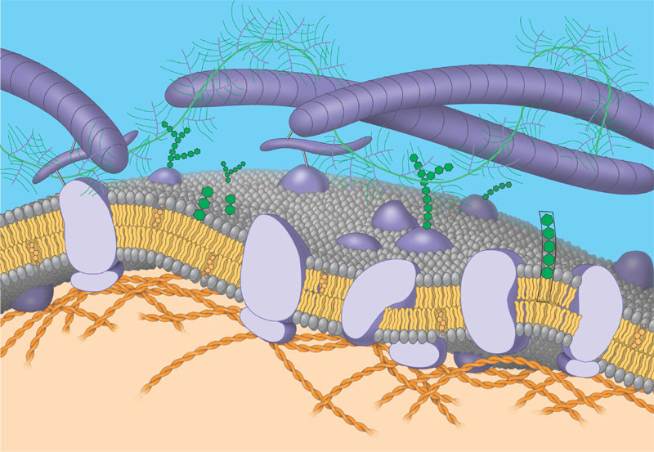
- List the six broad functions of membrane proteins.
- How do glycolipids and glycoproteins help in cell to cell recognition?
- Why is membrane sidedness an important concept in cell biology?
- How has our understanding of membrane permeability changed since the discovery of aquaporins?
- What is diffusion and how does a concentration gradient relate to passive transport?
- Why is free water concentration the “driving” force in osmosis?
- Why is water balance different for cells that have walls as compared to cells without walls?
- Label the diagram below:
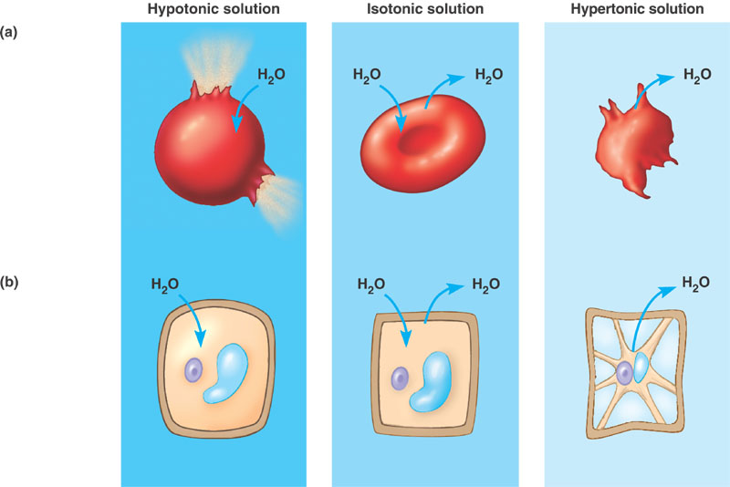
- What is the relationship between ion channels, gated channels and facilitated diffusion – write 1 -2 sentences using those terms correctly.
- How is ATP specifically used in active transport?
- Define and contrast the following terms: membrane potential, electrochemical gradient, electrogenic pump and proton pump.
- What is cotransport and why is an advantage in living systems?
- What is a ligand?
- Contrast the following terms: phagocytosis, pinocytosis and receptor-mediated endocytosis.

