AP Biology Name _________________________
Chapter 8 Guided Reading Assignment

- Contrast the catabolic and anabolic pathways.
- Define the following terms: these terms and concepts are critical – they would be “great” quiz words.
  - Energy
  - Kinetic energy
  - Heat/thermal energy
  - Chemical energy
  - Thermodynamics
  - First Law of Thermodynamics
  - Second Law of Thermodynamics
  - Free Energy
- Contrast exergonic and endergonic reactions in terms of: free energy, stability, capacity to do work.
- How do you know if a reaction is spontaneous?
- Can a closed system at equilibrium do work? Why or why not?
- List and give an example of the thee main kinds of cellular work done by ATP.
- Label the diagram below and indicate how cellular work is done by ATP.
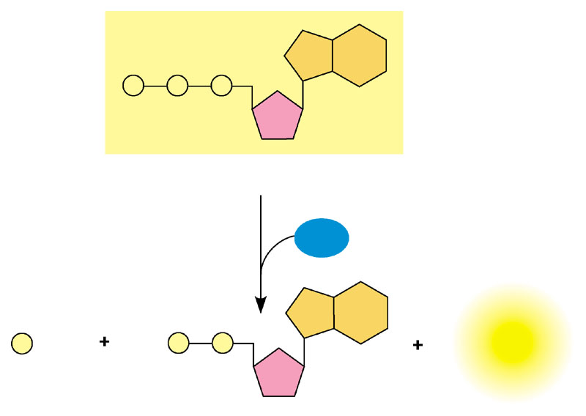
- Define phosphorylated.
- In your own works, explained the concept of coupled reactions and ATP doing work.
- What is the relationship between exergonic reactions, endergonic reactions and the use and regeneration of ATP?
- What is activation energy?
- Label the diagrams below including the change in free energy.
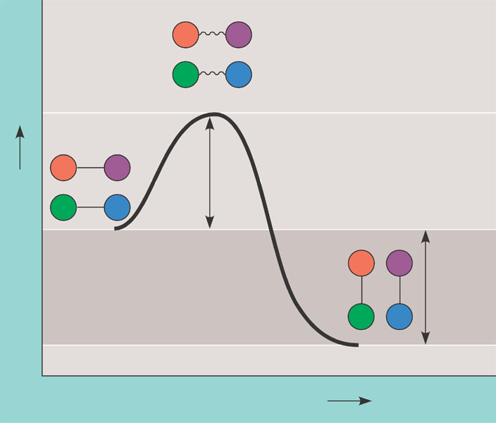
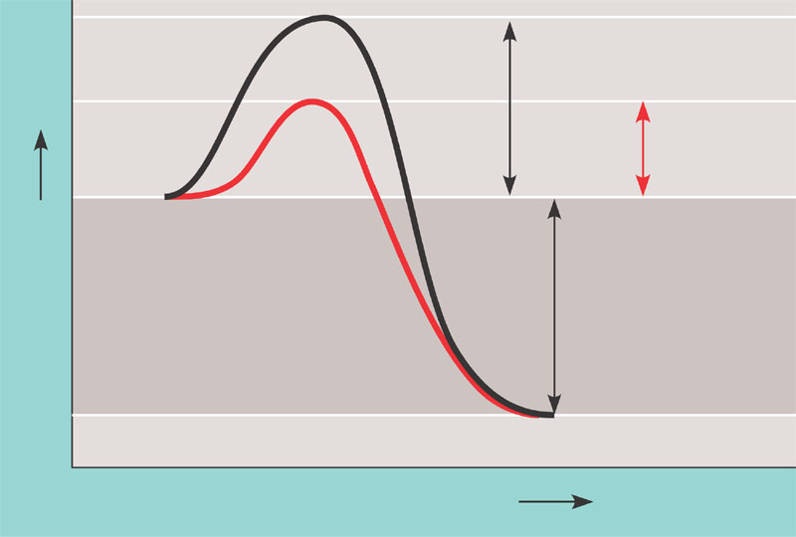
- Define the following terms:
  - Substrate
  - Enzyme substrate complex
  - Active site
  - Induced fit
- Label the following diagram:
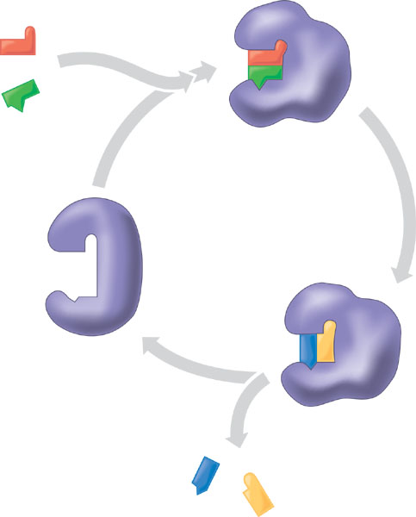
- How do temperate and pH (specifically) affect enzyme activity?
- Compare and contrast competitive and noncompetitive inhibitors.
- What is allosteric regulation and how does assist in the regulation of metabolism?
- What is cooperativity?
- How does feedback inhibition work?

