AP Biology Name _________________________
Chapter 9 Guided Reading Assignment
Hint: review the concept check questions – these are great quick quiz questions!
- Define the two catabolic pathways:
  - Fermentation
  - Cellular respiration
- Use the following terms correctly in a sentence: redox reactions, oxidation, reduction, reducing agent and oxidizing agent.
- Why is being “reduced” equivalent to having a greater potential energy?
- In cellular respiration, what is being oxidized and what is being reduced?
- Label the diagram below of the electron movement with regard to the coenzyme NAD+.
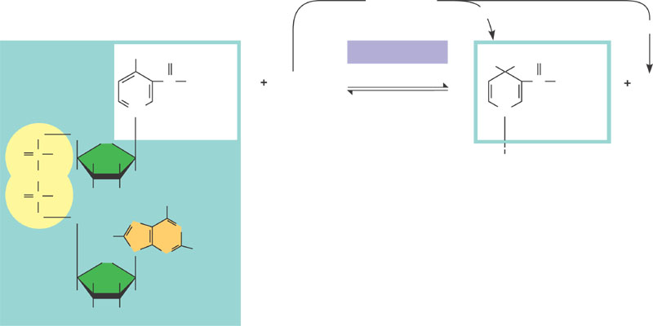
- Why are electron transport chains an advantage to living systems?
- What are the three stages of aerobic cellular respiration?
- What is substrate-level phosphorylation?
- Complete the chart below re: glycolysis
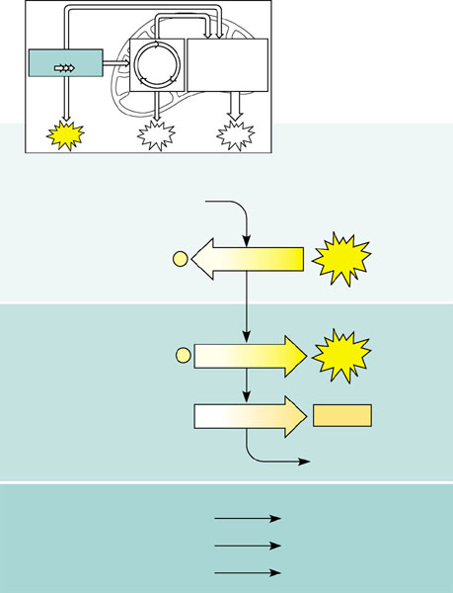
- Label the transition reaction converting pyruvate to acetyl coA below:
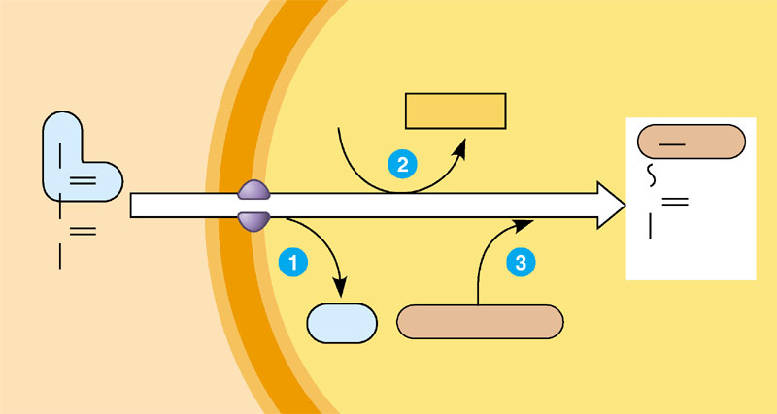
- Label the citric acid cycle below:
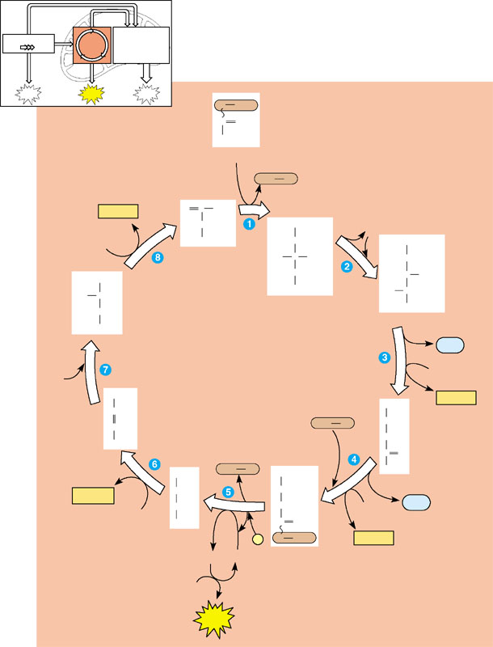
  - Where does the C “go” that is removed?
  - What is happening when NAD+ → NADH + H+?
  - Where is substrate level phosphorylation happening?
- What is oxidative phosphorylation?
- What are cytochromes?
- Define chemiosmosis and label the diagram below.
chemiosmosis:
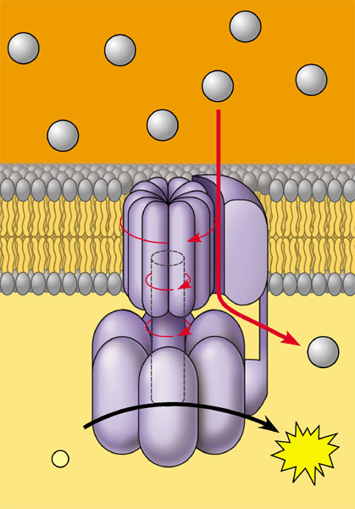
- Label the diagram below of the activities occurring on the ECT.
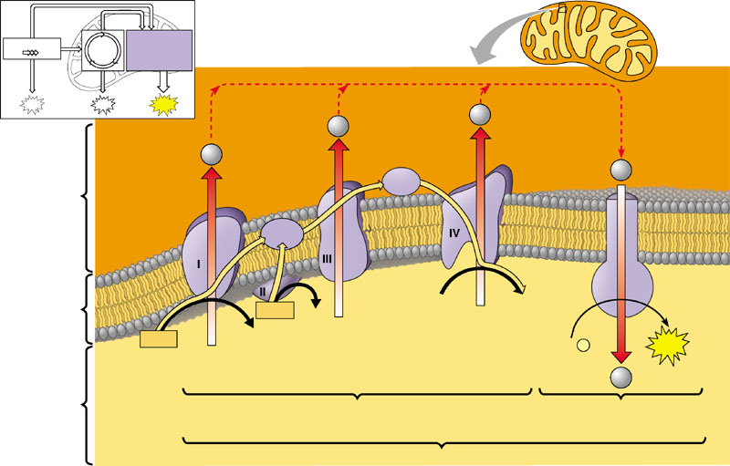
- Complete the summary diagram of cellular respiration. You are responsible for these #’s and locations!
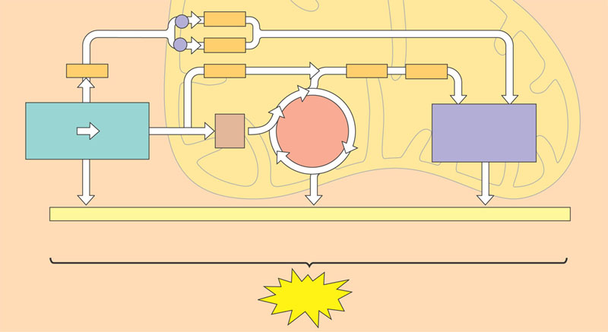
- Label the diagram of fermentation below:
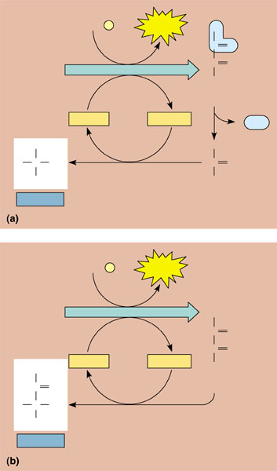
- Does aerobic cellular respiration happen in prokaryotic organisms – if yes – where?
- What is the overall purpose of fermentation? Why does it have to occur?
- What is a facultative anaerobe?
- What is the evolutionary significance of glycolysis?
- Why do fats provide a little more than twice as many calories per gram as compared to carbohydrates or proteins? Hint: Think of the output of the Citric Acid Cycle.
- Why would AMP stimulate cellular respiration and ATP inhibit it?
- Why would phosphofructokinase being allosteric in character be an advantage to the control of cellular respiration?

