**HOW TO CREATE AND PUBLISH A BLOG POST**

**ON THE KABT WEBSITE**

Eric Kessler

[ekessler@bluevalleyk12.org](mailto:ekessler@bluevalleyk12.org)

1. Travel to the KABT website at [www.kabt.org/](http://www.kabt.org/).

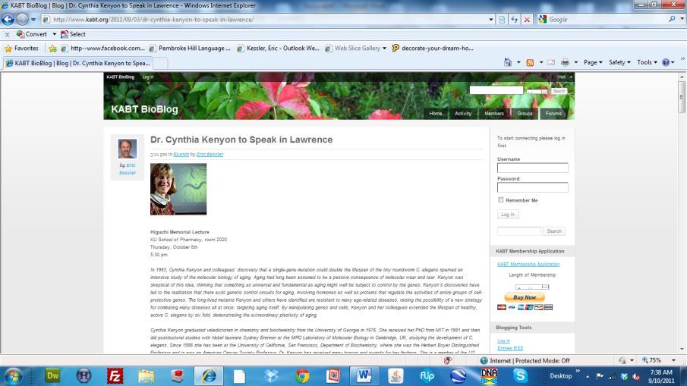

1. **Logging in to KABT** - Log in to the website by typing in your “user name” and “password” in the appropriate text boxes along the right hand column of the site or click on the “Log in” link further down under Blogging Tools. In the latter case, you will be asked for the same credentials via a word press log in. If you have forgotten your log in credentials and/or don’t have administrative permissions contact Brad Williamson.
2. 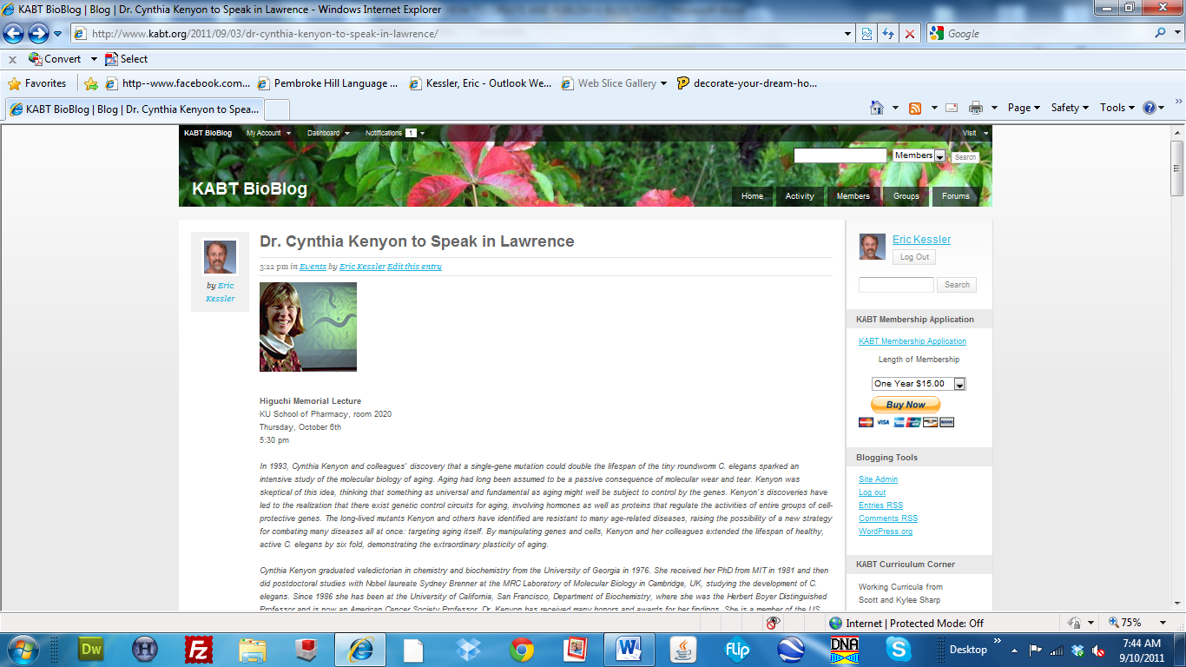**Entering Site Administration** - Once you are logged in, you will notice the appearance of a new link under Blogging Tools along the right hand column of the site. This new link is titled “Site Admin”. Click on that link.
3. **Viewing the Dashboard** - Upon clicking, the page will change and you will now be in Dashboard. Take some time to familiarize yourself with the entire screen landscape. In the upper left hand column of the site you will notice five options for viewing particular content that is housed in this area (Posts, Media, Comments, Profile, and Tools).

Of the five, I generally only use the “Posts” button. Upon clicking it, the middle field will show a summary of all the posts that you have ever made in chronological order. I use it to reopen posts that I have been working on but that are not currently published. Such posts will be followed by the word “Draft” for easy reference. I also you this button to “Add New” posts. You should see a link with that name appear under the “Post” button after you have clicked there. In don’t use the “Media” button (since I add the Media in another manner) but the “Tools” button looks worth an exploration (I have never used it before).

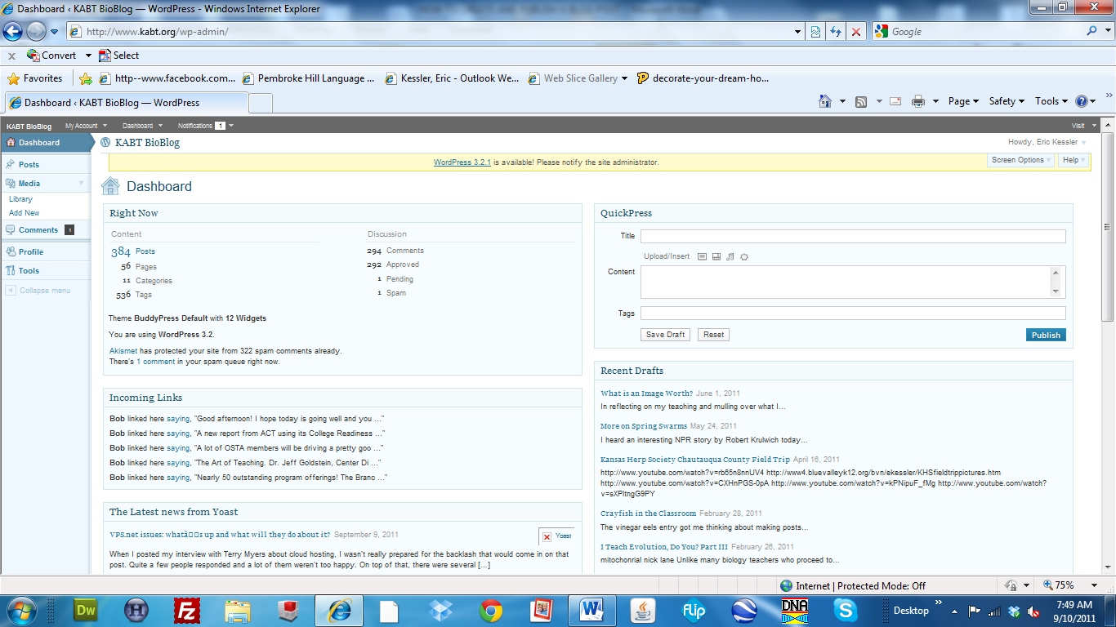

On the main Dashboard page you will also see a text area labeled QuickPress and Recent Drafts on the right hand side of the page. If haven’t used the QuickPress option, but if you have a short simple post to publish this maybe the way to go. You will know after having viewed the full host of content options in the more advanced publishing option. The Recent Drafts field obviously one quicker access to posts that you are currently working on.

1. **Adding a New Post** - So, now that you have a general feel for Dashboard click on the “Posts” button and “Add New” once it appears under that heading. Like before, take a few minutes to familiarize yourself with the screen. From top to bottom and left to right, you will see that there is a text box for entering your title, a text box for adding your specific content, buttons associated with publishing the post, and means for categorizing and tagging your post. Now that you are where the action actually takes place, I will cover each of these items separately.

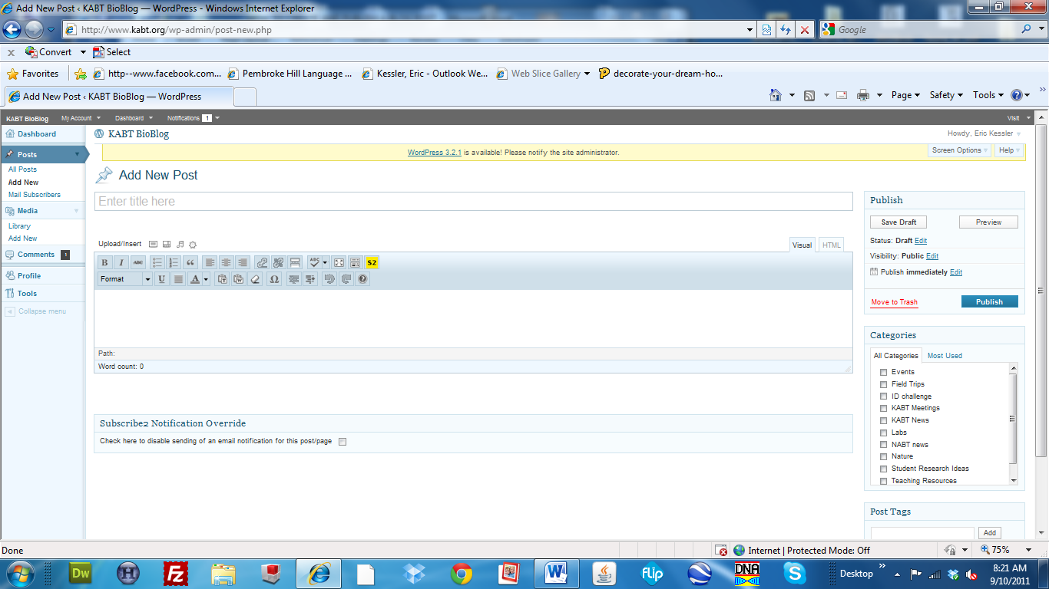

1. **Titling your Blog Post**

Obviously I am an amateur blogger so take any of my advice with a grain of salt. In my opinion the title should not only be to the point and informative but it should also be catchy if possible. I suggest observing a number of blog sites to get some ideas.

1. **Saving and Previewing your Blog Post**

Although I haven’t really had issues with the site crashing it is wise to “Save Draft” after every major revision that you make, and I suggest that you use the “Preview” button to see if the formatting that you have chosen really appears in the manner that you wish it to. This often is not the case and you will become familiar with the quirks of WordPress with time.

1. **Categorizing your Blog Post**

Click the category boxes that apply to the information in your blog post. This is important for helping those that visit the KABT site find the information they are looking for more readily. One can search these categories to find posts that only fit that category.

1. **Tagging your Blog Post**

Tags are particular terms associated with your post that others may use as search terms to find your and similar posts within the KABT website, as well as when searching using google, etc… (I think I have that correctly). So, think seriously about the tags that you include. They should be comprehensive to the entire post and include general as well as specific terms that are associated with the content. If you go back and look at posts on the KABT website, you will see the list of associated tags below the posts. As you surf around the web you will notice begin to notice tags associated with other content you view. Pay attention to those tags for ideas on how we can increase our viewership.

1. **Adding Text Content to your Blog Post**

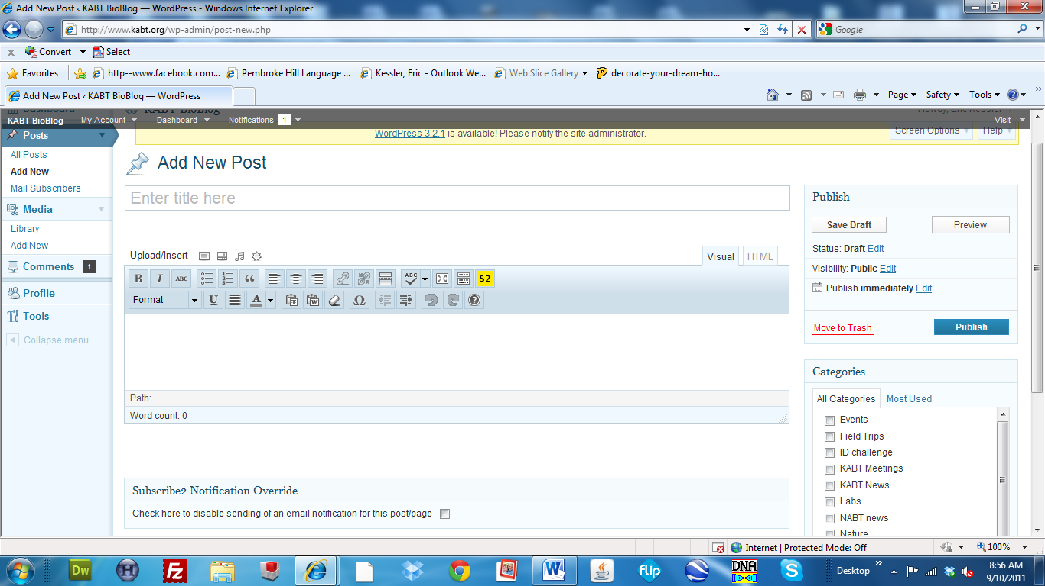

Many of the buttons in this field should be familiar to you from your work with other word processors. Familiarize yourself with those that you don’t know by hovering over each button for a short time. When done, pertinent information associated with that button will be displayed. I regularly use the following buttons:

*Bold*

*Italics*

*Bullets*

*Quotes*

When a field of text is highlighted and this button is chosen, that text will be indented, italicized, and placed in quotes. I often use this to help readers distinguish between content that I have written and content that I have cut-and-paste from some other source.

*Insert a Link & Unlink*

When you wish to add a link to text or an image, highlight that content and press the “Insert/edit link” button. The page will darken and a new box will appear where you can copy-and-paste a link to a website url.

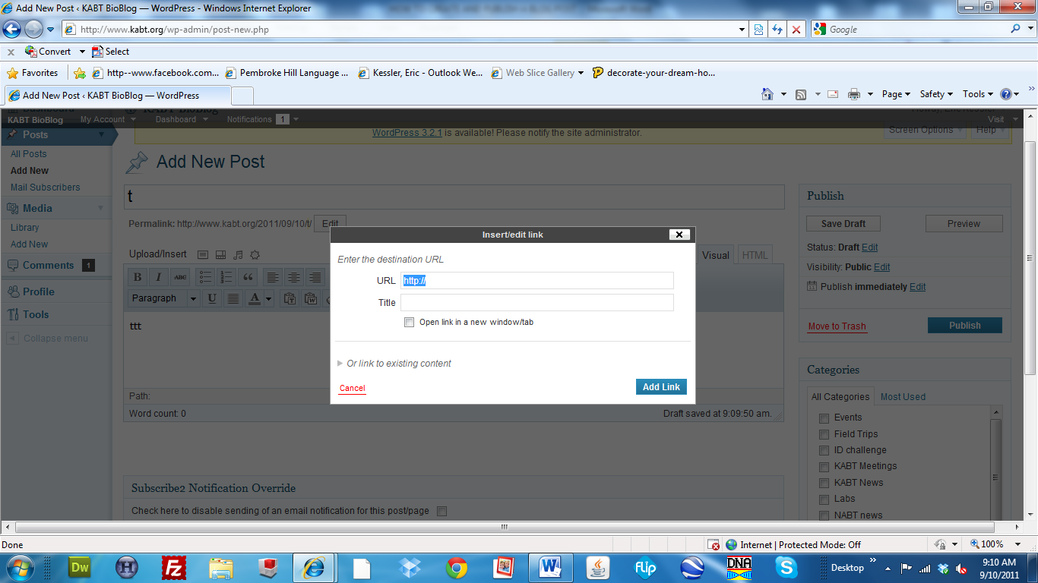

To copy a particular url, open another page in your browser, surf to the website of interest, highlight the link at the top of the page (a url most often begins with ”http://www.”), copy the link by depressing the “crtl” and “C” buttons on your keyboard, return to the pop-up as shown above, and depress the “crtl” and “V” buttons on your keyboard.

The title is not really necessary, although if the page doesn’t display correctly or someone saves it in their favorites this is title that will display as a summary. It is important that you click the box for “Open link in new window/tab”. I think most people appreciate that links prompt a new browser page to open. If this box isn’t selected, the page associated with the link will show within the window the viewer is currently in and they will no longer be able to view the page they were on without clicking on the back button.

The “Unlink” button, adjacent to the “Insert link” button is used to remove a link.

*Always check your links and make sure they direct the viewer to the appropriate website before publishing your blog post. Use the “Preview” button to do so.*

*Insert More Tag*

This button allows you to break your post in half. For really long posts that many may not be interested in, you can compose an introductory paragraph associated with the content, and then display the remainder of the content on another page. To use this function, place the cursor between your introductory and follow up information and click the button.

*Toggle Spell Checker*

*Toggle Fullscreen Mode*

Toggling to fullscreen mode allows one to more efficiently enter a lot of text without having to use the scroll bar, etc… as often, which can be quite cumbersome at times in the smaller screen mode. Not as many text functions are available in the full screen mode though. An alternative is that you can increase the size of the small screen viewing mode in the vertical direction by clicking and dragging on the lower corner of the content box (click where the three little lines are located and you’ll see).

*Underline*

*Indent and Outdent*

I have no idea what the “Insert Subscribe 2 Token” does.

1. **Adding Non-text Media to your Blog Post**

You will also notice that there is a series of Upload/insert buttons above the text field that you have been working with. Hovering over these icons will notice that you can insert an image, video, audio, or media. When you click on the “Insert an image” button as an example, a pop-up will appear. I have only uploaded from my computer although it appears there is a means of uploading an image from a website (I will check this out soon since I often use images found on other websites).

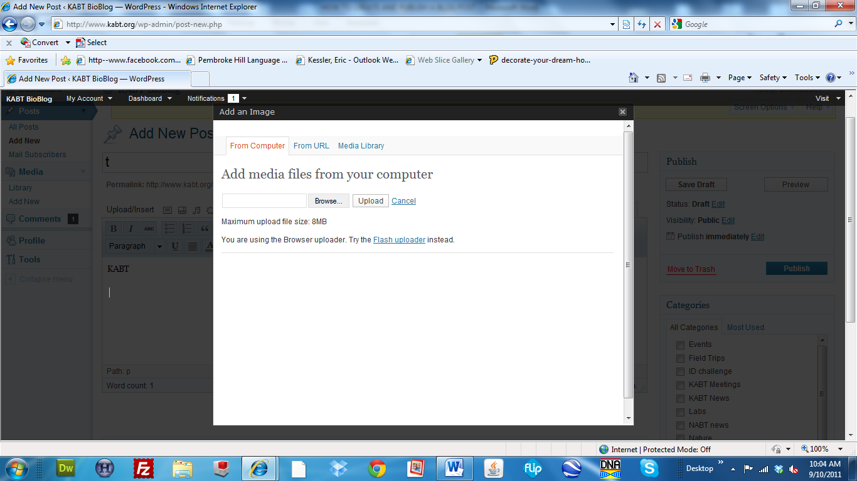

Once you have uploaded an image, it will appear as a thumbnail in the window and other information is displayed that you can change. I have only used the alignment and size options.

*If you change either from what it automatically selects, make sure that you preview it before you post since I have found that often it displays poorly. I haven’t figured out why.*

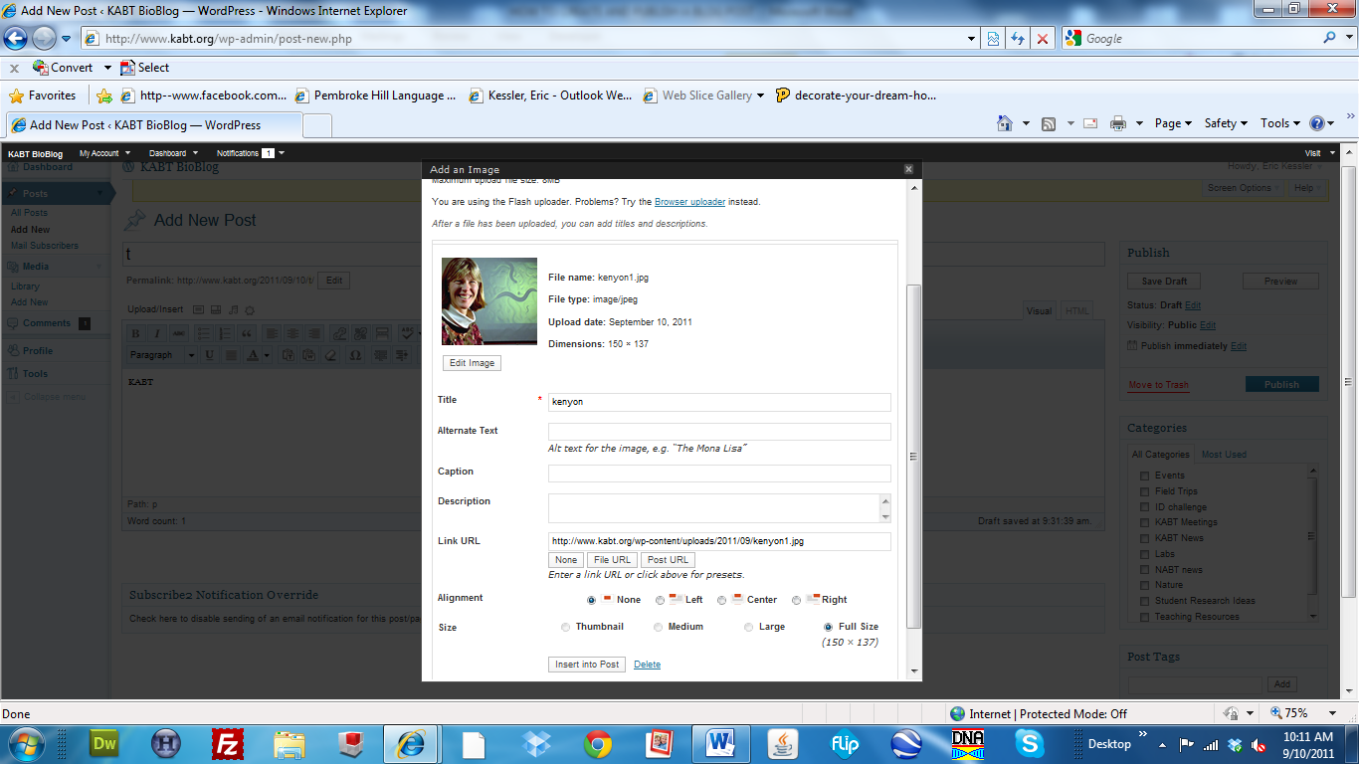

I have never added video or audio to a blog post directly. Instead I have a YouTube account where I upload my videos. Then, I imbed them into the post using the url to that video. To embed a YouTube video directly in a post, copy-and-paste the url of the video into the appropriate place in the blog post. When you do this, it will automatically make it an underlined and hot link. If you post in this manner, only a link will display. To get it to embed in the post, place the cursor at the left end of the url that you have added and use the backspace to remove the link (you can highlight the entire url and use the unlink button as well). In either case, preview the post before publishing to see if it embedded properly. Interestingly enough, the last time I did this it didn’t work so these instructions may not be helpful.

1. **Editing your Blog Post**

If you notice that you have made some mistake(s) once you have published your blog post, you can still edit it in a number of ways. I imagine that you have learned enough by now that you have the confidence to figure it out on your own. Let me know if you need help.