Name: ________________________________________________________________________

**Quarter 1 – Unit 1 – Structure and Function**

**Level 2**

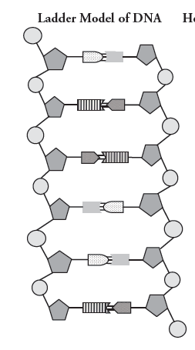

Instructions:

1. Label the:
   1. Deoxyribose sugar
   2. Phosphate
   3. Nitrogen base
2. Circle a nucleotide
3. Pair each base with its match

Name: ______________________________________________

**Quarter 1 – Unit 1 – Structure and Function**

**Level 3**

Instructions: Make a protein using the given DNA sequence. Fill in the missing blanks.

DNA: TACCCATGGTTTCGGGGAAGCAACATT

Step 1: _________________________________

Takes place in the __________________________ of the cell.

_____________:

Step 2: _________________________________

Takes place in the __________________________ of the cell.

_____________:

**Word Bank:**

Amino acids mRNA Transcription Ribosome

Translation Nucleus

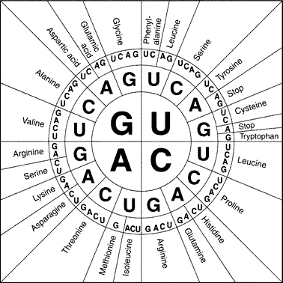

Name: ______________________________________________

**Quarter 1 – Unit 1 – Structure and Function**

**Level 4**

Instructions: Answer the given Open Written Response in a full paragraph. Include an introduction and conclusion. Use your decoding strategies.

How does the structure of DNA determine the structure of proteins, which carry out the essential functions of life?

In your response, include the following information:

1. Describe the role of transcription. Where does it take place in the cell?
2. Describe the role of translation. Where does it take place in the cell?