**Hominid Skull Analysis**

For this lab you will be analyzing the various Hominid/Primate skulls to gain a better understanding of the various anatomical adaptations that have been acquired by hominids over time.

**Skull Types:**

|  |
| --- |
| *Pan troglodytes* (Chimpanzee) Modern *Gorilla gorilla* (Gorilla) Modern *Homo sapiens* (Human) Modern *Homo neanderthalensis* (Neandertal man) 120,000-30,000 years ago *Homo erectus*  (Upright man) 2.0 million years ago *Australopithecus boisei*  2.3-1.2 million years ago *Australopithecus afarensis*  (“Lucy”) 4.0 million years ago |
|  |
|  |
|  |

**Measurements:** Complete the following measurements for each group (A-C).

ALWAYS MEASURE IN MILLIMETERS [mm] and round off to whole numbers.

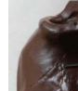**A. BRAINCASE**: (7 items #1-7)

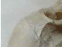1. Does the FOREHEAD (frontal bone) look more vertical OR flatter when the skull is held in Standard Anatomical Position [SAP] (i.e., with the eyes oriented forward)?

2. Is a SUPRAORBITAL(above the orbital) BROWRIDGE present or absent?





3. If present, is the BROWRIDGE DIVIDED in the middle, or CONTINUOUS?

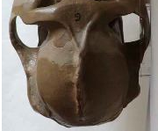

4. What is the WIDTH OF THE BRAINCASE at the widest point

(take the measurement while looking at the skull from above)?

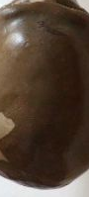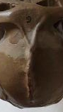

5. Is a SAGITTAL CREST prominent (2), present (1), or absent (0)?

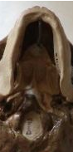

6. Measure the distance from the front teeth to the front ridge of the FORAMEN MAGNUM [mm].

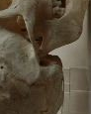

7. Is the MASTOID PROCESS relatively flat OR does it noticeably protrude (project)?

**B. FACE**: (5 items: #8-12)

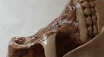8. Are the NASAL BONES protruding OR flat?

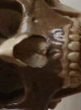

9. Measure the MAXIMUM BREADTH (width) of the NASAL OPENING [mm].



10. Measure the MAXIMUM HEIGHT of the NASAL OPENING [mm].

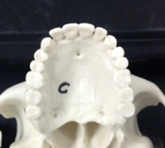

11. Measure the WIDTH of the MAXILLA

(the upper jaw) [mm].

(Measure from the outside of the back molars.)

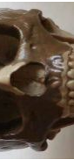

12. Measure the BIZYGOMATIC BREADTH [mm].

(This is the width or breadth of the face from the widest part of one zygomatic arch to the widest part of the other zygomatic arch.)



**C. DENTITION**: (6 items #13-18)

13. SHAPE OF THE DENTAL ARCADE: Do the tooth rows

diverge towards the back OR are they more straight-sided and

parallel to one another?

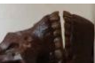14. When viewed from the side, are the INCISORS angled forward

OR are they vertical?



15. Measure the COMBINED WIDTH of the 4 INCISORS together.

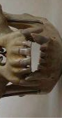

16. Place the MAXILLA and MANDIBLE together. Do the CANINE teeth project above and below the chewing surfaces of

the other teeth?

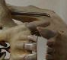

17. Is a CANINE DIASTEMA present?

(Gap on the medial side of the canine)



18. Measure the COMBINED LENGTH of the LEFT 2 PREMOLARS and 3 MOLARS together by measuring from the back of the last molar to the front of the first premolar to determine the length of the chewing surface of the "cheek teeth". [mm].

   

Sagittal suture or possibly crest

Zygomatic process

Zygomatic process

Zygomatic process

Zygomatic bone

Foramen Magnum

Nasal bone

Supraoribital browridge

Mastoid process

Frontal

Mandible

Maxilla

**Once measurements are complete:**

* Create 3 graphs (one for each data group A, B &C) that illustrate the changes in the anatomy of the primates.
* Choose just one characteristic from each data set to illustrate in your graphs.
* Graphs should be completed with “specimen” on the X-axis arranged in sequential order with the great apes and modern humans on the far right.

Data

|  |  |  |  |  |  |  |  |
| --- | --- | --- | --- | --- | --- | --- | --- |
| A- Braincase | | | | | | | |
| Specimen | 1. Forehead | 2. Browridge | 3. Browridge | 4. Braincase | 5. Sagittal crest | 6. Foreamen magnum | 7. Mastoid |
|  |  |  |  |  |  |  |  |
|  |  |  |  |  |  |  |  |
|  |  |  |  |  |  |  |  |
|  |  |  |  |  |  |  |  |
|  |  |  |  |  |  |  |  |
|  |  |  |  |  |  |  |  |
|  |  |  |  |  |  |  |  |

|  |  |  |  |  |  |  |  |
| --- | --- | --- | --- | --- | --- | --- | --- |
| B - Face | | | | | | | |
| Specimen | 8. Nasal Bones | 9. Nasal opening width | 10. Nasal opening height | 11. Maxilla width | 12. Bizygomatic breadth |  |  |
|  |  |  |  |  |  |  |  |
|  |  |  |  |  |  |  |  |
|  |  |  |  |  |  |  |  |
|  |  |  |  |  |  |  |  |
|  |  |  |  |  |  |  |  |
|  |  |  |  |  |  |  |  |
|  |  |  |  |  |  |  |  |

|  |  |  |  |  |  |  |  |
| --- | --- | --- | --- | --- | --- | --- | --- |
| C - Dentition | | | | | | | |
| Specimen | 13. Dental Arcade | 14. Incisors | 15. Incisors width | 16. Canine | 17. Diastema | 18. Chewing surface |  |
|  |  |  |  |  |  |  |  |
|  |  |  |  |  |  |  |  |
|  |  |  |  |  |  |  |  |
|  |  |  |  |  |  |  |  |
|  |  |  |  |  |  |  |  |
|  |  |  |  |  |  |  |  |
|  |  |  |  |  |  |  |  |

DISCUSSION:

1. Why do you think the canine tooth reduced in size so much from earlier to later hominids?

2. Why do you think the face flattens over time in hominids?

3. How does the position of the foramen magnum relate to the body posture and locomotion of the animal (how it walks)?

4. What areas or portions of the braincase enlarge first and which ones enlarge later in the hominids?

5. Which specific traits distinguish modern humans from modern apes?

6. Based on your measurements, are the extinct hominids more closely related to modern humans or modern apes? Explain using specific facial features.

7. If you were on an archeological dig and found the remains of a skull that only contained the mandible, could you use that determine if the remains are early hominid, modern human, or ape? Justify your answer using evidence from the lab.

--Teacher Use--

[**http://www.indiana.edu/~ensiweb/lessons/hom.cran.html**](http://www.indiana.edu/~ensiweb/lessons/hom.cran.html)

**DISCUSSION answers**:

1. Why do you think the canine tooth reduced in size so much from earlier to later hominins? (Ans.: grasping function of long canines replaced by easy use of hands, associated with bipedalism).

2. Why do you think the face flattens over time in hominins? (Ans.: similar reason as for item 1.)

3. How does the position of the foramen magnum relate to the body posture and locomotor pattern of the animal? (Ans.: more forward and under the skull, associated with erect posture of bipedalism; skull balances on top of spinal column. With semi-erect posture of apes, foramen magnum is located more to the rear of the skull.)

4. What areas or portions of the braincase enlarge first and which ones enlarge later in the hominins? (Ans.: Rear portion enlarges first; top and forward portions enlarge later.)